

Liverpool John Moores University

School of Computer Science and Mathematics

**6200COMP Project**

Final Year Dissertation

submitted by

**Jole Challinor**

**963402**

**Computer Games Development**

Title

**Creating a Procedural Floating Island Generator Within Unreal Engine 5 for Design Time and Real Time Usage**

Supervised by

**Dr Chris Carter**

Submitted on

**26 April 2024**

Dedication

To my family and especially my mum for her endless outpouring of support and care over the course of my degree these last 3 years, who has been there through countless ups and downs, and never once stopped pushing me on to achieve the best I could. She’s always had my best interests at heart and I wouldn’t be where I am today without her help.

To my cats, Tiddles and Rosey, two of my best friends.

Acknowledgements

I would like to acknowledge my project supervisor and personal tutor Dr Chris Carter for his expert knowledge and outstanding guidance throughout both this project and university in general, as well as his amazing support. I wouldn’t be where I am now without his guidance over the past 3 years.

I would also like to acknowledge Katie Highfield from Clear Links for her fantastic mentoring and assistance with all my written reports and assignments, who’s support and assistance has been invaluable. I’d also like to thank Paul Vernon, also from Clear Links, for always being there for weekly meetings whenever I needed them, and for always being someone I could talk to and get advice from. He’s helped through lots of tough times.

I would also like to thank all my friends and family for their invaluable help and support these last 3 years, and for putting up with me when things got tough.

I’d like to acknowledge David Tully, who gave me a great work experience opportunity and support throughout my time at university.

And last but certainly not least, I’d like to acknowledge one of my two cats Rosey, who’s interest in my computer monitor led him to inadvertently fix his fair share of bugs and issues through lengthy discussions.

Abstract

Procedural content generation is a widely used, well established, and popular field of study within game development. Through this area, many advances have been observed; from endless sprawling landscapes to procedural weaponry and levels, and even to procedurally learning advanced artificial intelligence. Common procedural generation techniques delve into the same handful of areas, usually terrain generation or some variation.

This project aims to demonstrate the use of procedural content generation techniques in a modern game development environment to create something unique that has not seen much exploration, specifically in the creation of procedural floating island geometry. An extensive literature review has been performed on all aspects of procedural content generation, including modern options in the industry, algorithms and techniques, third party solutions, and various engines and frameworks. The artefact is comprised of a tool that demonstrates the generation of island meshes and their inclusion in large scale levels, as well as their generation in both run time and design time scenarios.

Contents

Introduction 14

Project Overview 14

Project Methodology 14

Research Focus 15

Development Focus 16

Chapter Outline 17

Domain Research 18

What is Procedural Content Generation 18

Uses of PCG 18

History of PCG 18

Current Trends in PCG 23

Game Engine Support for PCG 34

Case Studies 38

Deep Rock Galactic 38

Valheim 39

Amnesia: The Bunker 40

Runtime VS Design Time PCG 41

Runtime 41

Design Time 41

Algorithms 42

Conclusion 42

Technical Research 43

Procedural Generation of Real-Time Graphics 43

Overview of Real-Time Graphics In Games 43

Object Spaces 44

Programmable Pipeline 44

Input Assembly 50

Vertex Data and Buffers 50

Texturing 51

Game Engine Approaches to Content Generation 52

Low Level Rendering Frameworks 52

Unreal Engine 54

Unreal Engine Content Generation Techniques 55

Actors/Components 55

Existing PCG Libraries For Unreal Engine 56

Integration with Unreal Engine Concepts 60

Collision Detection 60

Data Formats and Import/Export Within Unreal Engine 62

Conclusion 67

Requirements and Behavioural Design 68

Introduction 68

Chosen Development Methodology 68

What is Agile? 68

Requirements Specification 70

Prototype Functional Requirements 70

Prototype Non-Functional Requirements 70

Feature Overview 71

Component Workflow 71

Component #1: Generation of a wide variety of island geometry 73

Component #2: Island Placement for diverse levels 75

Component #3: Exporting and migration for additional work and use 77

Behavioural Specification 78

Use Case Diagrams 78

Activity Diagrams 79

Conclusion 82

Structural Design AND Implementation 83

Introduction 83

General Notes 83

Component #1 – Generation of a wide variety of island geometry 86

Overview of Solution 86

Structural Composition of the Level 94

DesIgn Evaluation 95

Run-Time Evidence 96

Component #2 – Island Placement for Diverse Levels 97

Overview of Solution 97

Structural Composition of the Level 111

Design Evaluation 112

Run-Time Evidence 113

Conclusion 114

Project Evaluation 115

Introduction 115

Choosing a Testing Methodology 115

Types of Testing 115

Testing Types Chosen 116

Evaluation Details 117

Analysis 117

Functional Requirement Testing 117

Non-Functional Requirement Testing 120

Conclusions 125

Conclusion 126

Project Conclusion 126

Project Overview 126

What I Learned 126

Comparison with existing solutions 127

Strengths and Weaknesses 128

Future Work 129

State of the Domain 130

Appendices 132

Project Management 132

Original Specification and Time Plan 132

Revised Time Plan and Changes to project Goals 132

Supervision Meeting Logs 133

Sources 134

Testing Evidence 135

Bibliography 142

figures

Figure 1 – An example of a Mandelbrot set. The self-similar iterative structure is found in both small and large natural structures such as reefs and vegetables. 9

Figure 2 – Example of Perlin noise generated online. 10

Figure 4 - A diagram showing the spectrum of PCG games, technologies and techniques. 13

Figure 5 – A gameplay screenshot of Borderlands 2. 13

Figure 6 – A screenshot of the game Raft. 14

Figure 7 – A screenshot of Minecraft. 15

Figure 8 – A screenshot of Left 4 Dead 2. 15

Figure 9 – Above, an embedded video essay on Left 4 Dead 2. 16

Figure 10 – A screenshot of Alien Isolation 17

Figure 11 – Above, a video essay on the AI of Alien Isolation. 18

Figure 12 – An example from Breath of the Wild, showing Links feet aligning to the ground using procedural animation. 20

Figure 13 – A diagram showing different layers of hand crafted 2D maps that are used by the GPU procedural asset placement to generate trees, objects, roads, water and more. 21

Figure 14 – An example of a Quixel Megascan. 23

Figure 15 - A screenshot of the Mixamo interface for generating a rig from specified areas like knees and elbows. 23

Figure 16 - A screenshot of the Unreal landscape painting tools with certain aspects highlighted. 24

[Figure 17 - A video demonstrating Unreal's PCG Framework. 25](https://ljmu-my.sharepoint.com/personal/cmpccart_ljmu_ac_uk/Documents/_Teaching/Projects-BSc/2023-24/Project-JC/Templates/Dissertation-Thesis-Template.docx#_Toc165042789)

Figure 18 - The procedural content framework makes use of a completely unique set of nodes in a node based workflow. 25

Figure 19 – A screenshot of Unreal Engine’s Control Rig, showing several nodes alongside a rigged character. 26

Figure 20 – Nested prefab randomisation within Unreal Engine. 27

Figure 21 - A screenshot of a cave in Deep Rock Galactic. Some dwarves are visible. 28

Figure 22 - A screenshot of terrain in Valheim. A river is visible in the distance, alongside two wooded areas. 29

Figure 23 – A screenshot of Amnesia: The Bunker. 30

Figure 24 – Given a 3D representation of objects and a camera, a 2D image is produced. 33

Figure 25 – An example of the real-time rendering pipeline stages. 35

Figure 26 – The individual stages of the Vertex stage. 35

Figure 27 – A diagram showing view space after being transformed from world space. 36

Figure 28 – Showing new vertices generated on primitives after clipping has occurred. 36

Figure 29 – An exaggerated example of guard band culling. The white square is the view, and the salmon shape is the guard band. 37

Figure 30 – The process of rasterization simplified, given a single triangle. The red dots refer to pixels that will render this triangle from the given data (the red line). 38

[Figure 31 - An example of a 2-dimensional mesh with vertex and index buffers specified. 41](https://ljmu-my.sharepoint.com/personal/cmpccart_ljmu_ac_uk/Documents/_Teaching/Projects-BSc/2023-24/Project-JC/Templates/Dissertation-Thesis-Template.docx#_Toc165042803)

Figure 32 - Different examples of texture mapping on 3D objects. 41

Figure 33 – A screenshot of one of Hieroglyph 3’s demos. 42

Figure 34 – A screenshot of the Falcor rendering framework. 43

Figure 35 - An example of the UE5 Material Editor for a simple material. 44

Figure 36 - A small example of actor and component hierarchies in Unreal Engine. Both Actors and Components inherit from UObject. 45

[Figure 37 – A demo of Geometry Script using the in-engine Generated Dynamic Mesh Actor. 46](https://ljmu-my.sharepoint.com/personal/cmpccart_ljmu_ac_uk/Documents/_Teaching/Projects-BSc/2023-24/Project-JC/Templates/Dissertation-Thesis-Template.docx#_Toc165042809)

Figure 38 – Meshes generated with Geometry Script. 46

[Figure 39 - A video showcasing Unreal's modelling mode and dynamic mesh actors 47](https://ljmu-my.sharepoint.com/personal/cmpccart_ljmu_ac_uk/Documents/_Teaching/Projects-BSc/2023-24/Project-JC/Templates/Dissertation-Thesis-Template.docx#_Toc165042811)

Figure 40 – A small number of examples of what is capable with Procedural Mesh. 48

[Figure 41 - A video showcasing use of PCG Script 49](https://ljmu-my.sharepoint.com/personal/cmpccart_ljmu_ac_uk/Documents/_Teaching/Projects-BSc/2023-24/Project-JC/Templates/Dissertation-Thesis-Template.docx#_Toc165042813)

Figure 42 - A screenshot of Unreal Engine’s PCG Graph for use with the Procedural Content Generation Framework. 49

Geometry Script can also work at design time and comes with many blueprint nodes to facilitate procedural mesh creation.43 – An example of collision for a static mesh, featuring 3 different shapes. 50

Figure 44 – Cylindrical colliders generated for each bone of a skeletal mesh. They each have the ability to be rotated, scaled and offset. 51

Figure 45 – Import options for both Static and Skeletal Meshes. 52

Figure 46 – Rokoko motion capture data being streamed directly into Unreal Engine for use with a Metahuman. 53

Figure 47 – The Datasmith Workflow. 54

Figure 48 – A demonstration of the Datasmith Direct Link Workflow, featuring automatic synchronization across programs to Unreal Engine. 55

[Figure 49 – A demonstration of Nvidia’s Omniverse. 56](https://ljmu-my.sharepoint.com/personal/cmpccart_ljmu_ac_uk/Documents/_Teaching/Projects-BSc/2023-24/Project-JC/Templates/Dissertation-Thesis-Template.docx#_Toc165042821)

Figure 50 – Examples of Sprints in an Agile production. 58

[Figure 51 - Each component of the program with possible techniques. 61](https://ljmu-my.sharepoint.com/personal/cmpccart_ljmu_ac_uk/Documents/_Teaching/Projects-BSc/2023-24/Project-JC/Templates/Dissertation-Thesis-Template.docx#_Toc165042823)

[Figure 52 - The flow of the program's functionality. 61](https://ljmu-my.sharepoint.com/personal/cmpccart_ljmu_ac_uk/Documents/_Teaching/Projects-BSc/2023-24/Project-JC/Templates/Dissertation-Thesis-Template.docx#_Toc165042824)

[Figure 53 - A visualisation of the program's components and their relationships. 62](https://ljmu-my.sharepoint.com/personal/cmpccart_ljmu_ac_uk/Documents/_Teaching/Projects-BSc/2023-24/Project-JC/Templates/Dissertation-Thesis-Template.docx#_Toc165042825)

Figure 54 - Use case diagram for island generation and placement, showing different forms of access for level designer and programmer 68

[Figure 55 – Activity diagram for the generation of island geometry 69](https://ljmu-my.sharepoint.com/personal/cmpccart_ljmu_ac_uk/Documents/_Teaching/Projects-BSc/2023-24/Project-JC/Templates/Dissertation-Thesis-Template.docx#_Toc165042827)

[Figure 56 – Activity diagram for the placement of island meshes 70](https://ljmu-my.sharepoint.com/personal/cmpccart_ljmu_ac_uk/Documents/_Teaching/Projects-BSc/2023-24/Project-JC/Templates/Dissertation-Thesis-Template.docx#_Toc165042828)

[Figure 57 - Activity diagram for exporting/migration of mesh assets 71](https://ljmu-my.sharepoint.com/personal/cmpccart_ljmu_ac_uk/Documents/_Teaching/Projects-BSc/2023-24/Project-JC/Templates/Dissertation-Thesis-Template.docx#_Toc165042829)

Figure 58 - Generic C++ macros within UE5 73

Figure 59 - Examples of UPROPERTY and UFUNCTION within the context of the program 73

Figure 60 - The base definition for all definition data assets in the program. Holds the only commonly used variable. 74

[Figure 61 - An example of a data asset in editor, specifically for the small island type. 74](https://ljmu-my.sharepoint.com/personal/cmpccart_ljmu_ac_uk/Documents/_Teaching/Projects-BSc/2023-24/Project-JC/Templates/Dissertation-Thesis-Template.docx#_Toc165042833)

[Figure 62 - Several examples of generated islands 76](https://ljmu-my.sharepoint.com/personal/cmpccart_ljmu_ac_uk/Documents/_Teaching/Projects-BSc/2023-24/Project-JC/Templates/Dissertation-Thesis-Template.docx#_Toc165042834)

Figure 63 - The base floating island class, written in C++ 77

Figure 64 - Material specification for the islands, within blueprints 78

[Figure 65 - Material graph specification for the island materials 78](https://ljmu-my.sharepoint.com/personal/cmpccart_ljmu_ac_uk/Documents/_Teaching/Projects-BSc/2023-24/Project-JC/Templates/Dissertation-Thesis-Template.docx#_Toc165042837)

Figure 66 - A rough diagram I drew earlier as a guide for developing the island geometry 79

[Figure 67 - An early iteration of the island generation 79](https://ljmu-my.sharepoint.com/personal/cmpccart_ljmu_ac_uk/Documents/_Teaching/Projects-BSc/2023-24/Project-JC/Templates/Dissertation-Thesis-Template.docx#_Toc165042839)

[Figure 68 - A more advanced island generation diagram 80](https://ljmu-my.sharepoint.com/personal/cmpccart_ljmu_ac_uk/Documents/_Teaching/Projects-BSc/2023-24/Project-JC/Templates/Dissertation-Thesis-Template.docx#_Toc165042840)

Figure 69 - The entry point to the function; grabbing the dynamic mesh, and generating cones with a for loop 80

[Figure 70 - A zoomed out picture of the entire function graph for geometry generation 80](https://ljmu-my.sharepoint.com/personal/cmpccart_ljmu_ac_uk/Documents/_Teaching/Projects-BSc/2023-24/Project-JC/Templates/Dissertation-Thesis-Template.docx#_Toc165042842)

Figure 71 - Specifying the selected cone variable based on number of cones generated 81

Figure 72 - Setting up cone width and height 81

[Figure 73 - Setting the cone position 82](https://ljmu-my.sharepoint.com/personal/cmpccart_ljmu_ac_uk/Documents/_Teaching/Projects-BSc/2023-24/Project-JC/Templates/Dissertation-Thesis-Template.docx#_Toc165042845)

Figure 74 - Finally generating the cone and applying self union, then adding its values to the array via a cone parameter struct 82

[Figure 75 - From broken geometry to clean 82](https://ljmu-my.sharepoint.com/personal/cmpccart_ljmu_ac_uk/Documents/_Teaching/Projects-BSc/2023-24/Project-JC/Templates/Dissertation-Thesis-Template.docx#_Toc165042847)

[Figure 76 - The iterative process after generating the base island shape, from remeshing, to random distortion, to final normal repair and cleanup. 83](https://ljmu-my.sharepoint.com/personal/cmpccart_ljmu_ac_uk/Documents/_Teaching/Projects-BSc/2023-24/Project-JC/Templates/Dissertation-Thesis-Template.docx#_Toc165042848)

[Figure 77 - data asset definition for the island parameters 83](https://ljmu-my.sharepoint.com/personal/cmpccart_ljmu_ac_uk/Documents/_Teaching/Projects-BSc/2023-24/Project-JC/Templates/Dissertation-Thesis-Template.docx#_Toc165042849)

[Figure 78 - A diagram showing the barebones structure of the parts that make up an island 84](https://ljmu-my.sharepoint.com/personal/cmpccart_ljmu_ac_uk/Documents/_Teaching/Projects-BSc/2023-24/Project-JC/Templates/Dissertation-Thesis-Template.docx#_Toc165042850)

Figure 79 - An annotated image of the components of the level 84

[Figure 80 - Lots of islands from a distance. 86](https://ljmu-my.sharepoint.com/personal/cmpccart_ljmu_ac_uk/Documents/_Teaching/Projects-BSc/2023-24/Project-JC/Templates/Dissertation-Thesis-Template.docx#_Toc165042852)

[Figure 81 – Several islands close up. 86](https://ljmu-my.sharepoint.com/personal/cmpccart_ljmu_ac_uk/Documents/_Teaching/Projects-BSc/2023-24/Project-JC/Templates/Dissertation-Thesis-Template.docx#_Toc165042853)

[Figure 82 – A close up of a single generated island. 86](https://ljmu-my.sharepoint.com/personal/cmpccart_ljmu_ac_uk/Documents/_Teaching/Projects-BSc/2023-24/Project-JC/Templates/Dissertation-Thesis-Template.docx#_Toc165042854)

[Figure 83 - Examples of runtime island and prop placement 87](https://ljmu-my.sharepoint.com/personal/cmpccart_ljmu_ac_uk/Documents/_Teaching/Projects-BSc/2023-24/Project-JC/Templates/Dissertation-Thesis-Template.docx#_Toc165042855)

Figure 84 - Public UPROPERTY and UFUNCTION definitions of the floating island level class 88

Figure 85 - The use predefined actor boolean alongside several variables that rely on it being enabled/disabled. 88

Figure 86 - Two images showing the different sets of variables being locked off depending on if pre defined actor use is enabled or not 91

[Figure 87 - All categories for the level generator are visible in this image, showing their organisation with a clean UI 91](https://ljmu-my.sharepoint.com/personal/cmpccart_ljmu_ac_uk/Documents/_Teaching/Projects-BSc/2023-24/Project-JC/Templates/Dissertation-Thesis-Template.docx#_Toc165042859)

[Figure 88 - A struct holding a pointer to a spawned actor, its bounds, and the props that have been spawned on top of it. This struct acts as an easy way to hold data on an island, and prevents having to grab it from the island actor itself at a later date. 92](https://ljmu-my.sharepoint.com/personal/cmpccart_ljmu_ac_uk/Documents/_Teaching/Projects-BSc/2023-24/Project-JC/Templates/Dissertation-Thesis-Template.docx#_Toc165042860)

Figure 89 - An overview of the island spawning for loop. 93

Figure 90 - Definition of method for cleaning up spawned islands and props. 93

Figure 91 - Definition of method for picking a spawn volume. 94

Figure 92 - An early if statement that alerts the developer if no spawn volumes have been specified, then quits the level generator early. 94

Figure 93 - Both prop spawning functions with their methods compared. Similar areas of functionality have been annotated and are explained in further detail below. 95

Figure 94 – Like other areas of the program, a check is done first to ensure random props are present. 97

Figure 95 - Ease of access variables are set up, and the actor is checked for validity. 97

Figure 96 - The line trace for spawning a prop is set up, and then cast. 98

[Figure 97 - Rough diagram indicating the functionality of the line trace. 98](https://ljmu-my.sharepoint.com/personal/cmpccart_ljmu_ac_uk/Documents/_Teaching/Projects-BSc/2023-24/Project-JC/Templates/Dissertation-Thesis-Template.docx#_Toc165042869)

Figure 98 – A prop is spawned from the cast’s impact point. 99

Figure 99 - The prop definition data asset in C++. 100

Figure 100 - Randomised static mesh selection and actor rotation in blueprints. 100

Figure 102 - A diagram showing the barebones parts that make up the level generator. 101

[Figure 103 - An annotated image of the components of the level. 101](https://ljmu-my.sharepoint.com/personal/cmpccart_ljmu_ac_uk/Documents/_Teaching/Projects-BSc/2023-24/Project-JC/Templates/Dissertation-Thesis-Template.docx#_Toc165042874)

[Figure 105 - Some islands with props visible. 103](https://ljmu-my.sharepoint.com/personal/cmpccart_ljmu_ac_uk/Documents/_Teaching/Projects-BSc/2023-24/Project-JC/Templates/Dissertation-Thesis-Template.docx#_Toc165042875)

[Figure 104 - Overview of islands with props on them, with debug rendering enabled. 103](https://ljmu-my.sharepoint.com/personal/cmpccart_ljmu_ac_uk/Documents/_Teaching/Projects-BSc/2023-24/Project-JC/Templates/Dissertation-Thesis-Template.docx#_Toc165042876)

Figure 105 – Hand crafted 3D models of floating islands. 110

Figure 106 – More examples of floating island assets. 110

Figure 107 - Some examples of my own floating islands. 111

Figure 108 - An example of some different island shapes from top down. 111

Figure 109 - Examples of medium and small islands with lots of variety. 112

Figure 110 - An example of how the island generation could possibly be improved with additional cones and shapes. 112

Figure 111 - A zoomed out overview of the level and all islands generated. 113

[Figure 112 - A supposed floating island mesh generator available in Blender. 117](https://ljmu-my.sharepoint.com/personal/cmpccart_ljmu_ac_uk/Documents/_Teaching/Projects-BSc/2023-24/Project-JC/Templates/Dissertation-Thesis-Template.docx#_Toc165042884)

Figure 113 - A PCG Graph based tool that creates floating islands with their own biomes. 117

[Figure 114 - A devlog for a game using procedural floating islands in Unity. 118](https://ljmu-my.sharepoint.com/personal/cmpccart_ljmu_ac_uk/Documents/_Teaching/Projects-BSc/2023-24/Project-JC/Templates/Dissertation-Thesis-Template.docx#_Toc165042886)

[Figure 115 - State of Unreal livestream, showing future content coming to the engine. 120](https://ljmu-my.sharepoint.com/personal/cmpccart_ljmu_ac_uk/Documents/_Teaching/Projects-BSc/2023-24/Project-JC/Templates/Dissertation-Thesis-Template.docx#_Toc165042887)

Figure 116 - Upcoming PCG additions to Unreal Engine. 120

[Figure 117 - The original project time plan. 122](https://ljmu-my.sharepoint.com/personal/cmpccart_ljmu_ac_uk/Documents/_Teaching/Projects-BSc/2023-24/Project-JC/Templates/Dissertation-Thesis-Template.docx#_Toc165042889)

[Figure 119 - Testing evidence - ARCH1 125](https://ljmu-my.sharepoint.com/personal/cmpccart_ljmu_ac_uk/Documents/_Teaching/Projects-BSc/2023-24/Project-JC/Templates/Dissertation-Thesis-Template.docx#_Toc165042890)

[Figure 118 - Testing Evidence - ARCH1 125](https://ljmu-my.sharepoint.com/personal/cmpccart_ljmu_ac_uk/Documents/_Teaching/Projects-BSc/2023-24/Project-JC/Templates/Dissertation-Thesis-Template.docx#_Toc165042891)

Figure 120 - Testing Evidence - ARCH1 (Note the Regenerate Island button in the outliner) 126

Figure 121 - Testing Evidence - ARCH4 126

[Figure 122 - Testing Evidence - ARCH5 127](https://ljmu-my.sharepoint.com/personal/cmpccart_ljmu_ac_uk/Documents/_Teaching/Projects-BSc/2023-24/Project-JC/Templates/Dissertation-Thesis-Template.docx#_Toc165042894)

Figure 123 - Testing Evidence - ARCH6 127

Figure 124 - Testing Evidence - ARCH7 127

Figure 125 - Testing Evidence - ARCH7 (Note that collision boxes do not show up on the dynamic mesh, but they are present) 128

Figure 126 - Testing Evidence - MG2 (Note the wide variety of island meshes) 128

Figure 127 - Testing Evidence - IP1 129

Figure 128 - Testing Evidence - IP1 129

Figure 129 - Testing Evidence - IP2 (Notice the 3 spawn volumes, which are also specified in the outliner on the right for the level generator) 130

Figure 130 – Testing Evidence - IP3 (Developers can use a predefined actor definition to specify any blueprint to be spawned) 130

Figure 131 - Testing Evidence - IP4 130

Figure 132 - Testing Evidence - IP4 131

Figure 133 - Testing Evidence - IP4 131

TABLES

Table 1 - Glossary of terms. 0

Table 3 - A table showing pros and cons of the agile methodology 59

Table 4 - A table showing pros and cons of the waterfall methodology 59

Table 5 – A table showing functional requirements of the prototype 60

Table 6 - A table showing non-functional requirements of the prototype 60

Table 7 - Functional requirements of the mesh generation component 64

Table 8 - Functional requirements of the island placement component 66

Table 9 - Attributes and functions for the parameter definition data asset. 75

Table 10 - Attribute and functions for the base definition data asset. 75

Table 11 - Attributes and functions for the floating island C++ actor and inherited Blueprint class 75

Table 12 - Attributes and functions for the floating island level generator C++ class. 89

Table 13 - Attributes and functions for the floating island spawn volume C++ class. 90

Table 14 - Attributes and functions for the spawned island actor definition struct. 92

Table 15 - Features of Black, Grey and White Box testing. 105

Table 16 - Prototype functional requirements testing. 108

Table 17 - Functional requirements testing for the island component. 108

Table 18 - Functional requirements for the island level generation component. 109

GLOSSARY

|  |  |
| --- | --- |
| Term | Description |
| PCG | A plural for procedural content generation. |
| Procedural Content Generation | A term or field of study used to describe the creation of game content in real time by a computer, without the aid of a user or developer. |
| L-Systems | An algorithm used to define the growth of trees, commonly used to procedurally generate trees in game development. |
| Unreal Engine | A powerful modern game engine used to develop AAA games. Forms the basis of this project with its geometry script functionality. |
| C++ | A modern programming language widely used in the industry. Used by Unreal Engine 5 alongside Blueprints |
| Blueprints | A node based programming language used in Unreal Engine 5, commonly used either on its own or alongside C++. |
| Geometry Script | A tool within Unreal Engine to procedurally construct 3D mesh geometry. |
| Vertex/Vertices | A single point within a 3D model, typically connected by edges. 3 or more vertices form a face. |
| Static Mesh | A term used by Unreal Engine to describe a mesh with no skeleton or rig. |
| Skeletal Mesh | A term used by Unreal Engine to describe a mesh with an attached skeleton or rig. Capable of having its bones be animated. |
| FBX | A file format widely used in the games industry for storing 3D models and associated materials. |
| Omniverse | A platform of APIs and tools that allow real time transferring and migration of assets and content from one program to another, using Pixar’s USD format. |
| USD Format | Universal Scene Description format – A format used by Pixar to describe a scene of objects, materials, etc… Used by Omniverse to transfer scenes from one program to another, for example from Unreal Engine to another engine. |
| Extensibility | Code with the quality of being able to add additional functionality and capabilities. |
| Modularity | Code with the quality of being comprised of separate parts that do not rely on each other to function. |
| Interoperability | Code with the quality of being able to be integrated easily with additional code and software. |
| Rasterization | The act of taking a scene of 3D models and converting it into a 2D image of pixels displayed on a screen. |
| Agile methodology | Project management approach that breaks project into phases and emphasises collaboration for improvement. |
| Waterfall methodology | Project management approach that is linear, which means that cannot move onto the next stage unless the former stage is completed. Suitable for clearly defined objectives. |

Table - Glossary of terms.

# Introduction

## Project Overview

The aim of this project was to construct a dedicated tool within Unreal Engine for the dynamic procedural creation of meshes and geometry that resemble floating islands. This tool was created with a designer/developer first perspective in mind, with functionality and features built, that focus on extensibility, modularity and interoperability. A focus was put on the use of the tool in both runtime and design time situations, for the generation of either runtime island generation for procedural games, or design time island generation for static levels. The project is comprised of 2 main components, one for the creation of the islands themselves, and another for the creation of levels comprised of island geometry, including the spawning of props to make the levels more detailed.

The project required research into all aspects of procedural content generation regardless of engine, case studies into existing games that make use of PCG, and technical research into Unreal Engine’s components and features to ensure an optimal amount of compatibility with both Unreal Engine components, and existing Unreal Engine projects.

Two research questions were posed by this project, and fulfilled by the construction of the artefact:

* What modern techniques are most relevant for in-engine integration of PCG? What engines and techniques would be most suitable for the project?
* Can we produce an entire full-stack workflow for the creation of procedural floating islands? Namely, can we go from the construction of geometry to the exporting of islands to static meshes or migration to other projects?

## Project Methodology

The approach of this project was to first go into research on the vast topic of PCG, namely through two separate areas:

* **Domain Research** – Research into general PCG techniques, the area and field of study, existing solutions in a variety of games and engines via discussion of existing and third-party solutions and case studies into several games that make use of procedural content, and finally the differences and comparisons between runtime and design time procedural content generation. A brief look into some procedural algorithms is discussed.
* **Technical Research** – Research into the programmable graphics pipeline and options for procedural content generation mainly in Unreal Engine, as well as Unreal Engine’s approach to collision detection, data formats, and the import/export workflow.

Design and implementation of the project is taken via an agile fashion via iterative sprints, several different techniques are trialled to see which would be the best for the project prototype. Not all prototypes are fully realised but are explored in depth to come to the best solution for the artefact.

Artefact evaluation took the form of critiquing the nonfunctional requirements of the program via a qualitative discussion of the pros and cons, and acceptance testing of the program’s functional requirements defined during the design process. This involves critiquing both the prototype’s functional requirements, and the actual functional requirements of each of the program’s components.

The project concludes with an evaluation of the project, critiquing the approach taken, strengths and weaknesses of the project and potential avenues for future work.

## Research Focus

To gain an understanding of the potential techniques that could be employed for the procedural generation of floating island geometry, the project required research into the following topics:

* A brief history into pioneering algorithms within the field of procedural content generation, including Brownian motion, Mandelbrot fractals and Perlin noise.
* Current trends within procedural content generation, with a focus on players and mainly talking about games and mechanics that make use of procedural content generation, and developers, mainly talking about techniques in engines and particular games that make clever and interesting use of procedural content generation.
* Case studies on several games that make use of procedural content generation in some way.
* A look into runtime vs design time procedural content generation.
* A brief look into algorithms employed by common procedural content generation techniques.

Before I went into this project, I had no idea procedural content generation was used so widely by developers in the industry and have gained a huge amount of insight into the process of creating large worlds, and the use of PCG to ease the process for developers.

I gained a deeper understanding of the process of developing content in games via procedural content generation, even for design time content generation for games that do not make use of procedural content generation at runtime. The discussion on runtime and design time content generation helped to provide a basis for how I wanted my project to be, compatible with these two techniques.

## Development Focus

Development methodologies were evaluated and Agile was selected as the most suitable approach, the possible technical solutions for each component of the program were evaluated, 3 techniques for the island generation component were selected, and 2 for the island level generation component were selected. The areas of technology covered in the technical research include:

* An overview and extensive look at the programmable graphics pipeline, index/vertex buffers and the process of rendering 3D models.
* Game engine approaches to procedural content generation, and a discussion on various low level rendering frameworks that could be used, and Unreal Engine’s approaches via built in and third-party plugins and solutions.
* Integration of 3D assets with Unreal Engine’s concepts, such as collision detection, actor/component relationships, the Unreal Engine object hierarchy, and analysis of Unreal Engine’s support for data formats and the import/export process.

This stage of the project helped to gain greater insight into choices that could be taken for the project, and Unreal Engine was eventually settled on as the engine of choice as the use of low-level frameworks, while making the project technically universal between programs, would have required too much boilerplate that was outside of the scope of the project

## Chapter Outline

The remainder of this dissertation is presented as follows, with the chapters covering the following areas:

* Chapter 2: Domain Research – A discussion of and research into the general field of procedural content generation, with a focus on the perspective of both players and developers.
* Chapter 3: Technical Research – Evaluation of possible options for the creation of the artefact, with a focus on Unreal Engine.
* Chapter 4: Technical Design, Methodology and Requirements Analysis – Showing the design of the artefact, the methodology used for project management, an analysis of prototype functional and design requirements, and eventually the final functional requirements of each component after the technique has been decided on. Multiple techniques for each component are discussed.
* Chapter 5: Implementation of the Artefact – The implementation of the artefact via Blueprints and C++.
* Chapter 6: Evaluation of Artefact via Software Testing – Evaluation of the artefact via a qualitative discussion of non-functional requirements and functional acceptance testing of functional requirements.
* Chapter 7: Project Conclusions – A conclusion on how the project went, including strengths and weaknesses, discussion of future work and an exploration into the progression of the field in the coming years.

# Domain Research

## What is Procedural Content Generation

Procedural Content Generation, or PCG, is a field of study in game development where portions of the game, or the entire game, are generated using algorithms by a computer, rather than hand crafted by a developer or an artist. PCG is used in many if not all games today, featuring some form of randomisation either in the gameplay or in the creation of hand-crafted assets or content.

## Uses of PCG

### History of PCG

While it is hard to find the first exact use of Procedural Content Generation in games, PCG has been around since the early 1980s and late 1970s, with games such as Beneath Apple Manor (1978). The very early history of games featured severe memory limitations, and as such, Procedural Content Generation was a way of adding extra content to games, and even giving them high replayability, while fitting within the small memory available to developers (Kenney, 2021).

#### 1827 – Brownian Motion

However, the history of procedural content and algorithms in general dates back even further, to the creation of Brownian Motion and later the algorithm Brownian Fractal Motion. The Brownian Motion is an important starting point, discovered by the botanist Robert Brown (1773-1858) (Blatz & Korn, 2017; Hänggi & Marchesoni, 2005). He observed the random motion of pollen grain particles within water, the motion being the result of non-visible molecules in liquids and gasses moving in random directions with random velocities and colliding with the pollen grains (Blatz & Korn, 2017).

Nearly a century later, a mathematician by the name of Norbert Wiener (1894-1964) was inspired by the phenomenon and together with Godfrey Harold they tried to map it to an algorithm (Blatz & Korn, 2017). Later the French physicist and Nobel-prize winner Jean Perrin had the idea of describing the Brownian motion with continuous, non-differentiable curves (Mandelbrot & Mandelbrot, 1982), which he came to call the “Wiener Process.”

#### 1980 - Mandelbrot

Mandelbrot used the Brownian motion to develop what he referred to as a “self-avoiding random walk” (Mandelbrot & Mandelbrot, 1982). The process described a function that is laid out on a grid, not allowing any individual point to intersect with another point. While this implementation doesn’t take into account the previous position in the grid, a rule is used which states that already entered areas cannot be entered again, and areas the function cannot leave again are blocked. 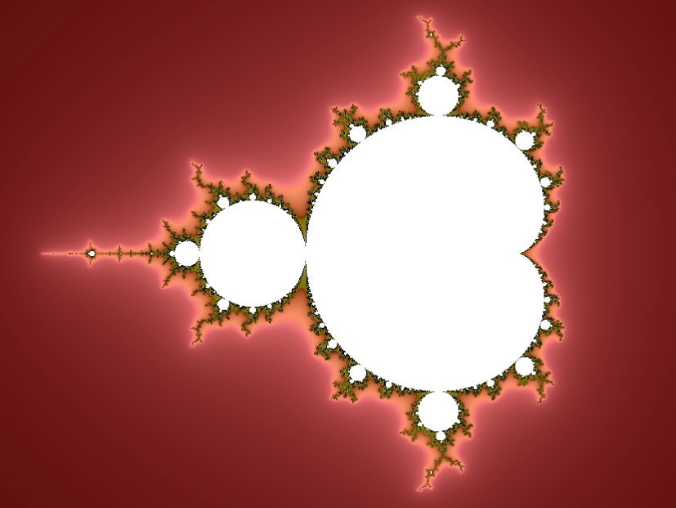

Figure 1 – An example of a Mandelbrot set. The self-similar iterative structure is found in both small and large natural structures such as reefs and vegetables.[1]

Mandelbrot Sets are fractal structures, fractals being defined as a mathematical set that exhibits a repeating pattern which displays at every scale (Boeing, 2016). Mandelbrot stated that the forms of nature like trees, mountains, shorelines or clouds could only be adequately described with fractals, indicating that fractals are well suited to represent naturally generated structures (Ziegler, 2013).

While the above algorithms are well suited towards the generation of natural structures, they require considerable computing power due to their heavy use of recursion (Blatz & Korn, 2017). This is where noise is more suited, as it is an algorithm which can describe well natural forms, while not suffering from the extended computer power required by recursion in most cases.

#### 1983 – Perlin Noise

Perlin noise describes an algorithm created by Ken Perlin while working on the movie “TRON” in 1983 (Vuontisjärvi, 2014). This work awarded him an Oscar for technical achievement and the algorithm has since become a standard in both movies and video games.

Figure – Example of Perlin noise generated online.[2]

Perlin was frustrated with the pixelated look of graphics at the time, and searched for something that could solve this issue. He defined his noise as a “texturing primitive you can use to create a very wide variety of natural looking textures” and explained that “combining noise into various mathematical expressions produces procedural texture” (Perlin, 1985). The texture can be applied to any object and can therefore be used in both 2D and 3D. Another advantage of his noise algorithm is that configurations are repeatable, with the same inputs producing the same output.

Perlin used the terms frequency and amplitude to describe his noise function, with the texture being single-channel typically greyscale image, with each pixel representing a frequency from -1 to +1. A high frequency meant details would be smaller, resulting in many more points in a specific area, while a lower frequency resulted in larger points. The algorithm’s amplitude described the range of height, from 0 to 255, or completely black and completely white.

#### Rogue and Elite

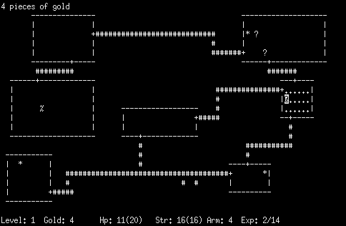Procedural Content Generation is cited as being first used in games such as Rogue (1980), or Elite (1984) (Smith, 2015).

While it is hard to find the first exact use of Procedural Content Generation in games, PCG has been around since the early 1980s and late 1970s, with games such as Beneath Apple Manor (1978). The very early history of games featured severe memory limitations, and as such, Procedural Content Generation was a way of adding extra content to games, providing high replayability whilst fitting within the small memory available to developers (Kenney, 2021).[3]

Rogue started an entirely new genre of game called roguelike and roguelite, which persist even to this day. The term roguelike and roguelite refer to games that are exactly like rogue’s iconic gameplay, hence roguelike, or games that are only slightly similar, hence roguelite. Roguelike games featured procedurally generated levels, in which the player must navigate a level generated to look like a sprawling labyrinth (referred to as a dungeon) (Kenney, 2021).

As mentioned before, roguelike and roguelite are two different genres, although roguelite can best be summarized as a subgenre of Roguelike.

Nearly a century later, a mathematician by the name of Norbert Wiener (1894-1964) was inspired by the phenomenon, together with Godfrey Harold they tried to map it to an algorithm (Blatz & Korn, 2017). Later the French physicist and Nobel-prize winner Jean Perrin had the idea of equating the Brownian motion with continuous, non-differentiable curves (Mandelbrot & Mandelbrot, 1982), which he came to call the “Wiener Process.”ROGUEBASIN, 2008).

This is considered a loose definition of the genre (Jeff Lait, 2009), and since then many attempts have been made to define the genre more rigidly. One of the most well-known is called the “Berlin Interpretation”, created at the Roguelike Development Conference 2008 (*ROGUEBASIN*, 2008).

Mandelbrot used the Brownian motion to develop what he referred to as a “self-avoiding random walk” (Mandelbrot & Mandelbrot, 1982). The process described a function that is laid out on a grid, not allowing any individual point to intersect with another point. While this implementation doesn’t consider the previous position in the grid, a rule is used which states that already entered areas cannot be entered again, and areas the function cannot leave again are blocked.

Several features of roguelike games were discussed by various attendants and were separated into high value factors and low value factors. Examples of both are as below:

|  |  |
| --- | --- |
| High Value | Low Value |
| Random environment generation | Controlled through a single character |
| Permadeath | Monsters share player characteristics |
| Turn based | Tactical challenge |
| Grid based | ASCII display |
| Complexity | Levels that are specifically dungeons |
| Resource management |  |

Mandelbrot Sets are fractal structures, fractals are defined as a mathematical set that exhibits a repeating pattern which displays at every scale (Boeing, 2016). Mandelbrot stated that the forms of nature like trees, mountains, shorelines or clouds could only be adequately described with fractals, indicating that fractals are well suited to represent naturally generated structures (Ziegler, 2013).

While the above algorithms are well suited towards the generation of natural structures, they require considerable computing power due to their heavy use of recursion (Blatz & Korn, 2017). This is where noise is more suited, as it is an algorithm which can describe natural forms well, whilst not suffering from the extended computer power required by recursion in most cases.

While still used today, the Berlin Interpretation has since been accused of being inaccurate, outdated and unrepresentative of a vibrant and open genre (Darren Grey, 2013). He objected to areas like the high and low value specifications, for example, stating that *“adding ASCII to your game does not in any way make it more roguelike. Taking ASCII away does not make it any less roguelike.”* (Darren Grey, 2013)

Below are some random examples of roguelike games:

* **Rogue** – The classic roguelike for which the entire genre is named after.
* **Nemesis** – Featured real-time gameplay and fog of war. This game did not feature procedural levels, but did feature permanent death.
* **Pokemon: Mystery Dungeon** – Part of the Mystery Dungeon series, which was inspired by Rogue’s gameplay.

Roguelites on the other hand seems to be a much vaguer definition but is best categorised as a subgenre of Roguelike. Roguelite games feature only some of the many elements that make up a roguelike.

Below are a few examples of roguelite games:

* **Risk of Rain** – A 2D side-scrolling action platformer, featuring 6 different levels with several options for pre-generated maps, which the game chooses randomly, and then fills with randomly placed chests and interactable objects. The game’s difficulty constantly increases on a timer.
* **The Binding of Isaac** – A 2D top-down dungeon exploration twin stick shooter. Inspired by The Legend of Zelda, but with procedural floors comprised of randomly chosen interconnecting rooms forming a labyrinth, with preset rules to define randomisation.
* **FTL**: **Faster Than Light** – A 2D top-down real-time strategy game styled around space travel. Players travel through procedurally generated solar systems through a galaxy map, participating in side quests while they attempt to avoid an armada of ships chasing them down.

### Current Trends in PCG

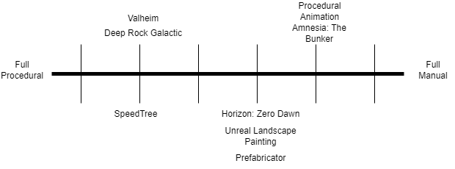The whole area of procedural content generation has become a trend in of itself in computer games development, being used in a broad spectrum from aiding designers in hand crafting levels, all the way to creating fully randomising levels each time the player starts the game. Roguelike or roguelite games, as mentioned before, are an increasingly popular genre – especially in the area of indie games – but PCG itself is becoming an extremely useful and popular tool to aid designers and developers in the creation of hand crafted, user authored experiences.

Figure - A diagram showing the spectrum of PCG games, technologies and techniques.

#### Improving Experiences for Players

Games are making increasingly heavy use of PCG to aid gameplay experiences, resulting in games with an almost infinite amount of replayability, and the opportunity for players to master mechanics in an infinite number of gameplay opportunities. It is important to note that not all games that make use of PCG are considered roguelikes, as this is just a single genre that makes heavy use of the concept. Many other games make smaller use of PCG, in varying ways.

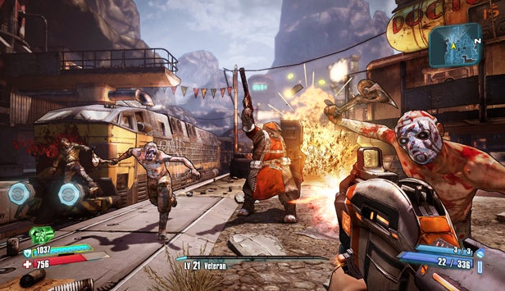One of the most popular forms of PCG is game state randomisation through the use of prefabricated assets. Some examples of such a concept are listed below – namely Borderlands, Raft, and further down Amnesia: The Bunker.

Figure – A gameplay screenshot of Borderlands 2.[4]

Perhaps one of the most famous examples, although not an old one, is the Borderlands series. Borderlands is well known for its humour, art style and combat, which have lasted across 3 games and spinoffs (Borderlands - 2K, 2023). Borderlands only makes light use of PCG – dedicating it entirely towards a very robust weapon system. As Borderlands is a looter shooter, there needs to be a high number of weapons for the player to use, and rather than handcraft weapons the game uses some controlled PCG to generate a seemingly infinite number of weapons.

The game has a pool of both parts and stats that can be rolled, and these parts are then assembled into a weapon. To control this, the game has “weapon manufacturers” – A term used to describe a common set of weapon parts and stats that you can expect to relate to each other. This means that the PCG is not chaotic, and although you will find many subpar guns, you can come to expect some coherency from them.

The game also takes the player’s stats and “level” into account when generating weapons, such that as you progress through the story, weapons linger around your player’s level, and you will always eventually find something stronger.

One of the most famous uses of PCG, and still used in many other games to this day, is the concept of terrain generation. This is the act of generating a world for the player to explore, and is typically used in survival games, but also stretches to other genres and even dungeon crawlers can be considered PCG.

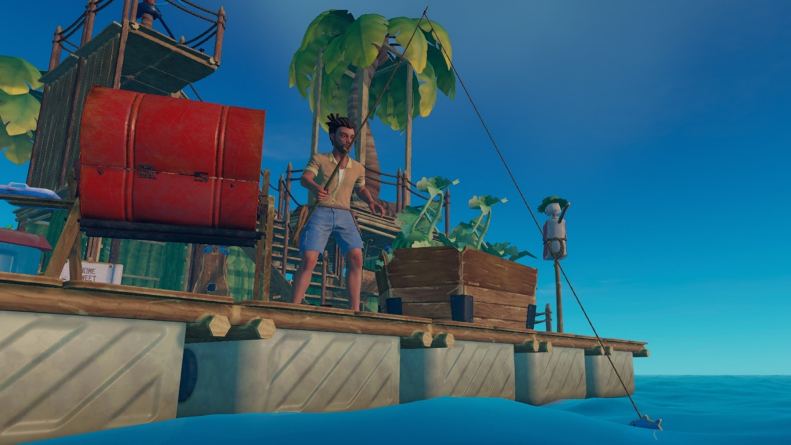

Figure – A screenshot of the game Raft.[5]

A simple example of this is Raft. Raft is a game that takes place on an infinite ocean, dotted with islands (Raft - Steam, 2022). The game works by generating islands as the player explores, picking from a premade pool of hand-crafted islands. This pool is quite small, and as such it is easy to come across everything the game has to offer. The game does things to improve this, such as adding biomes that change the type of island (to a desert island and a forest island), and as the game has a story there are several story based islands randomly placed in the world.

Figure 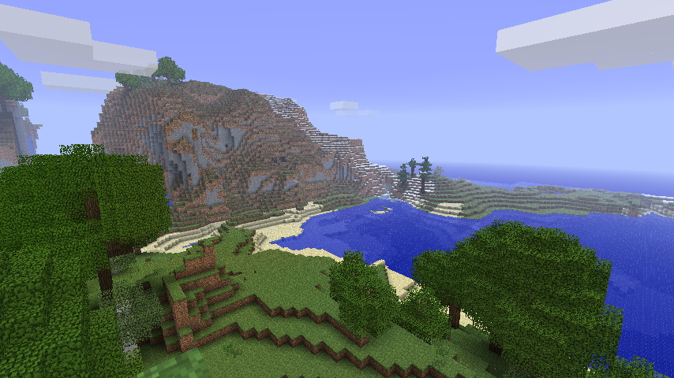 – A screenshot of Minecraft.[6]

One of the most famous examples of procedural terrain generation is Minecraft, which once held the record for the most popular and best selling game of all time (Minecraft - Mojang, 2023). Minecraft has evolved over the years, and so has the terrain generation, becoming highly sophisticated and generating extremely varied, well designed worlds. The game later added caves, making use of what they call “spaghetti and cheese” generation (two different existing algorithms), and other dimensions with completely unique forms of terrain generation.

Procedural content generation doesn’t have to be limited to gameplay content in the traditional sense – It can be used to elaborate on the gameplay in a more subtle approach. A great example of this is Left 4 Dead 2 (Left 4 Dead 2 - Steam, 2009), which uses the concept of a procedural Game Director. 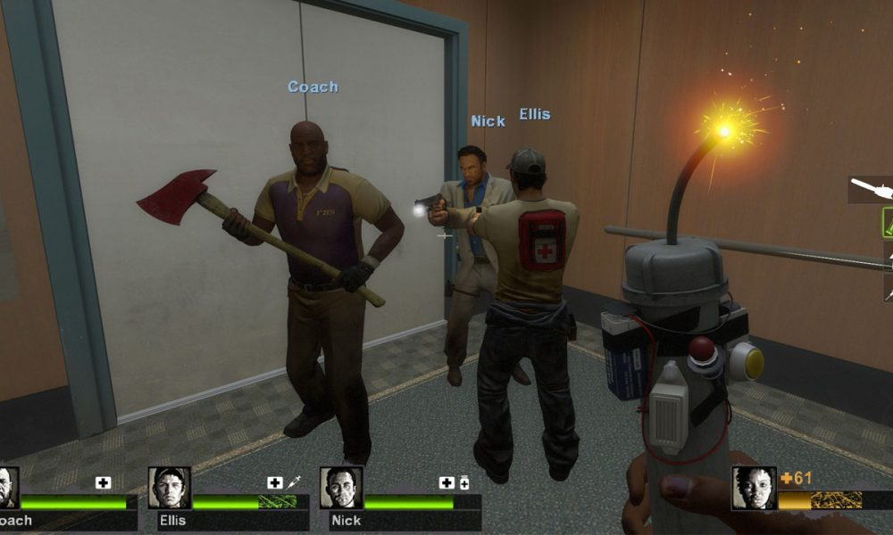

Figure – A screenshot of Left 4 Dead 2.[7]

The Game Director oversees each of the game’s campaigns. While the maps and events in the campaign are not procedural, the spawning of practically everything else is. The game will spawn hordes of zombies, special zombies, items, weapons, stashes, equipment and more completely on the fly depending on a mix of luck and the player’s performance. This means the game has high amounts of replayability, and you can go through the same hand crafted campaigns with a fresh experience each time.

Another thing Left 4 Dead 2 randomises is the zombies. The developers knew that a handful of zombie models would quickly become repetitive, but also making a more varied array of zombies would take too much time, so the zombies themselves are procedurally generated from prefabricated assets. The team created different parts of zombies, legs, arms, torsos, heads and more, and the game combines these together at runtime to create procedural zombies.

On top of this, they also hand crafted several zombies for specific levels, which filled specific roles, like hazmat suit zombies, zombies in themed gear (clowns, quarterbacks, fallen survivors, workers, riot gear).

**[](https://www.youtube.com/embed/6DfhZaq2_W0?feature=oembed)**

Figure – Above, an embedded video essay on Left 4 Dead 2.

The concept of a Game Director is not limited to just gameplay in this approach, as games like Alien Isolation (Alien Isolation - Steam, 2014) make use of it to directly affect the AI of the game’s primary antagonist.

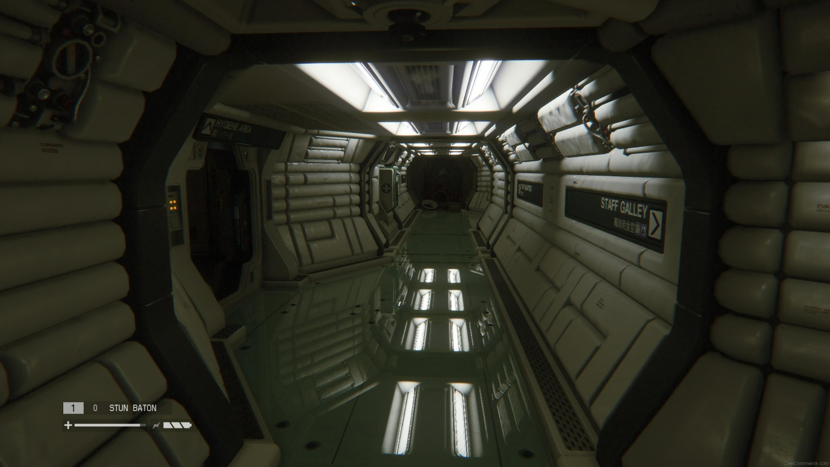

Figure – A screenshot of Alien Isolation[8]

Alien Isolation makes use of two pieces of AI that act in a procedural manner, a larger scale AI, and the Alien’s AI. The larger scale AI, referred to as a director, guides the Alien and ensures it always ends up in the right place at the right time (within close proximity to the player). It gives the Alien “hints” as to where the player is, but it never tells them where exactly they are. The alien must search these areas, looking through rooms and into hiding spots, in an attempt to find the player.

The developers made use of what they call a “menace gauge”, similar to Left 4 Dead 2’s “stress gauge” to manage the intensity of enemy attacks and calling them off when it gets too high. The menace would increase under different circumstances, allowing the Alien to act independently and harass the player, and then allowing it to be called off when the time is right.

The Alien itself makes use of the concept of behaviour trees, with the game procedurally unlocking these based on player behaviour. This gives the idea that the alien is learning from the player’s actions.

All of this means that the Alien is highly procedural, allowing players to approach the game differently every time. The Alien is almost never “on rails” or scripted, aside from a handful of in game events that happen at the same points in the story.

[](https://www.youtube.com/embed/P7d5lF6U0eQ?feature=oembed)

Figure – Above, a video essay on the AI of Alien Isolation.

#### Improving Experiences for Developers

With the rising costs of games production requiring more labour, more time, and more money (Yo Takatsuki, 2007), PCG is becoming an increasingly popular tool in the aid of game developers and development. PCG can aid in the creation of hand-crafted environments, textures, asset placement, and more, while still ensuring the game is fully handmade and offers a uniform experience for every player (that is – the player can expect generally the same experience each time they play).

Over time several tools have been developed to improve development times and to speed up the process of making games. Many of these tools have become industry standards in both video games and movies, and even Unreal Engine itself has been used in movies and shows such as The Mandalorian (Jeff Farris, 2020).

The common consensus with procedural generation is quick and easy iteration with visual interfaces, allowing for an artist, designer, or developer to quickly generate and test what they want to add to the game, saving hours of development time recreating terrain or assets. Procedural generation in this method is also used with algorithms, allowing for things like procedural animation.

[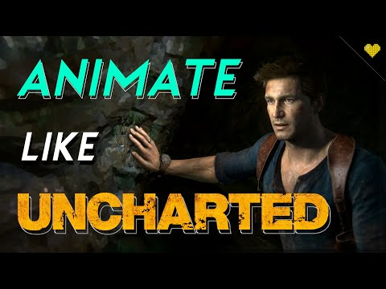](https://youtu.be/dlQqiJYdyYM?si=CL83HDaD95dGyiz5&t=73)Procedural animation is the process of using math and algorithms to generate animations for models. This technique is used in many games, typically only in small portions, but occasionally you may find a fully procedurally animated creature.

The above video shows an example of Uncharted, where the character you play as will reach out to push their hands away from walls as they walk near them, which is entirely dynamic and uses procedural animation.

In the case of Uncharted, although the animation is procedural there are several steps that are reproduced each time the animation is played to keep a consistent result. This is why procedural animation is typically used to enhance existing animations, like a tail with physics on a character, or aligning feet to the floor.

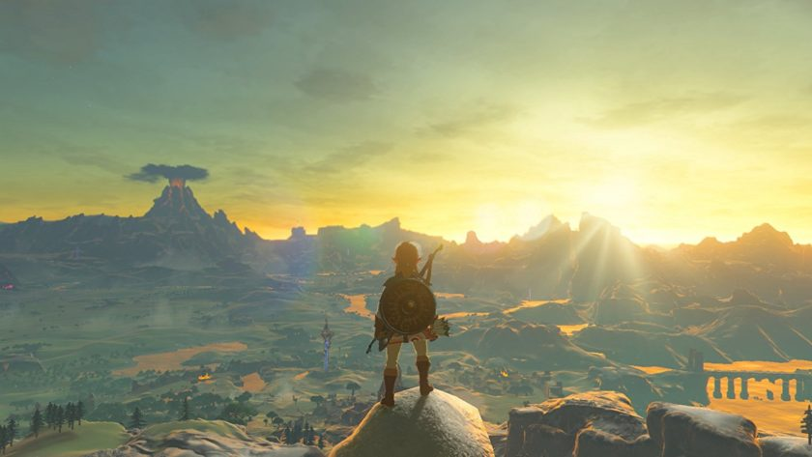

Figure – An example from Breath of the Wild, showing Links feet aligning to the ground using procedural animation.[9]

Another example of procedural animation is the Guardians from Breath of the Wild, which use fully procedural animation to move their legs and place their feet on the ground. The player can destroy their legs and the enemy will react, moving their legs differently and eventually being unable to walk.

[](https://www.youtube.com/embed/glN59YhNYeM?feature=oembed)

When it comes to procedural generation aiding developers more directly, one of the best examples to showcase 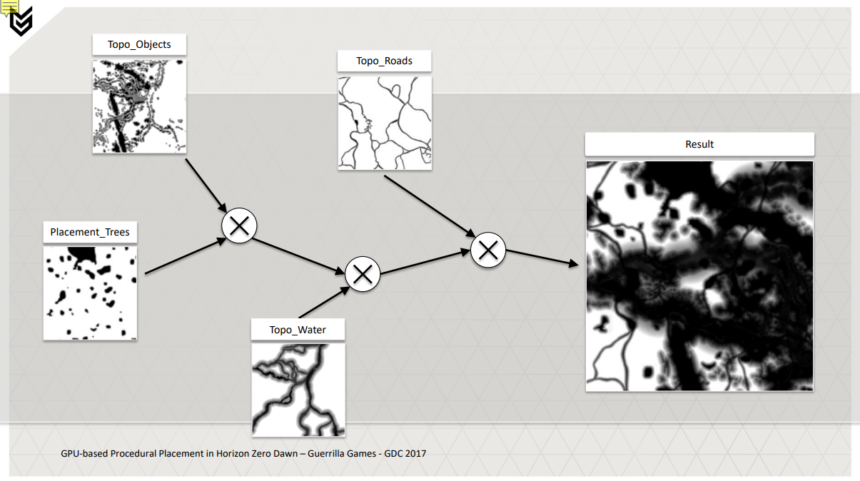is the GPU based procedural placement found in Horizon Zero Dawn.

Figure – A diagram showing different layers of hand crafted 2D maps that are used by the GPU procedural asset placement to generate trees, objects, roads, water and more.[10]

When making Horizon Zero Dawn, the developers required this method for several reasons, including quick iteration, large variety, and a believable look (van Muijden, 2017). This resulted in a system that procedurally placed assets for all forms of nature, with over 500 asset types, and 100,000 objects able to be generated in a single scene. The system allowed for easy iteration on terrain, using multiple types of height maps for objects, trees, roads, erosion, and more, with the system in place combining these to generate entire scenes procedurally.

[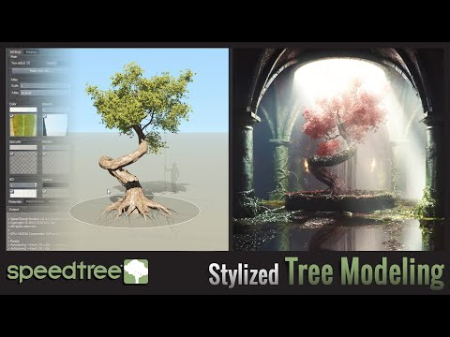](https://www.youtube.com/embed/L910rESD79M?feature=oembed)In terms of commercial software, a number of solutions have been developed over time, and one of the most popular is SpeedTree. SpeedTree is used to quickly and efficiently generate foliage like trees and bushes for games using L-Systems, and can be incorporated into several engines.

SpeedTree is an entirely visual software, as shown above, and allows for quick and efficient iteration on assets so an artist can easily generate any kind of tree they want. They can insert it into the engine easily, and just as easily go back to the drawing board to iterate further.



Figure – An example of a Quixel Megascan.[11]

Quixel Megascans are similar to SpeedTree, but rather than entirely procedural is a library of free assets. Quixel Megascans are scans of real-life objects, which are then dynamically generated into realistic looking assets for developers to use in their projects. This allows developers to easily find an asset from Quixel they like the look of, and to easily insert it into their game.

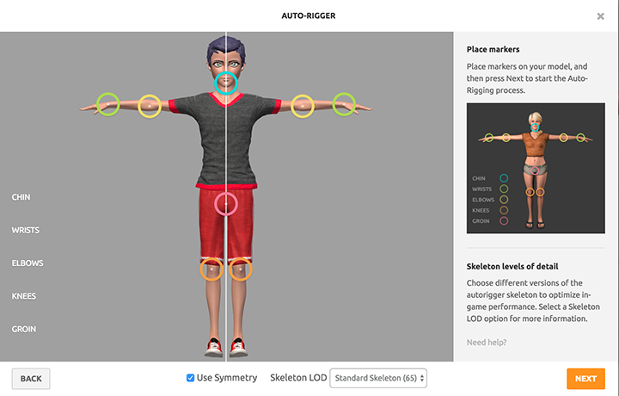Another example of procedural generation of assets is the Mixamo Autorigger, where a user can specify the placement of major extremities like elbows, knees, hands feet etc and the rigger will procedurally generate weight painting and bones for your model.

Figure - A screenshot of the Mixamo interface for generating a rig from specified areas like knees and elbows.[12]

### Game Engine Support for PCG

One of the biggest examples for in-engine support for PCG is Unreal Engine, featuring many fully featured and fleshed out tools for generating procedural content both at runtime and design time. Several third-party tools have been developed however, both for Unreal Engine and several other commercially used engines.

#### Unreal Engine

Perhaps the most widely known example of procedural design time generation of content in Unreal Engine are the terrain and landscape painting tools. While perhaps not the best example, they are in fact still procedural. The tools allow for a designer to simply paint on the landscape, and Unreal will generate terrain from those inputs. Several different brushes are available as well as support for custom brushes, masks, and more, and the tool even gives you the option to specify foliage which can be procedurally painted with a special foliage brush.

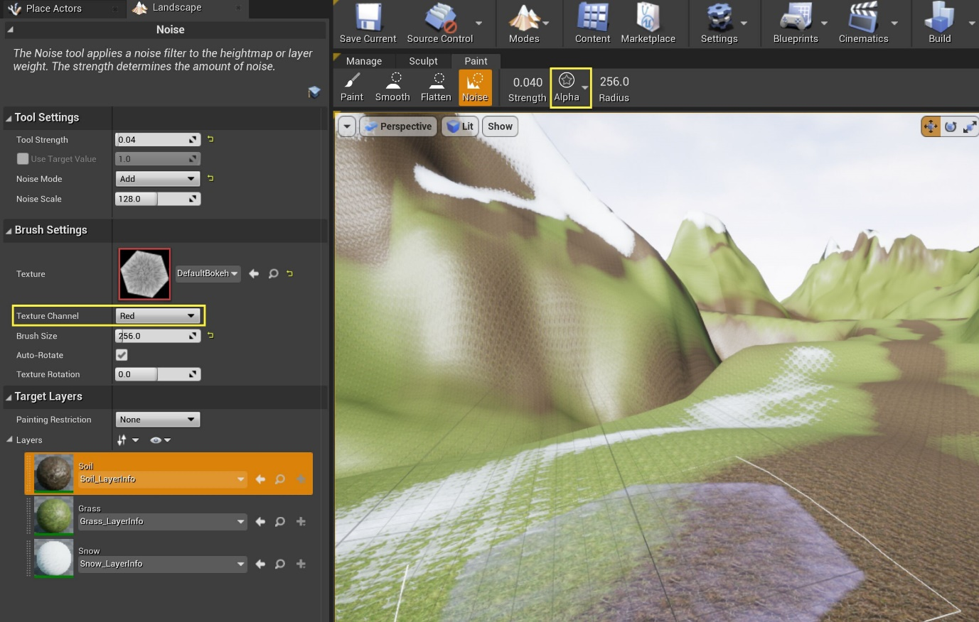

Figure - A screenshot of the Unreal landscape painting tools with certain aspects highlighted.[13]

[](https://www.youtube.com/embed/I7zyNDazmGQ?feature=oembed)In later years, lots of work has also been put into the PCG Framework. A brand new entirely node based workflow for procedurally generating levels by spawning assets and content, using rules, scripts and other functionality to dynamically generate game content (Epic Games - Procedural Content Generation Framework Overview, 2023).

Figure - A video demonstrating Unreal's PCG Framework.

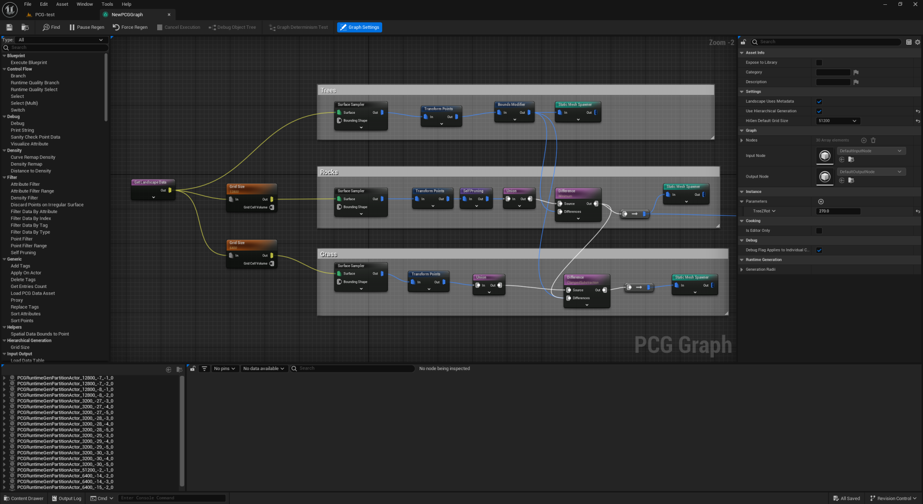

Figure - The procedural content framework makes use of a completely unique set of nodes in a node based workflow.[14]

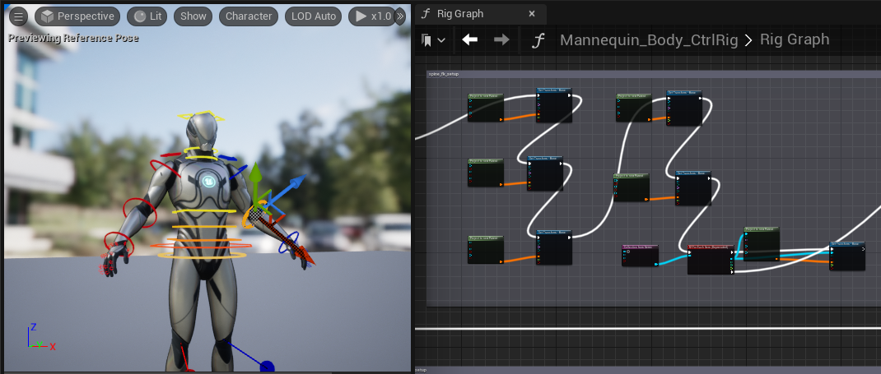Last but not least, another lesser known but very capable example of design time procedural content generation is Control Rig. Control Rig allows animating from within the editor, through a node-based setup very similar to Blueprints. This allows users to control bones and even make use of various types of IK, from full body to FABRIK. Control Rig can also take in variables from elsewhere, allowing blueprints to generate variables, such as aligning feet with the floor, and then send that to Control Rig which can handle the actual placement of the feet from these transforms.

Figure – A screenshot of Unreal Engine’s Control Rig, showing several nodes alongside a rigged character.[15]

#### Elsewhere

Procedural tools aren’t just limited to Unreal of course, while Unreal has many dedicated tools there are several third party addons and tools that exist elsewhere, with support for both Unreal Engine and other engines like Unity.

Prefabricator is an example of such a tool, which allows developers to quickly iterate on areas of a level by randomising positions and layouts of prefabricated assets, which are specified by the developer. Prefabricator has many options to help improve the level design workflow, several of which are procedural:

* **Nested Prefab Randomisation** – Allows simple collections of prefabs to be randomised, for example randomising the front of a building based on several tiled premade assets like window, balcony and wall segments.
* **Prefab Collections** – Allows similar prefabs to be grouped together into a weighted collection, which can randomly be selected to add variation.
* **Controlled Randomisation** – Uses “Seed Linkers” to enforce the same random selection across multiple prefab instances.
* **Runtime Support** – All of the above can be ran at runtime, rather than just in the editor.

Figure – Nested prefab randomisation within Unreal Engine.[16]

Halo Forge is a full map editor featured in many Halo Games, which, like Unreal Engine, adds support for procedural terrain generation through the use of design time tools. Halo Forge dynamically generates a “cost” for each object placed into the world, and it uses this total cost to define whether a level can be ran and uploaded for other users or not. By doing this, users are freely able to create levels while not ensuring they’re made too big.

## Case Studies

Below are several examples of games that make use of procedural content generation.

### Deep Rock Galactic

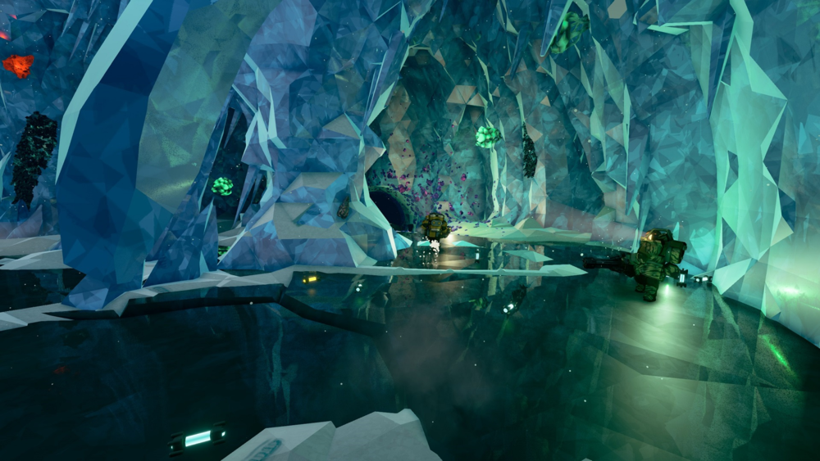

Figure - A screenshot of a cave in Deep Rock Galactic. Some dwarves are visible.[17]

Deep Rock Galactic is a roguelite game featuring procedurally generated caves (Deep Rock Galactic - Steam, 2020). Players control a dwarf assigned to one of four classes, each of which specialises in a different area. As a team of four, players must move through procedurally generated fully destructible caves, completing objectives and mining ores and minerals.

I spent a while looking up how the game generated its caves, and at first, I assumed it was cellular automata combined with marching cubes, but the approach is in fact much simpler.

The developers created a number of hand-crafted rooms, with the caves between these rooms being fully procedural. The caves themselves are then filled with objects like crystals, flora, stalagmites, stalactites and more. Afterwards, the game uses Perlin noise to deform the mesh and add extra variety, leading to caves that despite using a common set of rooms seem highly unique each time. This is further improved by the game using different cave generation for each type of game mode.

### Valheim

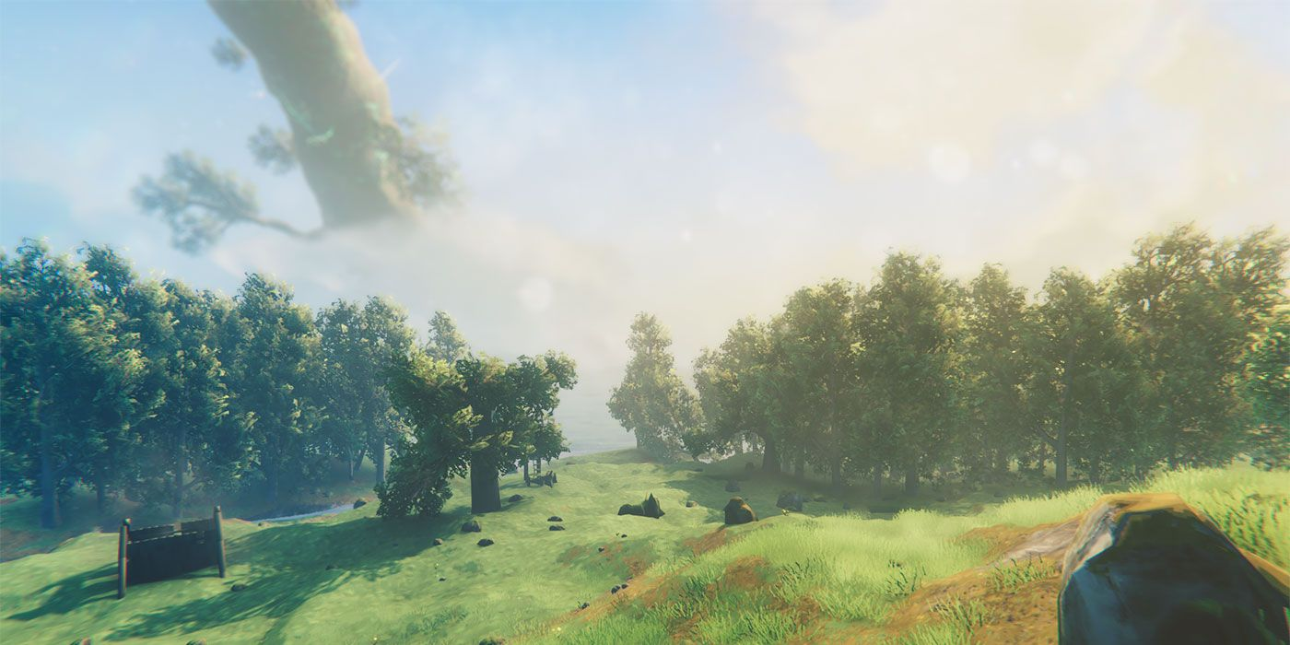

Figure - A screenshot of terrain in Valheim. A river is visible in the distance, alongside two wooded areas.[18]

Valheim is a survival game akin to Minecraft, featuring a procedurally generated map where players control a Viking sent to purgatory to earn their way into Valhalla (Valheim - Steam, 2021). Valheim, like Deep Rock, is surprising in that it has a simple approach to map generation. The game has a large texture in the game files which is converted into 3D terrain, with the placements of biomes and flora being procedural. Furthermore, the texture of the map is extremely large, and the game itself only uses a very small portion of it which is specified by the world seed.

Both Deep Rock Galactic and Valheim are examples of how when it comes to procedural generation, anything goes. Simple methods can be used to create a huge variety of content for players, and they may even think it uses a more complex method than it actually does.

### Amnesia: The Bunker

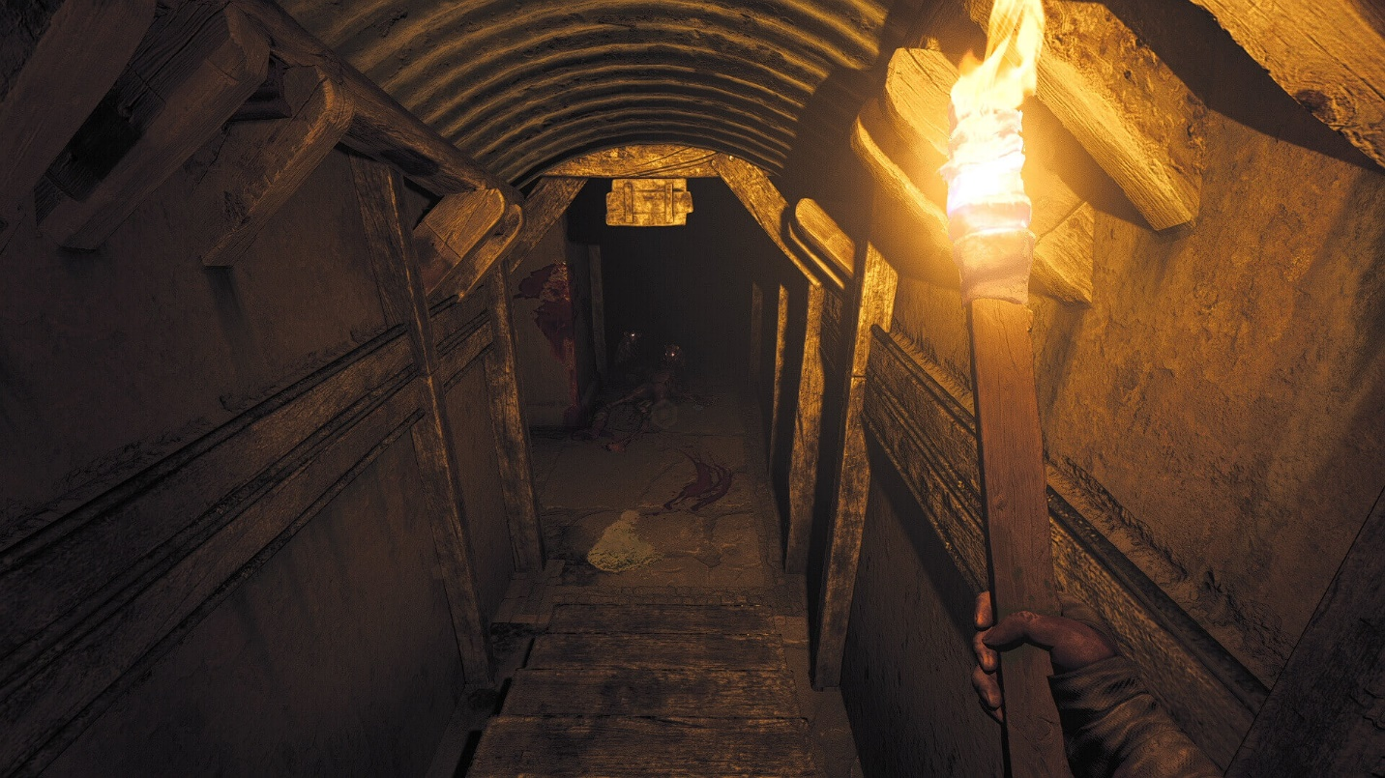

Figure – A screenshot of Amnesia: The Bunker.[19]

Amnesia: The Bunker (Amnesia: The Bunker - Steam, 2023) is a much different game compared to the other two examples, as the map is entirely hand crafted. This is an example of gameplay PCG over game world. The game features the same events each time the game is played, but what makes the inclusion of PCG significant is how it affects the way the player interacts with the world. The game’s placement of items, locked doors, traps, fuel for the generator, keys and more is entirely randomised. Sometimes a door may be open for the player to progress, and sometimes it may be locked, and they’ll have to find another way. Tools used to open vents and gain access to rooms may be in a different place the next time the game is started over.

In this way, Amnesia uses simple procedural generation techniques to compliment a hand crafted map, allowing for a relatively short game to have much more replayability, and also become much more frightening when strategies don’t go according to plan.

## Runtime VS Design Time PCG

When discussing PCG, it can best be divided up into two different areas, these being Runtime PCG, and Design Time PCG. Both are closely related but serve two different purposes.

The difference between Runtime and Design Time can be compared to Offline and Real-Time Rendering in 3D graphics.

* Offline Rendering refers to the rendering of an animation before it is displayed to the user, best compared to in the case of a movie. This method prioritises high visual quality, and typically can afford longer loading times.
* Real-Time Rendering refers to the animation being rendered in real time and is what games outside of areas such as pre-rendered cutscenes. This type of rendering typically compromises on quality and goes for a “good enough” approach to allow it to generate frames as quickly as possible.

### Runtime

Runtime PCG is procedural content generation that is generated at run-time of the game or program. Because of this, it must be able to run very fast and efficiently, to ensure minimal load times and quick iteration and generation of the content. Runtime PCG is what is usually used in games, through different means.

* Amnesia: The Bunker, while generating at Runtime, only does so once at the start of a new game. From then on, everything is static. After starting a new game a second time, this process repeats.
* Games like The Binding of Isaac and Enter the Gungeon both generate full dungeons and do so at the start of each game. Typically, they will only generate one dungeon at a time, and as the player progresses to a new level, the previous dungeon is removed from memory and a new one is generated.

The Binding of Isaac and Enter the Gungeon typically make use of premade content (each room is premade), and each dungeon uses a selection of rules to generate a dungeon combining these rooms. In Gungeon’s case, the dungeons are also connected with corridors, and the entire dungeon is one single scene. In Isaac’s case, each room is a separate “scene”, so only one is loaded at a time.

Despite this use of premade content, full procedural elements may still be used, like the placement of enemies in a room, the choice of items in a shop, what item comes out of a chest, etc.

### Design Time

Design Time PCG is procedural content generation that is generated during the development of the game. This allows for quick iteration on content, like pre-generating a large open world for later hand-crafted refinement. Design Time PCG is widely used in the games industry, as it massively speeds up development times, while still allowing for a human touch, and allowing designers who may have little to no level design experience to adjust content until it matches their vision.

Several tools, plugins and frameworks have been mentioned previously that make use of Design Time PCG.

* Horizon Zero Dawn’s open world makes use of a large amount of Design Time PCG, where all of the foliage in the world is procedurally placed from several different heightmaps that are merged together. Through this, they can quickly iterate on worlds, and are able to convert a forest into a desert and vice versa extremely quickly.
* SpeedTree allows developers to quickly generate various types of trees from simple parameters, and these trees can be easily iterated on, or exported to FBX files for further use.
* Unreal Engine’s landscape tools generate maps and terrain procedurally based on the developer’s use of the landscape painting tools.
  + Fortnite’s UEFN is a fork of Unreal Engine designed specifically to act as a replacement for Fortnite’s Creative Mode. It incorporates many of Unreal Engine’s tools.

## Algorithms

Many algorithms exist that make use of some form of procedural content generation, and are highly useful for procedurally generated content. This is either by facilitating content such as dungeon room placement or procedural height maps for terrain, or by procedurally generating aspects such as mesh data, as is the case for marching cubes.

* **Perlin Noise –** Perlin Noise is a useful and robust noise generation algorithm used in a variety of situations from procedural generation of height maps for terrain, all the way to procedural textures, materials, and texture maps such as roughness and metallic.
* **Marching Cubes –** An algorithm useful in the generation of 3D mesh data. Arbitrary points can be generated by a user, and then fed to Marching Cubes which will convert the arbitrary points into a list of vertex and index data for insertion into something like Procedural Mesh Component or Realtime Mesh Component.
* **Cellular Automata –** An algorithm used to model complex systems such as living creatures or cells, by specifying rules that decide their replication or destruction. It is also useful in the generation of caves.
* **L-Systems –** An algorithm used to describe the growth of trees, L-Systems are also useful in the generation of procedural trees in games and is specifically used in SpeedTree.
* **Recursive Backtracking –** An algorithm that generates dungeons and mazes by exploring paths and backtracking when necessary.

## Conclusion

In this chapter we have discussed the domain research behind the project. This includes an overview of procedural content generation, the history of notable algorithms, existing support in game engines as well as current trends in the industry and tools/software such as Quixel Megascans and SpeedTree. We have done case studies into games Deep Rock Galactic, Valheim and Amnesia: The Bunker, as well as the differences between runtime and design time content generation. Finally, we briefly discussed algorithms that generate different types of content.

# Technical Research

## Procedural Generation of Real-Time Graphics

### Overview of Real-Time Graphics In Games

Real time rendering in games refers to the act of rendering a 2D image from a scene in real time given components such as lights, effects, and objects from the point of view of a camera. This process is referred to as the graphics rendering pipeline. The most common example of this pipeline used today is the programmable graphics pipeline.

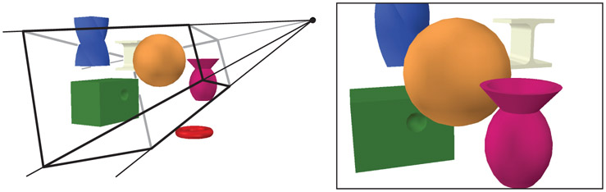

Figure – Given a 3D representation of objects and a camera, a 2D image is produced. [20]

### Object Spaces

An object’s space refers to the relationship between coordinates, given an origin. Several different spaces exist within 3D, and it is important to know the difference as the programmable graphics pipeline makes use of several different examples. Spaces to consider include:

* **Local Space** – Local Space is used in the context of parent-child object relationships. The parent object’s location is defined as the origin, and any child objects attached to that parent consider the parent’s object the origin. This continues down the hierarchy, such that children of children consider the first parent up as their origin.
* **World Space** – World Space considers a central point within world as the origin.
* **Camera Space** – Camera Space, or View Space considers the camera as the origin, with the direction it faces as positive or negative Z.
* **Model Space** – Model Space considers the model with no transformation from a central point.
* **Screen Space** – Screen Space considers the screen as 2D coordinates, with a given corner starting from x = 0 and y = 0.

### Programmable Pipeline

The programmable graphics pipeline refers to a variation of the graphics rendering pipeline where each stage can be programmed by the user, allowing for a customisable and varied output that is particular to the software in question (Akenine-Moller et al., 2019).

The pipeline executes each stage in parallel, meaning that each stage requires the output of the last stage, and if that stage gives an incorrect result, then the output of the next stage may be incorrect and so on. The pipelining process gives an increase in performance over non-pipelining (Hennessy John & Patterson David, 2011).

Given a non-pipelined system, if said system is divided up into *n* pipelined stages, it will result in a speedup of *n*. This increase in performance is the main excuse to use pipelined stages.

For example, if there is a pipeline with 3 stages, each stage taking 20 seconds to complete, then the maximum output of this pipeline is 3 per minute. These pipeline stages execute in parallel but are stalled until the slowest stage completes its task. If the second stage takes 30 seconds, then suddenly the output is only 2 per minute. The third stage is considered starved while the second stage stalls, and the second stage is considered the bottleneck (Akenine-Moller et al., 2019).

Roughly, the real-time rendering pipeline can be divided into four main stages:

* Application
* Geometry Processing
* Rasterization
* Pixel Processing

(Blinn, 1996)

Each stage is usually considered a pipeline in of itself, so that subsequent stages are instead sub-stages.

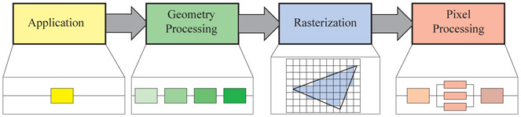As the rendering pipeline is highly customisable, a stage has a certain task to perform but does not specify how that task is executed. Therefore, an implementation of the pipeline may combine two stages into one or execute it using programmable cores while another more demanding stage is divided into several hardware units (Akenine-Moller et al., 2019).

Figure – An example of the real-time rendering pipeline stages.[21]

A more specific example of the stages can be read below. This is not exhaustive, and not all of the stages must be used:

* Input Assembler – Reads input and vertex data.
* Vertex Shader – Gets the input and vertex data and processes it for the next stage.
* Primitive Assembly – Reads the vertices that make up a single primitive and passes them on.
* Hull Shader – Accepts primitives, writes control points (transformed/non-transformed), inputs for the domain shader and extra data that drives tessellation.
* Tessellation Stage - Creates vertices and connectivity for tessellated lines and triangles.
* Domain Shader – Given the previous inputs, creates vertices.
* Rasterizer – Rasterizes the given primitives.
* Pixel Shader – Given vertex data, outputs pixel colours.

(Giesen, 2011)

#### Geometry Stage

The Vertex Stage is the initial stage that happens in the pipeline and is responsible for most of the per-triangle and per-vertex operations. It can be split up into 4 categories and converts the 3D coordinates of the vertices in the world to 2D coordinates on the screen.

Figure – The individual stages of the Vertex stage.[22]

The initial task is to set up an ordered list of vertices to be sent to the pipeline. The ordered list of vertices generated establishes the boundaries of a primitive (basic shapes – triangles, lines and points), and is defined as a vertex array (Baek & Kim, 2019).

Initially, a model is in its own model space, meaning no transformation has occurred. Several model transforms can be associated with a single model, so several instances can have their own properties and be displayed on the screen independently, without requiring the basic geometry to be replicated.

After the model transform has been applied to these coordinates, the model is within world space. All objects within the game exist within this space, sharing the same origin (Akenine-Moller et al., 2019).

The camera itself has a location in world space, as well as a direction that it faces. To allow projection and clipping, the camera and all objects are additionally transformed with the view transform. The space generated after these calculations have been performed is known as camera space.

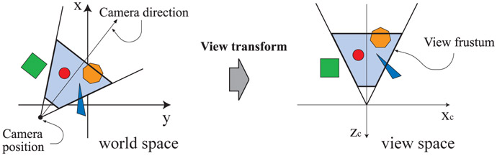

Figure – A diagram showing view space after being transformed from world space.[23]

The view transform reorients the world so that the camera is the origin, looking along its negative Z axis with the Y axis facing upwards, which allows the clipping and projection operations to be quicker and simpler to perform (Akenine-Moller et al., 2019).

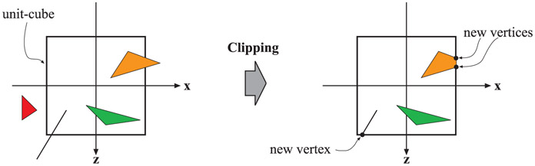Clipping occurs next, to remove unnecessary elements from the view and save processing power. Clipping is defined as the process of removing vertices from outside the view on a partially rendered object. This generates new vertices that intersect the edge of the view, such that objects outside are not rendered, and objects inside are fully rendered. This is typically performed after the view and projection calculations are performed so that clipping is easier and more consistent (Giesen, 2011). Culling is also applied to faces that point away from the camera, usually using the normal or winding order of the face in question (such that faces pointing away have a reverse winding order).

Figure – Showing new vertices generated on primitives after clipping has occurred. [24]

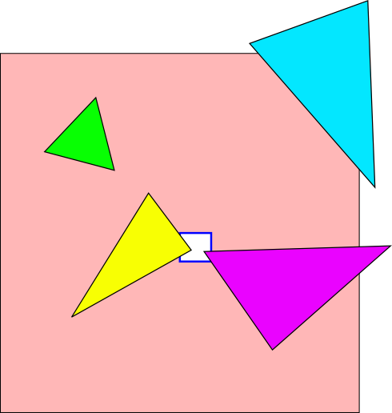Another type of clipping is referred to as guard band clipping and is simpler. Primitives outside of the view but not outside of the guard band region are instead rendered in full, whereas primitives within the guard band but not within the view are not rendered at all. This offers a simpler form of clipping without the computational task of generating extra vertices that intersect the view boundary (Giesen, 2011).

Figure – An exaggerated example of guard band culling. The white square is the view, and the salmon shape is the guard band.[25]

The next stage defines the visual appearance of the models, through the use of light cast within the scene and materials applied to the object by computing shading equations at various points.

Typically, these are performed during the geometry processing stage, but some of them may be computed at the pixel processing stage. The vertex shading results are then sent to the rasterization and pixel processing stages to compute the actual shading of the surface of the object.

Finally, the geometry stage calculates the screen-space mapping of the view. Coordinates that enter this stage are still 3 dimensional and must be flattened “against” the screen. This process is handled exclusively by the GPU, and cannot be exposed to the programmer, which is why there isn’t much information on it.

#### Rasterization and Pixel Processing

After the complex process of transforming and projecting the vertices within the 3D world, the next stage is the process of finding all pixels that are inside the generated primitives being rendered. This is done to allow the pipeline to compute the actual colours of each pixel, given the shading and material data generated earlier.

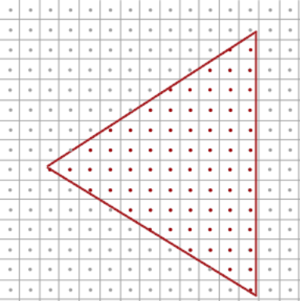The previously generated stage did not actually create a usable image on the screen, but rather generate the data to allow that image to be created. The data given here is still vertices, edges and faces. Monitors use pixels, and so this data is unusable and the material data hasn’t been applied as colour yet.

Figure – The process of rasterization simplified, given a single triangle. The red dots refer to pixels that will render this triangle from the given data (the red line).[26]

Rasterization can be split up into two sections, Triangle Setup and Triangle Traversal.

* **Triangle Setup**  - Triangle Setup refers to the process of computing the differentials, edge equations and other data for a triangle. This data can be used both for triangle traversal, and for interpolating the shading data produced by the geometry stage.
* **Triangle Traversal** – Triangle Traversal is where fragments are generated from the parts of a pixel that overlaps the given triangle. Fragment depth is included, as well as the shading data from the geometry stage.

(Akenine-Moller et al., 2019)

Finally, the pixels that have been found through triangle traversal are processed using all the data generated.

Pixel processing refers to the stage where per-pixel/per-sample operations are performed on pixels or samples that are inside a primitive. It can also be referred to as fragment shading.

A fragment contains the data used to perform the final image. It contains the window space position, the depth, interpolated attributes such as colour, texture coordinates etc, and potentially more. A set of fragments exists for each primitive rendered onto the screen.

* First, given the appropriate texture and UV map, texturing is applied to each fragment.
* Then, primary and secondary colours are applied, and if applicable fog calculations may be performed.

(*3D Graphics with OpenGL - The Basic Theory*, n.d.)

In the context of procedural generation, this would require the developer to “hook into” whatever rendering framework they are using (such as Unreal Engine’s), so that if they were to generate 3D models at runtime they’d have to incorporate this into Unreal Engine’s rendering systems.

Many tools and plugins for Unreal Engine already offer this, like the previously mentioned Procedural Mesh Component and Realtime Mesh Component. Realtime Mesh in particular offers many improvements over Procedural Mesh Component, and is specifically designed to be used similarly to Procedural Mesh.

This means that developers making use of these plugins can focus on generating the mesh data, and safely rely on Realtime Mesh to hook into Unreal Engine’s rendering system to render the mesh data.

## Input Assembly

### Vertex Data and Buffers

In the computer graphics world, models are made up of faces. Faces are triangles, triangles are points, and points are a simple location in 3D space, represented in model space (Blinn, 1996).

There are several ways to handle the storing and rendering of vertex data, the rendering of which has been discussed earlier. The storing of this data is typically handled through a single Vertex Buffer and an Index Buffer per model.

Vertex Buffers and Index Buffers are how data in a mesh is stored and ordered. DirectX refers to these as Vertex Buffers, while OpenGL refers to them as Vertex Buffer Objects (VBOs) (Akenine-Moller et al., 2019).

The idea behind a vertex buffer is that it stores model data in a chunk of memory, taking the form of a 1-dimensional array of vertexes in a specific format, like a vector, or something unique. The format may also specify whether the vertex has a normal, texture coordinate, colour, tangent, or whatever else the format requires.

Some notes about vertices within vertex buffers:

* The size of bytes of a vertex is called its stride.
* The type of storage is called an interleaved buffer, as each vertex has its data in a group, stored one vertex after another.

(Akenine-Moller et al., 2019)

Alternatively, some approaches store data in a set of vertex streams. This takes the form of a single array for positions, one for normal, one for texture coordinates and more. This is the approach that Realtime Mesh Component uses.

In their paper Optimising the Graphics Pipeline with Compute (Wihlidal, 2016), Wihlidal discusses different ways that multiple streams can help performance, including API calls, aching and CPU processing advantages. As an example, they say that SSE (Streaming SIMD Extensions) and AVX (Advanced Vector Extensions) used for processing of vectors are easier to apply in a separate stream (Wihlidal, 2016). Another reason is for mesh updating. If for example just the location of some vertices is updated or changes over time, it is much easier to update this data as a separate buffer or stream, compared to regenerating and sending over the entire stream again.

On the other hand, there are Index Buffers.

Vertex Buffers are referenced by Index Buffers, and they can take several forms (Akenine-Moller et al., 2019). An Index Buffer handles the referencing and creation of triangles, and typically takes the form of a custom class or struct holding the 3 indices of vertices for a single triangle, or as a continuous list of indices, where each 3 indices form a single triangle. The benefits of this method are the storing of less data. Holding a simple index to a point within the vertex buffer is more efficient than replicating this data.

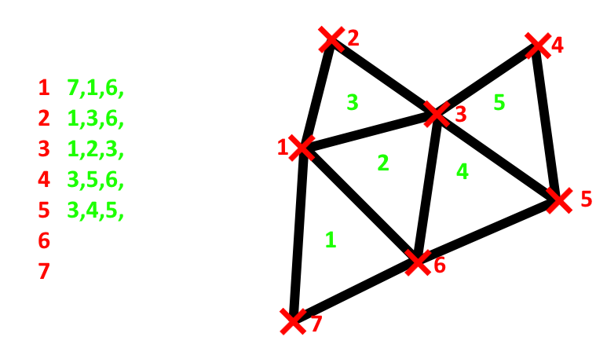The order of triangles in an index buffer is specified by its winding order. The winding order can be either clockwise or counter-clockwise, where the direction of the winding order will decide whether the triangle is rendered or not due to the engine or framework’s back-face culling. This saves performance, by not rendering triangles that are not being looked at.

Figure - An example of a 2-dimensional mesh with vertex and index buffers specified.

### Texturing

Texturing is the final step in the modelling process, which involves mapping a 2 dimensional image onto a 3 dimensional model’s faces (Akenine-Moller et al., 2019).

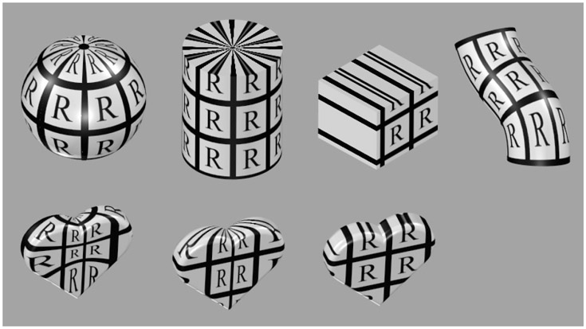For each vertex of the model, it is given a 2D coordinate in the space UV (where U denotes horizontal, and V vertical). When all three coordinates of a triangle are defined, this defines which part of the texture appears on the model.

Figure - Different examples of texture mapping on 3D objects.[27]

## Game Engine Approaches to Content Generation

### Low Level Rendering Frameworks

Almost all engines are built on top of some kind of existing rendering framework/API. 3 main examples of this exist, which are Vulkan, DirectX (12), and OpenGL.

* **DirectX** – DirectX is a collection of APIs developed by Microsoft, where the main one for rendering in 3D is Direct3D. Direct3D is widely used in the development of games today, primarily for Windows and Xbox consoles. As Direct3D is the most widely used component of DirectX, the two names are sometimes used interchangeably.
* **OpenGL** – OpenGL is a cross platform API for rendering 2D and 3D graphics. The API is now developed by a group of organisations and companies called Khronos Group.
* **Vulkan** – Vulkan is a low-level API, developed to address the shortcomings of OpenGL and allow developers more control over the GPU.

In the case of Direct3D and OpenGL, Direct3D changes are made by Microsoft and then hardware and software vendors quickly respond to the changes. OpenGL is the opposite, where changes are implemented by vendors, and then applied to OpenGL’s standard.

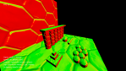Several frameworks are written in C++, which could be useful for the project artefact.

Figure – A screenshot of one of Hieroglyph 3’s demos.[28]

Hieroglyph 3 is an open-source C++ rendering framework which makes use of Direct3D. The library is primarily written by Jason Zink, and designed to be an easy-to-use modular API which can utilise the advanced features of Direct3D. Hieroglyph also allows developers to implement their own rendering systems with a minimal amount of work, making it a good candidate for prototyping new algorithms (Zink, 2010).

On the other hand is Falcor, an open-source rendering framework designed specifically for rapid prototyping. It comes with many features such as support for DXR, physically based shading, a modular library, animation paths, support for FBX and more. Falcor is developed and supported by Nvidia.

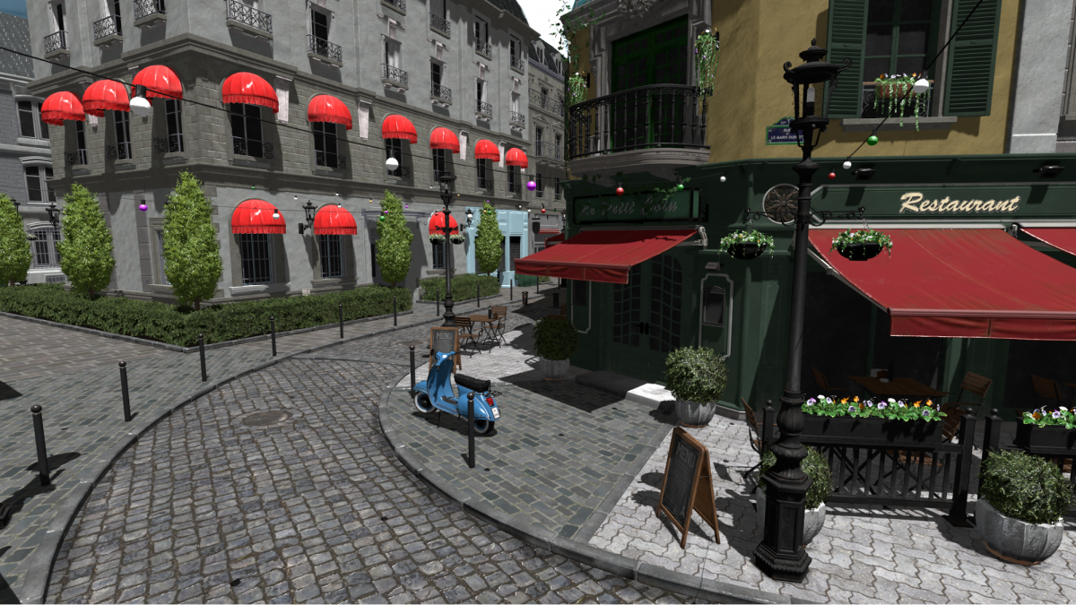While these frameworks would provide a nice, low level option for 3D rendering and starting my project, the requirement of building a games framework on top of them, as well as the lack of typical PCG tools offered by engines like Unreal Engine, makes them unsuitable for the scope of this project.

Figure – A screenshot of the Falcor rendering framework.[29]

### Unreal Engine

Unreal on the other hand is much more high-level, offering automatic import and parsing of FBX files, as well as built in support for editing meshes in-engine. Unreal primarily supports FBX files either rigged or unrigged, with differing tools for both Static Meshes and Skeletal Meshes (discussed in more detail below). As well as this, Unreal engine provides built in and third-party support for procedural mesh generation using the built in plugin Procedural Mesh Component, or the third-party plugin Real-time Mesh Component.

Additionally, the use of Geometry Script allows a simpler way to generate meshes at runtime and provides Boolean operations and additional triangulation and normal recomputing techniques (Epic Games - Geometry Script Overview, 2023).

Unreal also offers tools for quick prototyping and iteration of shaders or materials, through what it calls Material Graph. Material Graph is a node-based shader editor, which allows a universal, platform independent way to develop shaders, and leave platform specific shader code generation to the engine itself.

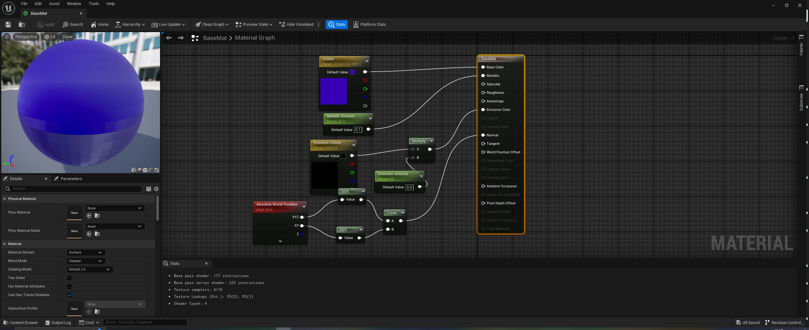

Figure - An example of the UE5 Material Editor for a simple material.

This is done using an ubershader, which refers to a single large shader which can be compiled with different features enabled or disabled for different platforms.

## Unreal Engine Content Generation Techniques

### Actors/Components

Unreal makes use of an Actor/Component relationship when it comes to creating objects. Everything placed within the world is an Actor, and an Actor is made up of several Components that add on functionality.

Every object within Unreal inherits from UObjectBase, the base class of the engine. Further down the tree are Actors, which are the base class that can be placed into a world. Approximately 6223 classes inherit from UObject.

Figure - A small example of actor and component hierarchies in Unreal Engine. Both Actors and Components inherit from UObject.

(Epic Games - Actors and Geometry, 2023)

Different objects and classes within Unreal engine fulfil different, important roles.

* **AActor** – An object that can be placed into the world. Usually not controlled by any external source (for example AI or the player).
  + **APawn** – Base class used for objects that can be controlled by external sources such as the Player or AI.
    - **Character** – Pawn featuring movement capabilities such as jumping, running, crouching and swimming.
* **UActorComponent** – Base component for actors. Features no transform or rendering capabilities.
  + **USceneComponent** – Extension of component, features transform but no rendering capabilities.
    - **UMeshComponent** – Base abstract mesh class.
      * **UStaticMeshComponent** – Base mesh class. Features no support for skeletons.
      * **USkeletalMeshComponent** – Features skeleton support and animation blueprint support.

In the case of procedural content generation, content will likely be generated either as actors placed into the world by an external “controller” actor, or by use of the Procedural Mesh Component, which will then be attached to an actor to be placed into the world.

### Existing PCG Libraries For Unreal Engine

Several libraries and plugins exist for Unreal Engine already, providing built in or third-party support for procedural content generation.

#### Geometry Script

[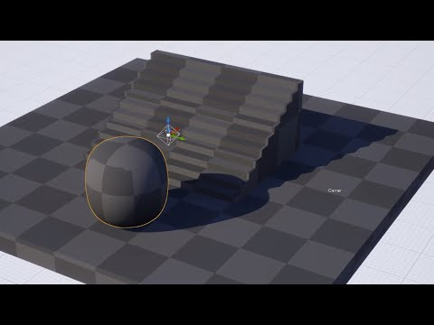](https://www.youtube.com/embed/xDwi_DDe2p4?feature=oembed)A developer by the name of Gradientspace has worked on several systems as third-party plugins for Unreal Engine. Both of these have now become part of the engine itself via experimental plugins – and Gradientspace was even hired by Epic Games to work on these tools.

Figure – A demo of Geometry Script using the in-engine Generated Dynamic Mesh Actor.

These tools are namely Geometry Script, a set of Blueprint/Python functions that act as a thin layer over a C++ geometry creation library, and Geometry Processing, a name for the underlying geometry processing tools within the engine (Epic Games - Geometry Script Overview, 2023; Schmidt, 2022). Geometry Script itself originally started as an open-source library called Geometr53Sharp that allowed runtime editing of meshes, this plugin was eventually written in C++ and became Geometry Script (Ryan Schmidt, 2020). Geometry Script is made possible through the Dynamic Mesh Component, a component that allows dynamic construction of mesh geometry at runtime by hooking into Unreal Engine’s rendering framework to rebuild the geometry at any point.

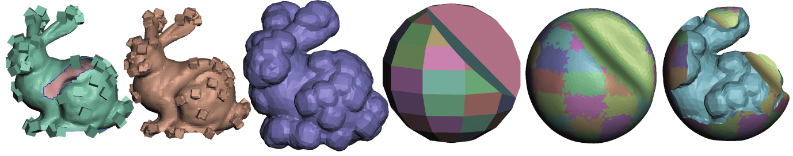

Figure – Meshes generated with Geometry Script.

(Source: https://www.gradientspace.com/tutorials/2020/9/21/command-line-geometry-processing-with-unreal-engine)

[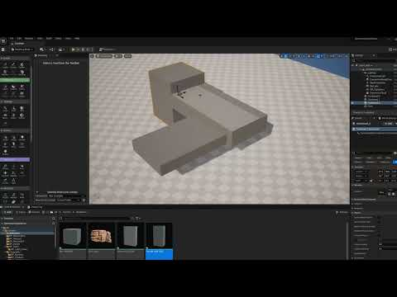](https://www.youtube.com/embed/ZNVtz0Z2fwA?feature=oembed)Geometry Script comes with many design time and runtime features that facilitate dynamic mesh creation. Particularly, Unreal Engine’s Modelling Mode is built using Geometry Script/Geometry Processing, to allow meshes to be constructed in the editor – particularly level geometry.

Figure - A video showcasing Unreal's modelling mode and dynamic mesh actors

Geometry Script can also work at design time and comes with many blueprints nodes to facilitate procedural mesh creation.

In all, Geometry Script comes with many features that make it a great robust tool for procedural and dynamic mesh creation, with features including:

* **Design and Runtime mesh creation** – Geometry Script can construct geometry at runtime or design time, either through the construction script and blueprints or the modelling mode for design time creation, or via blueprints itself for runtime mesh creation.
* **Exporting to Static Mesh** – After constructing geometry, meshes can be exported to static mesh.
* **Realtime collision generation** – Collisions can be generated in real time, for both complex (trimesh) or simple (primitive) collisions.
* **Boolean functionality** – Functionality for Boolean operations, namely union subtract and difference, are included.
* **General Mesh Processing Features** – General mesh processing such as uniform remesh, simplification, manual vertex/face additions, and mesh warping are provided.
* **Realtime material application** – Materials can be applied to faces in real-time.

#### Procedural and Realtime Mesh Component

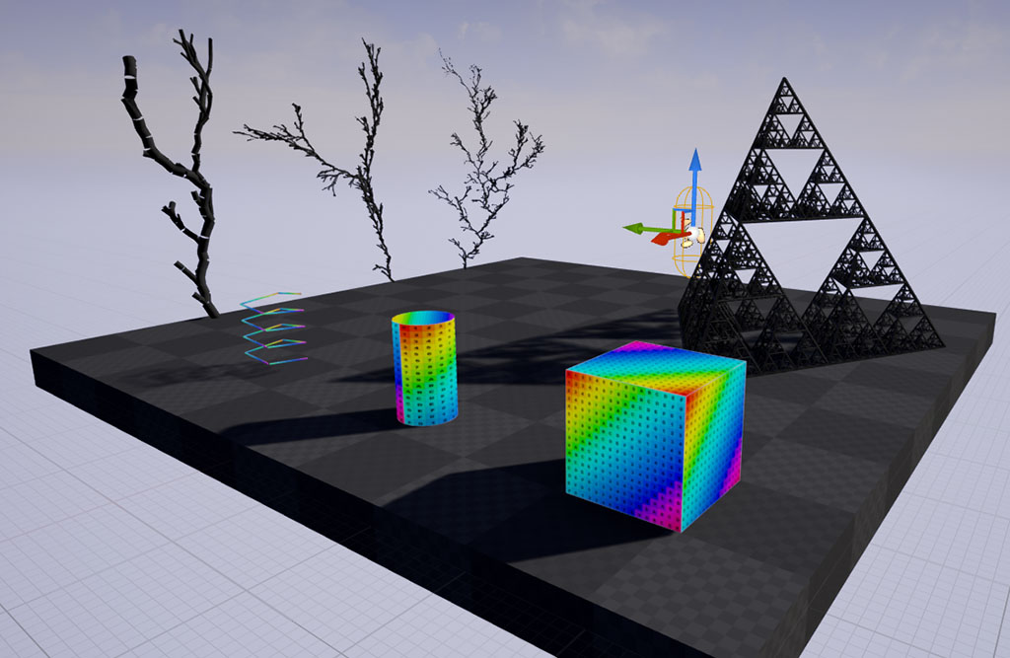In other areas, Unreal provides support for constructing meshes dynamically from the ground up. This is done using the Procedural Mesh Component, a built-in plugin for building meshes from vertex and index buffer data (Epic Games - Procedural Mesh, 2023).

Figure – A small number of examples of what is capable with Procedural Mesh.[30]

Elsewhere, Koderz is responsible for the creation of RMC, or Realtime Mesh Component, formerly Runtime Mesh Component (Koderz & Triaxis Games, 2023). RMC aims to be an improvement over Procedural Mesh Component by offering improved features and processing speed.

Realtime Mesh Component is a plugin available for Unreal Engine that improves on Unreal Engine’s Procedural Mesh Component (a component designed for procedural mesh creation from the ground up). This is namely in that developers must construct geometry themselves through the use of index and vertex buffers, as opposed to Geometry Script which is a more visual and simpler way of constructing geometry through the use of abstracting function libraries.

Realtime Mesh Component is great for runtime mesh creation in this way, and even includes functionality for converting to static mesh. Features include:

* **Full Collision Support** – Collision is supported for both static triangle meshes and dynamic moving objects.
* **Variable Mesh Formats** – Variable mesh formats are available, allowing developers to choose a tradeoff between needed features and performance overhead.
* **8 Texture/UV Coordinate Channels**
* **Normal or High Precision UV Channels**
* **LOD Support** – Dynamic LOD support is provided, allowing for up to 8 levels of Level of Detail and full dithering support.

In the future, the RMC aims to be a full replacement to Dynamic Mesh Component, while still keeping the tools provided by Geometry Script (Koderz & Triaxis Games, 2023).

#### Procedural Content Generation Framework

[](https://www.youtube.com/embed/s41GdoN2QGg?feature=oembed)Finally, one of the most notable and currently worked on aspects of Unreal Engine is the Procedural Content Generation Framework and PCG Graph (Epic Games - Procedural Content Generation Framework Overview, 2023). This is a system built fully from the ground up for the dynamic creation of levels and scenes in Unreal using Procedural Content Generation.

Figure - A video showcasing use of PCG Script

The PCG framework is built from the ground up for extensibility, allowing artists and designers to quickly build fast iterative tools as well as content of any complexity. This ranges from asset utilities like building and biome generation, up to the generation of entire worlds.

This is made possible through the use of the Procedural Node Graph or PCG graph, the central part of the PCG framework.

Figure - A screenshot of Unreal Engine’s PCG Graph for use with the Procedural Content Generation Framework.[31]

## Integration with Unreal Engine Concepts

When working on this project, it is important to consider how it will integrate with existing Unreal Engine features such as collisions.

### Collision Detection

Collisions are necessary to make the generated content game-ready, and thankfully Unreal Engine comes with features to generate collisions for meshes built in.

#### Static Meshes

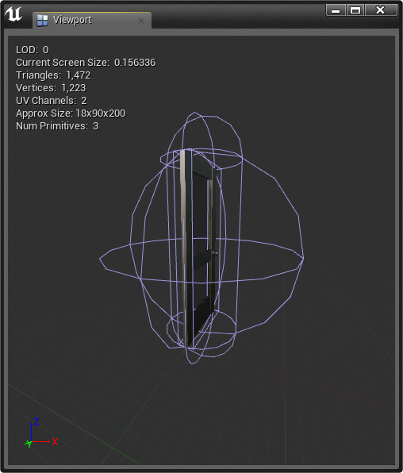Static meshes are extremely simple to generate collisions for, as they are automatically generated when the mesh is imported into the engine. Furthermore, exporting the mesh at a later date generates a literal collision object within the FBX file, separate from the actual mesh of the object, to show you how the collisions will look.

Unreal Engine also offers the ability to set up your own collisions for an imported static mesh, such that you can combine many simple shapes to form a collision box for any shape or size mesh.

Geometry Script can also work at design time and comes with many blueprint nodes to facilitate procedural mesh creation. – An example of collision for a static mesh, featuring 3 different shapes.[32]

In all, Geometry Script comes with many features that make it a gre robust tool for procedural and dynamic mesh creation, with features including:

#### Skeletal Meshes

Skeletal meshes do not offer the above functionality, however they do make use of an alternative which essentially performs the same role for collisions. In Unreal Engine’s Physics Asset editor, a tool used to generate physics collisions and restraints for a skeletal mesh’s skeleton, the developer has the option to generate simple primitives for each bone that act as collisions. Depending on the difference in size between skeleton and mesh, this can offer a simple method to generate collisions which move and deform along with the skeleton.

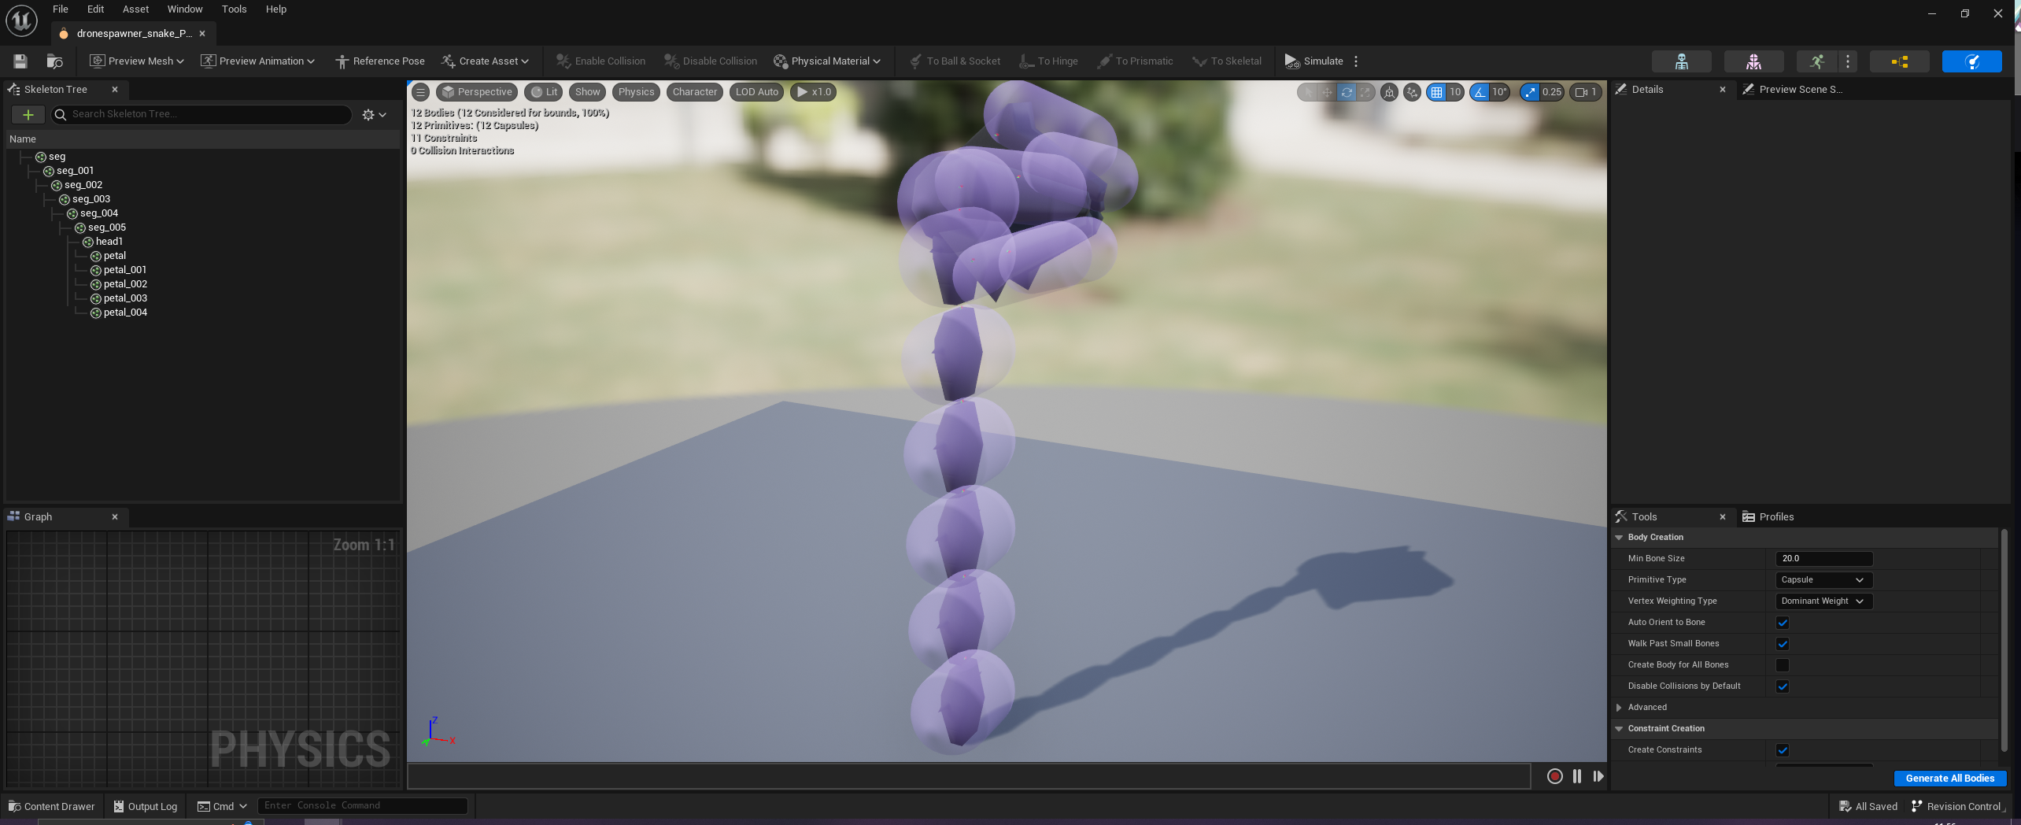

Figure – Cylindrical colliders generated for each bone of a skeletal mesh. They each have the ability to be rotated, scaled and offset.

(Epic Games - Skeletal Meshes, 2023)

#### Procedural Meshes

Since procedural meshes can be generated at design time and used as simple FBX files, the generation of collisions can be identical to the kind used for static meshes. However, if they are intended to be generated and ran at runtime, then more complex solutions may be necessary.

In the case of collisions for procedural meshes, this is all handled directly by Unreal Engine. Unreal will generate collision data at runtime or whenever the mesh is generated, just like Static Meshes. No extra work has to be included by the developer.

### Data Formats and Import/Export Within Unreal Engine

Unreal Engine offers integration and import/export options for many commercially used tools, software and third party plugins.

#### FBX File Format

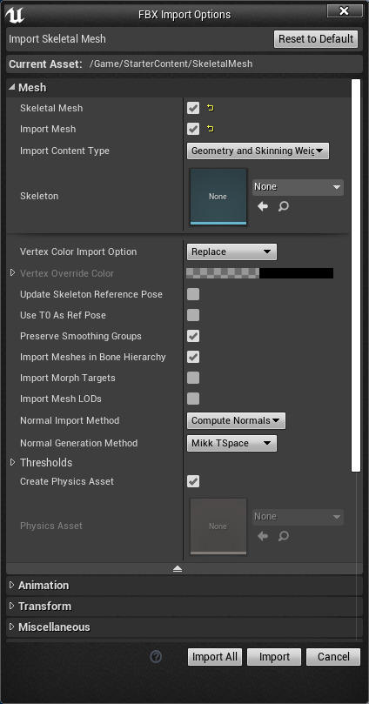Starting from the basics, FBX is the primary import/export method supported by Unreal Engine, used primarily for importing, but also for exporting content from the engine to outside it (like, for example, combining meshes in the level editor into a single actor, then converting it to a static mesh and exporting). Unreal comes with a powerful importing tool both for importing static meshes, as well as skeletal meshes.

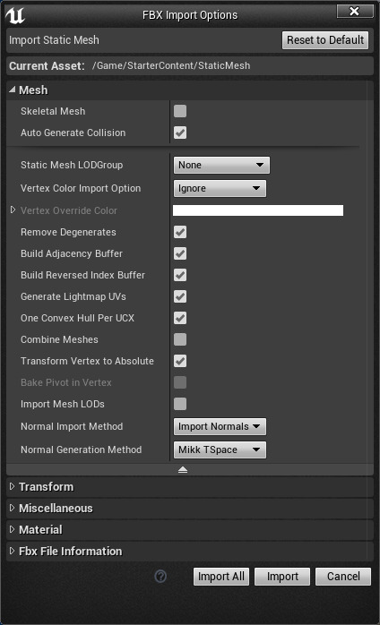

Figure – Import options for both Static and Skeletal Meshes.[33]

#### Third Party Plugins

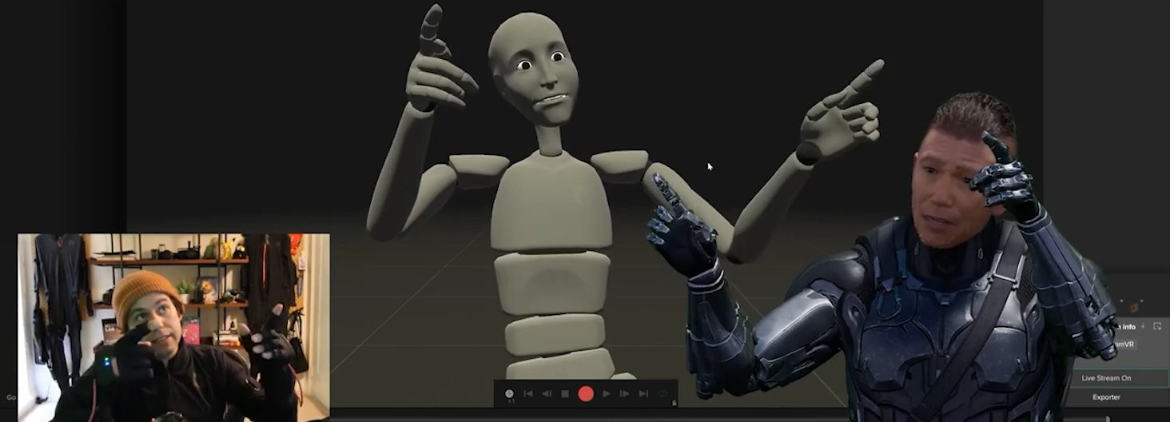Rokoko, a powerful motion capture based animation tool, offers full support within Unreal Engine through a third party plugin. Using this plugin, motion capture data can be streamed directly into the engine to be used as animation data, and changed and edited in real time.

Figure – Rokoko motion capture data being streamed directly into Unreal Engine for use with a Metahuman.[34]

Elsewhere, Prefabricator as mentioned before is a plugin used to extend the level editing tools offered in Unreal Engine. This tool primarily makes use of preexisting assets and through the use of randomisation can combine them together. Through Unreal Engine’s blueprint export option, users can export a blueprint to FBX, preserving all static meshes attached to it and then import this into Blender or elsewhere as a fully completed mesh. This is achieved by right clicking the actor that Prefabricator generates within the level, converting it to a static mesh, and then exporting this.

#### DataSmith

DataSmith is a collection of tools and plugins created to allow developers to bring entire prefabricated scenes and complex collections of assets created in many industry standard applications into Unreal Engine.

DataSmith is also highly useful for those who want use Unreal Engine as a visualisation tool, for music videos, rendering animations, demonstrations or more.

DataSmith comes with the following features:

* Allows entire preconstructed scenes and assets to be brought into Unreal Engine, regardless of how large or dense they may be.
* Supports a wide variety of 3D design applications and file formats. Made to reuse the assets and layouts already built in these tools.
* Handles bringing in changes from the source material through the use of the Datasmith Reimport Workflow
* Focused on translating design content that Unreal can understand and render in real time.

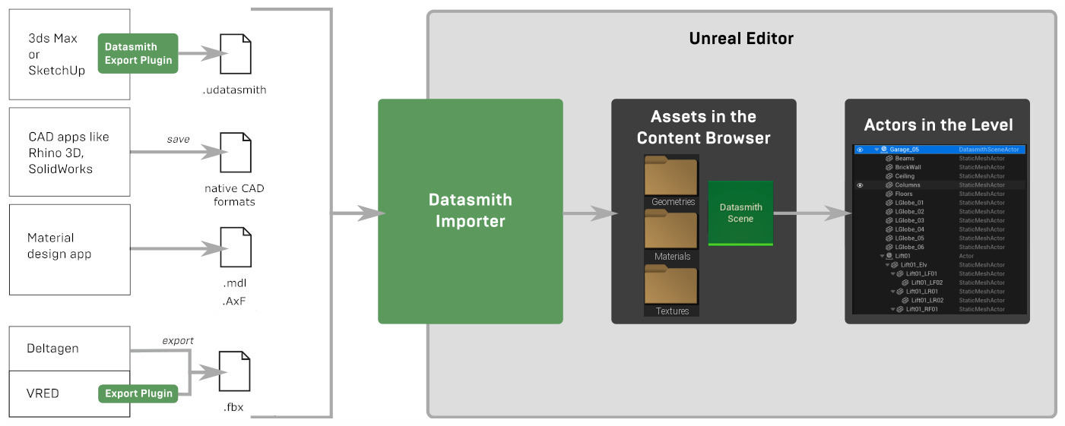

Figure – The Datasmith Workflow.[35]

Once content is imported into Unreal Engine using Data Smith, it is split up into each asset type, rather than bundling the entire scene together as a single static mesh, or a single material.

* Static meshes are imported as separate assets, as a single large complex mesh is very hard to light and render smoothly, while maintaining good performance. It also restricts developers from working with the various parts of their scene individually within Unreal Engine.
  + Multiple instances of a single mesh also carry over, with Unreal Engine creating a static mesh for one of them and copying this into the scene multiple times.
* Materials are automatically created and assigned to meshes.
  + Texture assets are imported and correctly assigned to materials.
* Animations that modify transforms of objects are converted into Unreal Engine’s Sequence Assets, so that they can be replayed.
* Lights in scenes that make use of IES profiles are also imported, with the importer making use of the texture assets that define the light intensities.

Many different software makes use of Datasmith to allow seamless importing into Unreal Engine, including:

* 3DS Max
* Cinema 4D
* Revit
* SketchUp Pro
* IFC
* Rhino 3D
* SolidWorks
* CATIA
* VRED
* DELTAGEN
* And more...

[](https://www.youtube.com/embed/53er5KOi3HQ?feature=oembed)

Figure – A demonstration of the Datasmith Direct Link Workflow, featuring automatic synchronization across programs to Unreal Engine.

#### Nvidia’s Omniverse

Similar to DataSmith, Nvidia’s Omniverse is a universal tool which allows seamless usage of projects across various commercial software through the use of what it calls Connectors and the Omniverse Nucleus.

Omniverse Connectors are plugins that connects various software to each other. It exports the files from one platform to the OpenUSD format, and then uploads the exported files to an Omniverse Nucleus Server. This server then allows for exporting to any other software, such as taking a scene from Blender, and directly importing it into Unreal Engine.

[](https://www.youtube.com/embed/ElF53kfHrYc?feature=oembed)The Omniverse Platform makes use of the OpenUSD Universal Scene Description format developed by Pixar, a high performance extensible format allowing 3D scenes to be constructed and used in any engine or format.

Figure – A demonstration of Nvidia’s Omniverse.

The Omniverse Nucleus are the fundamental services that allow “client” applications and services to share “worlds”, or projects, to each other. Using Nucleus, teams can have multiple users connect together across several applications at once, allowing them to all work on the same project, as well as share it between applications and clients.

## Conclusion

In this chapter we have discussed the technical research behind the project. This includes the procedural generation of real-time 3D graphics such as the input assembly and programmable graphics pipeline. Furthermore, we have discussed in detail options for various frameworks that may suit the project, as well as the use of Unreal Engine, its actor systems, and integration with Unreal Engine concepts such as collision, and options for the procedural generation of meshes within Unreal Engine such as the RMC for worry free hooking into Unreal Engine’s render pipeline, and simpler less technical options such as Geometry Script. Finally, we discussed options for exporting and migration, such as Data Smith and Omniverse.

From this research, I can deduce which software I would like to use, as well as options for future work. I believe Unreal Engine would be the best choice as a widely available and commercially used game development software. It comes with many options for both content generation and asset migration/export, and would allow me to focus more on the island generation itself rather than building a game and rendering framework on top of something like Hieroglyph, Open GL or Falcor.

# Requirements and Behavioural Design

## Introduction

Based on the domain and technical research, I can now begin to design my artefact. I have arrived at several conclusions based on the research, with the technical research helping to form an understanding of how the islands themselves may be generated based on input assembly and mesh generation. As explained above, Unreal Engine is my primary choice of development due to its fast iteration and inclusion of a game framework, as well as several features to ease development. If I used a third-party API such as Falcor or Hieroglyph, I would be required to create a game framework myself, which is beyond the scope of this project.

## Chosen Development Methodology

For this project, I chose the Agile methodology.

### What is Agile?

Agile is focused on breaking larger tasks and sections of a project into smaller tasks that are more manageable. These smaller tasks comprise phases of a project’s development, called Sprints. Each Sprint of the project has a pre-defined duration, and at the start of a sprint, tasks are taken from the product’s backlog, or list of tasks, and added to the sprint. Each sprint usually has a predefined duration.

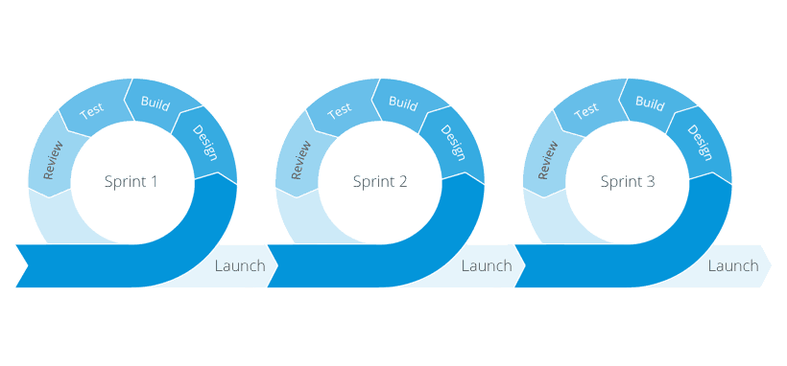Once a sprint has been completed, a review is usually done to see if the goals of the sprint have been completed to a satisfactory level, and whether anything needs more time, or whether any problems arose from the sprint. These points are then factored into the next sprint.

Figure – Examples of Sprints in an Agile production. [36]

Agile had a predecessor known as Waterfall, which is still used in certain places. Waterfall had many downsides compared to Agile, but comparatively provided a couple of upsides as well.

|  |  |
| --- | --- |
| Agile | |
| Pros | Cons |
| Short term deadlines that encourage productivity | As multiple phases are in development at the same time, some rely on previous phases, and effort must be spent if an earlier phase requires revision |
| Lots of flexibility to change the direction of the project | Deliverables are not a requirement for following phases, therefore it can be harder to ensure the team is on the same page. This problem increases with larger teams. |
| If clients are involved, the Agile methodology makes it easier for the team to share progress and use feedback | Due to the flexible nature of the project, it is harder to determine deadlines and timelines |

Table - A table showing pros and cons of the agile methodology

|  |  |
| --- | --- |
| Waterfall | |
| Pros | Cons |
| Provides a full, concrete plan of the project | As multiple phases are in development at the same time, some rely on previous phases, and effort must be spent if an earlier phase requires revision |
| Project requirements are established earlier on, which saves time | Issues are easy to miss, and once found, earlier phases must be looked through to find where the issue occurred |
| Each phase of the project requires a deliverable, so the process is more structured | Requires outlining the project from start to finish, doesn’t allow for flexibility or change |

Table - A table showing pros and cons of the waterfall methodology

As seen in the tables above, Waterfall is much more rigid and less flexible than Agile but allows for a more concrete plan of the project from start to finish. As I wanted to be able to iterate for this project, Agile was the best option for methodology, as it was easy to iterate, decide if I liked something, and then start over if not.

Agile is usually adopted alongside SCRUM, which involves a SCRUM master who plans and reviews the sprints, and small teams dedicated to key areas. This project only requires one person, so I can be both the SCRUM master and the owner/client of the project.

## Requirements Specification

This project is designed for developers first, with possible use by artists who choose to pre-generate islands.

Therefore, the project requires a solid backend, with code being written rather than visually scripted. The project should also be split into more classes to be reusable. For example, a class can develop the point data, another can convert it into a mesh. Another class can export this mesh to a usable file format, and another class can take islands and position them around the world to form fields of islands.

### Prototype Functional Requirements

|  |  |  |  |
| --- | --- | --- | --- |
| **ID** | **Name** | **Description** | **Priority** |
| ARCH1 | Runtime and Design time creation | Developers will have the ability to create islands at runtime and design time | Primary |
| ARCH2 | Exportable to FBX | Developers will be able to export their islands to FBX, and make use of tools like Omniverse | Tertiary |
| ARCH3 | Modular code | Developers will be able to reuse aspects of the program, the program must be modular | Primary |
| ARCH4 | Be able to work visually | Developers must be able to work visually, by designing an island with parameters | Primary |
| ARCH5 | Be able to work from code only | If the tool is to be used runtime only, developers should be able to operate it from code only | Primary |
| ARCH6 | Be textured dynamically | The islands should be textured, even if simply | Secondary |
| ARCH7 | Should have collision | The islands should have collision, which is provided by Unreal | Secondary |

Table – A table showing functional requirements of the prototype

### Prototype Non-Functional Requirements

|  |  |
| --- | --- |
| **ID** | **Description** |
| NF1 | The tool will run on top of Unreal Engine 5, and be compatible with its features |
| NF2 | The tool will be designed to run alongside Blueprints, to allow island creation for artists at runtime |
| NF3 | The tool must be able to generate islands quickly and efficiently |
| NF4 | Should offer a wide variety of customisation |
| NF5 | The island generator should create realistic looking islands |
| NF6 | Should be fast |

Table - A table showing non-functional requirements of the prototype

## Feature Overview

### Component Workflow

The workflow of components required thinking about the second research question:

*“Can we produce an entire full-stack workflow for the creation of procedural floating islands? Namely, can we go from the construction of geometry to the exporting of islands to static meshes or migration to other projects?”*

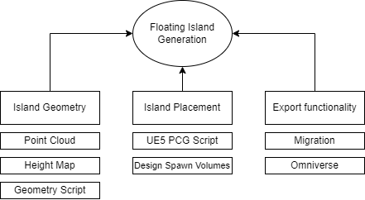In order to compare techniques, the prototypes will have variations of the following elements:

Figure - Each component of the program with possible techniques.

Figure - The flow of the program's functionality.

The section below will go over the features and sections of the components of the program. The island generation itself will be comprised of several sections with a focus on modularity. This is intended to make it easier both for developers and during the development of the prototype itself.

The implementation will come with several techniques implemented for each stage of the program. However, all but one of each technique for each component will remain a rough prototype. Only the chosen technique will be developed to completion.

Each component of the program will include:

* Three options for island geometry generation
  + Point cloud generation
  + Height map generation
  + Geometry script generation
* Two options for island placement
  + UE5 PCG script
  + Design time spawn volumes
* One option for export functionality, with an additional described for future work
  + In-engine migration and exporting
  + Omniverse USD exporting

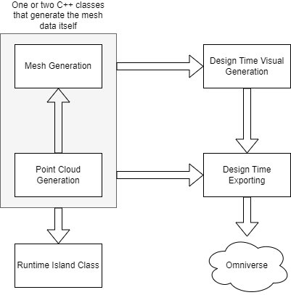Now, we go into discussion and detail on each of the project’s components. This section required a look at and thought into the first research question, namely:

Figure - A visualisation of the program's components and their relationships.

*“What modern techniques are most relevant for in-engine integration of PCG? What engines and techniques would be most suitable for the project?”*

### Component #1: Generation of a wide variety of island geometry

This section will go over the actual generation of the island geometry and mesh generation.

The actual generation of the point/mesh data for the island will be comprised within a single class. Depending on how mesh generation is handled, this may also require face data, as is the case with the point cloud technique which only generates point data.

#### Technique #1: Point Cloud Generation

This method involves generating a cube of 3D noise, then iterating over it top-down and cutting the noise down to a smaller radius, based on the existing noise values. This is slow in editor, but will produce a nice taper down the island that resembles the type of generation I’m looking for with these islands.

This method has several downsides, which makes it unsuitable for the complete prototype.

* **Hard to generate mesh data from** – Requires later generation of triangle data from the vertices as well as convex hull generation. This can be done through something like Delaunay Triangulation or Marching Cubes, which is beyond the scope of the project.
* **Very slow in editor** – When running this technique, the generation of the noise and then iteration downwards with the noise as well as the many calculations for the size of the noise makes it very slow. This is bad for the design time aspect of the program, as simple changes will take a long time to be generated.

#### Technique #2: Heightmap/Inverse Heightmap

This method involves creating two height maps, generating one to act as the top of the island, and flipping the other to act as the bottom. Both are then modified along the vertical axis using noise to form the shapes required.

This method has several upsides and downsides:

* **Easy to texture** – The top of the island being separate but lining up allows it to have a separate material applied without manually calculating normals, which works for low poly islands.
* **Easier to implement** – Generating two flat shapes and stretching them out vertically is very simple and fast, and makes quick design time iteration easy.
* **Hard to generate island outline from** – This method requires the generation of a top down island shape initially, which then requires Delaunay Triangulation or some other method to triangulate the point cloud. As stated above, Unreal has no built in method for this, and finding a third party library then importing it or writing my own implementation is out of the scope of the project.

#### Technique #3: Geometry Script

This method involves the use of Unreal Engine’s built in Geometry Script tools. With this method, the difficulty comes not from the generation of the actual mesh, but from deciding on the rules needed when assembling shapes and modifying them to form a wide variety of unique but natural looking floating islands.

Once again, this method has several upsides and downsides:

* **Fast to iterate on when developing** – This method is fast to iterate on when developing the program, and it is very easy to test different rules which can later be incorporated into the program.
* **Allows focus to be put on the island generation itself** – Rather than focusing on taking the data and turning it into a mesh, this method allows the focus to be put on generating the actual shape of the island.
* **Slightly difficult to work with** – This method involves appending shapes, applying Boolean operations, bevels, and more. This can cause difficulty when developing the prototype, as it can be cumbersome when appending shapes and performing operations on them.

#### Chosen technique

|  |  |  |  |
| --- | --- | --- | --- |
| **ID** | **Name** | **Description** | **Priority** |
| MG1 | Quick generation of mesh data | Developers should expect islands to be generated and assembled quickly, both at runtime and design time. | Secondary |
| MG1 | Wide variety of islands generated | Developers will be able to generate a wide variety of islands. | Primary |
| MG3 | Wide variety of parameters | Developers should be able to experiment with a wide number of parameters to form the islands they want. | Primary |

Table - Functional requirements of the mesh generation component

From the above requirements, techniques #2 and #3 are the most suitable, as they are both fast to iterate on. Technique #2 is unable to generate a wide variety of islands requires (islands with multiple spikes for example), but generation of the top half of the island is much easier. Technique #3 struggles a little with the top half, but can generate a wide variety of lower island halves, and with Boolean modifiers can have existing mountain meshes applied for the top half to provide more interesting results.

For these reasons, I chose technique #3. This option is less technically complex, which means the focus can be more on the rules of the island generation rather than assembling a mesh.

### Component #2: Island Placement for diverse levels

Stage 1 has generated the geometry for the mesh, and now stage 2 must place the island geometry around the level. This section will go over two possible solutions, spawn volume support, and PCG script support.

#### Technique #1 – Spawn Volume

This technique involves the developer or level designer specifying multiple spawn volumes within the level. From this the user can then add these volumes to the island placement class or script which will then use random logic to place the islands within the world.

#### Technique #2 – PCG Script

This technique involves using Unreal Engine’s PCG tools to define rules for where islands can spawn. This section can be either predefined or overridden by the developer or level designer to specify their own rules.

#### Overall Component Control

Due to the modular nature of the tool, this part of the island generation can be entirely overridden by the developer or user and is simply an optional tool which serves the purpose of an easy to insert level designing tool, but also a tool that can be used in the scope of the prototype to show levels formed from the islands. Likewise, the island mesh generation itself can be overridden, and existing floating island meshes can be specified - even procedural ones generated by the mesh generation component which have then been exported to static mesh.

This component will require a lot of parameters which can be set by developers:

* **Generic Island Parameters** – This can involve multiple parameters, such as max/minimum islands, max/minimum island size, island positioning distribution, max separation of islands, etc. This will allow for a wide variety of islands.
  + **Min/Max Islands** – Minimum and maximum islands that can spawn.
  + **Min/Max Island Scale** – Used to specify the minimum and maximum size of an island.
* **General Island Generation** – Usual Island parameters should be included that are involved with the mesh generator, such as noise, island height scale, etc.
* **Optional Placement of Assets** – To show use cases of the islands, the generator may be able to position and spawn assets on top of the islands, like trees, rocks, and more. This will be done through a custom data asset defining the asset blueprint, and a spawning weight assigned to the asset.
* **Specification of pre-generated Island Assets** – Developers should be able to specify if they want to use an existing island exported to static mesh.

This class may have use with Design Time Exporting, where the assets can be generated at design time and populate the level, which can then be exported to Omniverse.

#### Chosen Technique

|  |  |  |  |
| --- | --- | --- | --- |
| **ID** | **Name** | **Description** | **Priority** |
| IP1 | Wide variety of parameters | Developers should be able to specify a large variety of parameters when spawning the islands. | Primary |
| IP2 | Use of spawn volumes | Developers should be able to specify spawn volumes or PCG script for the island placement. | Secondary |
| IP3 | Use of existing meshes | Islands should be able to be generated with either fully procedural meshes or existing meshes. | Secondary |
| IP4 | Spawning of props | Developers should be able to specify a list of props that can spawn on an island | Tertiary |

Table - Functional requirements of the island placement component

Originally this section discussed using both techniques with options being given to the user, but due to time constraints, spawn volumes will be chosen. The spawn volumes will be given additional functionality, for example, spawning large medium and small islands, and placing islands around each other in more sophisticated ways than a random point in a bounding box. Spawn volumes are also able to be written in C++, whereas PCG Script is blueprints only.

### Component #3: Exporting and migration for additional work and use

Stage 3 now has either a single island mesh to work with, or a level composed of several island meshes and optional props/decoration. From here, the two options are to export to omniverse using the USD format for use in other engines, software, frameworks, or to export to FBX/migrate to other Unreal Engine projects.

Since the scope of the project has been primarily on the tools focusing on the island mesh and level generation, this section will focus on the in-engine migration and FBX export, while the USD format/Omniverse will be future work.

#### Technique #1: Internal Editor Migration

This option is what will be primarily focused on for the prototype and involves migrating the generated assets or exporting them to FBX for future work. This component is built into Unreal Engine by default, and as such has many options for developers to work on.

As the mesh generation of the tool will be primarily built using Geometry Script, static mesh conversion will be available to developers by default, built into the engine. It is possible that a button may be available within the mesh generation actor, to allow a single place to instantly convert the island into a static mesh. Several options exist, which give developers a wide degree of control over how they export and migrate their assets:

* **Static Mesh Conversion** – Developers can convert island mesh actors directly into a static mesh.
* **Merge Actors** – Developers can merge actors into a single actor, which can work for taking prop actors and combining their components with an actor.
  + **Component Harvesting** – Works similarly, but when converting an island in the level to a blueprint actor.
* **Actor Child** – Used to append the child actors using the child-actor component system.

Additionally, Unreal provides asset migration options, where assets can be migrated directly to another project (say if developers don’t want to include the tools directly in their project, but want the design time generation features).

These tools and features give developers a wide degree of freedom to do whatever they need with their generated islands and levels, built right into the engine.

#### Future Work: External Omniverse USD Format

While this phase will not be included in the project, it is described here for possible future work. Ideally the project will be able to export to Omniverse and the USD format, opening it up to be used in any software interchangeably without worrying about compatibility. This way, the level can be modified and edited in real time, and changes can instantly be propagated to any connected and open software. Developers can also collaborate on levels in real time.

## Behavioural Specification

Below are Use Case and Activity diagrams for the above specification.

### Use Case Diagrams

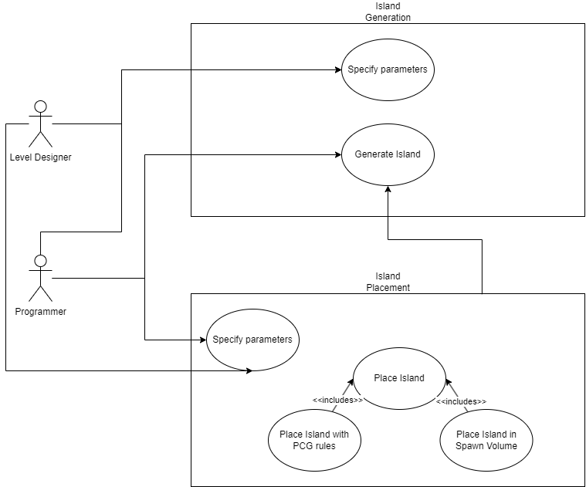

Figure - Use case diagram for island generation and placement, showing different forms of access for level designer and programmer

For this use case, the programmer and level designer have different forms of access.

For the level designer:

* Can place islands into the level by hand or via blueprints
* Can specify island parameters and spawn parameters
* Can make use of the island placement tool, or the programmer’s override

The programmer can additionally:

* Can place islands into the level purely via code, overriding island spawning
* Can specify island parameters and spawn parameters

### Activity Diagrams

#### Component #1: Generation of a wide variety of island geometry

Figure – Activity diagram for the generation of island geometry

#### Component #2: Island Placement for diverse levels

Figure – Activity diagram for the placement of island meshes

#### Component #3: Exporting and migration for additional work and use

Figure - Activity diagram for exporting/migration of mesh assets

## Conclusion

In this section, we went over the design of the project, discussing possible solutions for each of the 3 components of the project (island generation, island placement and island exporting). I chose a solution for each component, then went over the use case diagrams for each of the chosen components, and finally created an activity diagram to explain how each component might work.

In the next section, we go over the implementation of the project artefact and how it was realised.

# Structural Design AND Implementation

## Introduction

This section of the project will go over how the artefact was implemented and realised within Unreal Engine 5, using a combination of Blueprints and C++, referencing the structure of the key actors and parameters that can be used for customisation options.

## General Notes

As this is an Unreal Engine project written in a combination of Blueprints and C++, there is some UE5 C++ generic terminology to get through first. This is written here for organisation.

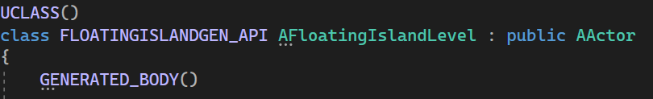

Figure - Generic C++ macros within UE5

UCLASS AND GENERATED_BODY are pregenerated when creating a class in UE5. UCLASS defines a class and comes with several properties that can be specified, and GENERATED_BODY is a pregenerated macro specifying code that must be included for the class to work correctly with Blueprints.

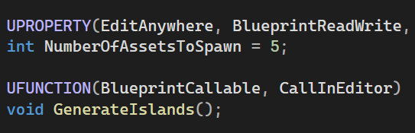

Figure - Examples of UPROPERTY and UFUNCTION within the context of the program

UPROPERTY and UFUNCTION specify a property/variable or function that Blueprints can access. They also come with several properties. For example, Call In Editor is used in various places throughout the project to allow for the code to be ran design time as well as run time.

Furthermore, Data Assets are used in several places. This is an Unreal term for a C++ class defining a number of values usable in Blueprints or C++, and saved in the editor as an easily editable asset that can be iterated on, with as many data assets created as the developer requires. Data assets are used in a number of key areas within the project, typically to “define” an object of some kind.

* **Base Definition** – The base for all required definitions, only holds the chance for the object to spawn, since this is used everywhere.
* **Prop Definition** – Props are defined as data assets, holding the prop to spawn and a spawn offset vector to allow it to be buried slightly in the ground.
* **Island Parameter Definition** – All island parameters are specified in a data asset so they can be easily switched out with a single island class and iterated on the fly. The number of props to spawn is also specified.
* **Predefined Actor Definition** – Predefined actors are also a data asset, defining the blueprint to spawn, and the number of props to spawn on top of it.

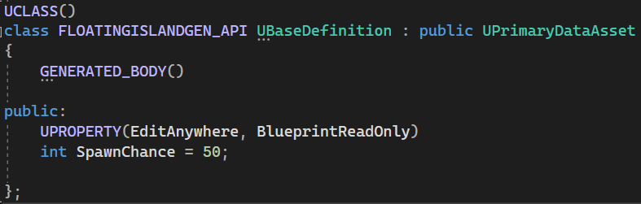

Figure - The base definition for all definition data assets in the program. Holds the only commonly used variable.

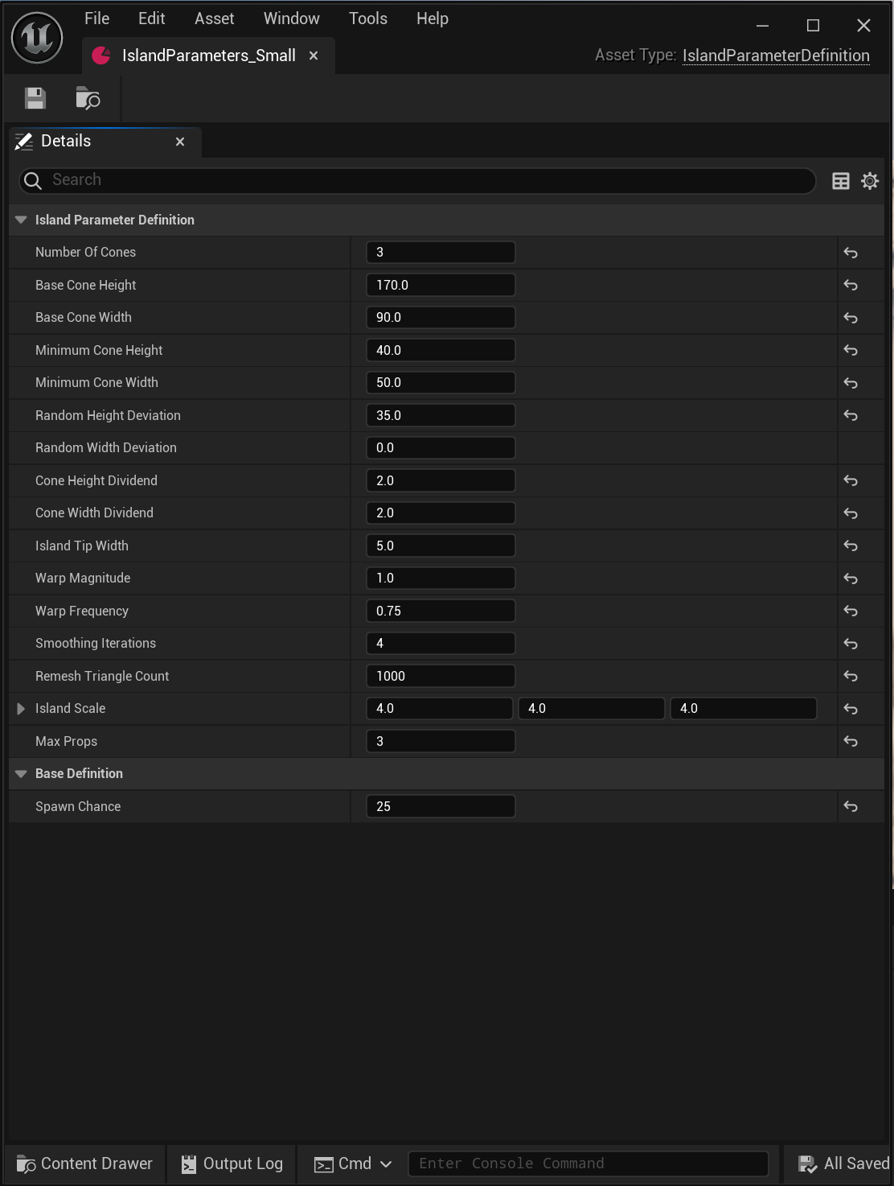Above is an example of the base definition data asset, and below is an example of the island parameter data asset within the UE5 editor.

Figure - An example of a data asset in editor, specifically for the small island type.

The base definition must inherit from primary data asset for its values to show up on sub data assets in the editor.

|  |  |  |
| --- | --- | --- |
| **Operation/Attribute** | **Class** | **Explanation** |
| NumberOfCones | UParameterDefinition | The number of cones to generate |
| BaseConeHeight | UParameterDefinition | The starting cone height |
| BaseConeWidth | UParameterDefinition | The starting cone width |
| MinimumConeHeight | UParameterDefinition | The cone height will not go below this |
| MinimumConeWidth | UParameterDefinition | The cone width will not go below this |
| RandomHeightDeviation | UParameterDefinition | Random deviation added to cone height |
| RandomWidthDeviation | UParameterDefinition | Random deviation added to cone width |
| ConeHeightDividend | UParameterDefinition | The cone height of the selected cone is divided by this and applied to the new cone |
| ConeWidthDividend | UParameterDefinition | The cone width of the selected cone is divided by this and applied to the new cone |
| IslandTipWidth | UParameterDefinition | The width of the "spike" of the cone |
| WarpMagnitude | UParameterDefinition | The magnitude of the warp applied to the island vertices |
| WarpFrequency | UParameterDefinition | The frequency of the warp applied to the island vertices |
| SmoothingIterations | UParameterDefinition | The number of iterations of smoothing applied to the island mesh |
| RemeshTriangleCount | UParameterDefinition | The target triangle count when remeshing the island geometry |
| IslandScale | UParameterDefinition | Scale of the island mesh |
| MaxProps | UParameterDefinition | Number of props to spawn on top of the island |
| IslandSpawnChance | UParameterDefinition | Chance for this island definition to be selected |

Table - Attributes and functions for the parameter definition data asset.

|  |  |  |
| --- | --- | --- |
| **Operation/Attribute** | **Class** | **Explanation** |
| SpawnChance | UBaseDefinition | The spawn chance for the base definition data asset |

Table - Attribute and functions for the base definition data asset.

|  |  |  |
| --- | --- | --- |
| **Operation/Attribute** | **Class** | **Explanation** |
| IslandParameters | AFloatingIslandActor | Specifies the island parameter data asset to be used by the island |
| RegenerateIsland | AFloatingIslandActor | Blueprint overridable and editor callable function to generate island geometry |
| TargetMesh | FIGIslandActorBP | Reference to the target mesh on the dynamic mesh component |
| GeneratedCones | FIGIslandActorBP | Function to generate, append and boolean a cone |
| GeneratedConeParameters | FIGIslandActorBP | Array holding the parameters of all generated cones |
| DirtMaterial | FIGIslandActorBP | The material to use for the dirt |
| GrassMaterial | FIGIslandActorBP | The material to use for the grass |

Table - Attributes and functions for the floating island C++ actor and inherited Blueprint class

## Component #1 – Generation of a wide variety of island geometry

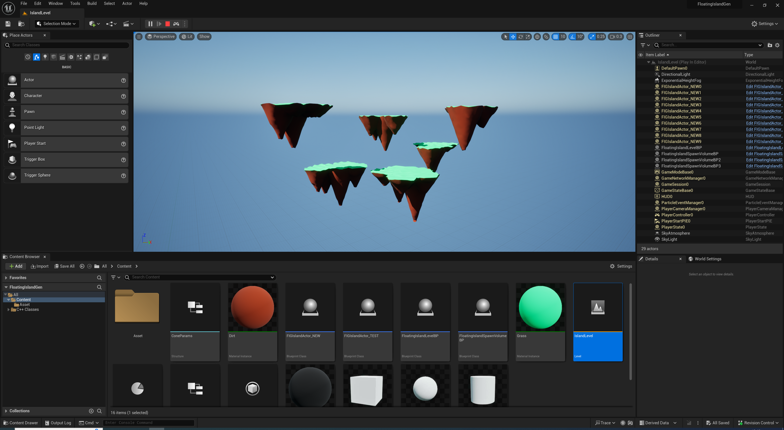

Figure - Several examples of generated islands

### Overview of Solution

This component of the project involves the dynamic runtime/design time generation of a wide variety of island geometry. This was achieved through a long process of trial and error, multiple attempts with different algorithms and techniques, and a lot of iteration. Ultimately, the result seen above was created using Geometry Script in Blueprints. An attempt was made to create it in C++, but the includes and build.cs modules weren’t able to be found, and it would have taken too long to get it working.

Briefly, the final result was achieved through the appending and union of multiple cone shapes, with several other iterative steps applied over the top of the final mesh shape, to achieve the effect seen above. These steps will be described in detail below, but are briefly described as follows:

* **Material Specification** – Materials are set up on the object.
* **Generation of Cones** – The cones are generated, appended, and unified with the mesh.
* **Material Application** – Then, the materials are applied.
* **Iterative Process Performed** – Several steps are applied to achieve a more pleasing result.
  + **Uniform Remesh** – Uniform remesh is applied to remove the n-gons and other bad geometry generated from union.
  + **Math Warp** – A warp is applied to distort the island slightly, making it less clean looking.
  + **Normal Recompute/Repair** – Normals are recomputed for the final step, and repaired. The repairing may not be necessary but is there for safety.
  + **Iterative Smoothing** – The mesh is smoothed out a little to fix seams and strange edges.

#### Overview

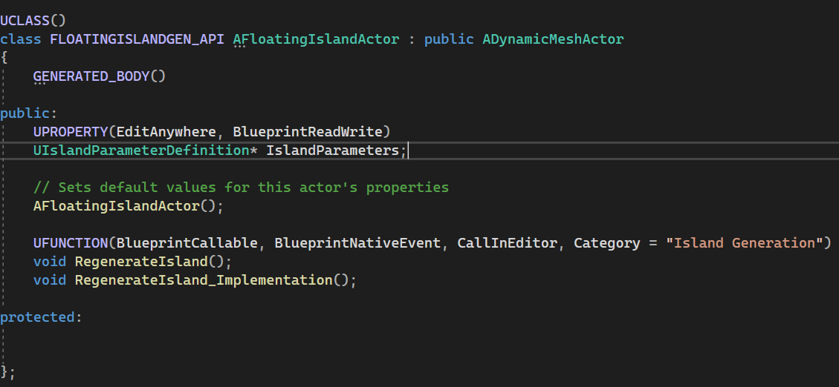

Figure - The base floating island class, written in C++

The island class inherits from a very basic and mostly empty C++ class. This class allows for an island parameter to be specified, and a ufunction to regenerate the islands geometry that can be overridden in blueprints. This function is set to be callable within the editor, allowing for design time generation and iteration of island geometry.

#### Implementation – Material Specification

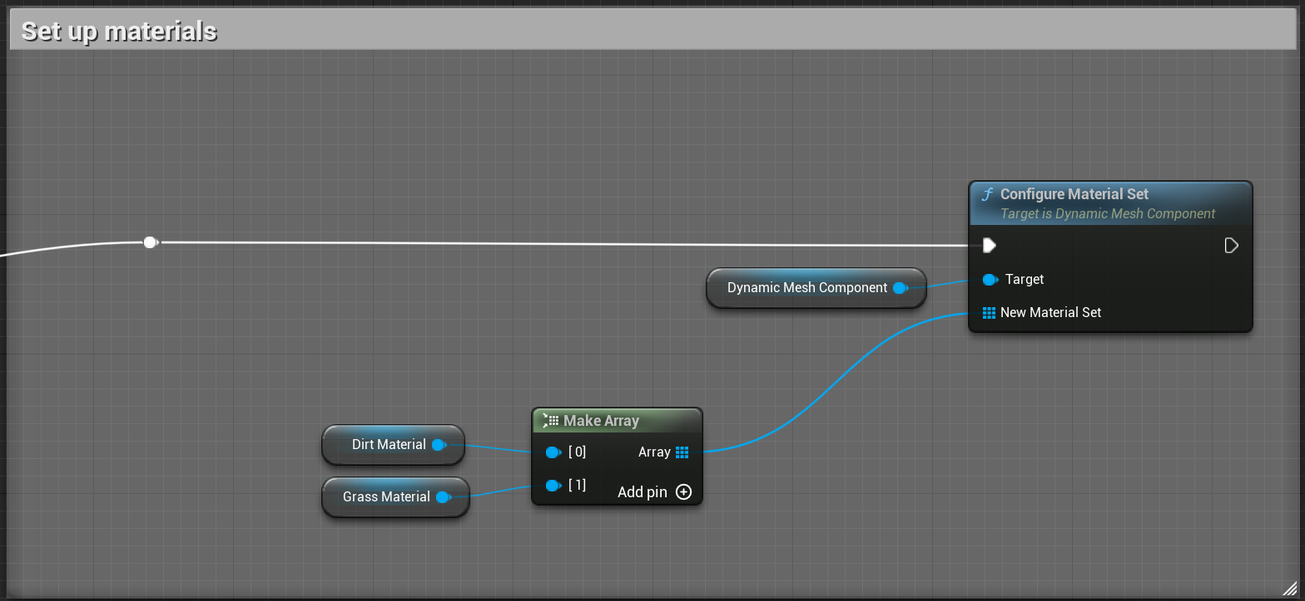

Figure - Material specification for the islands, within blueprints

The specification of materials is quite simple, and involves adding all materials involved to an array, then using the configure material set node. This allows materials to be set by just defining the material ID of a face.

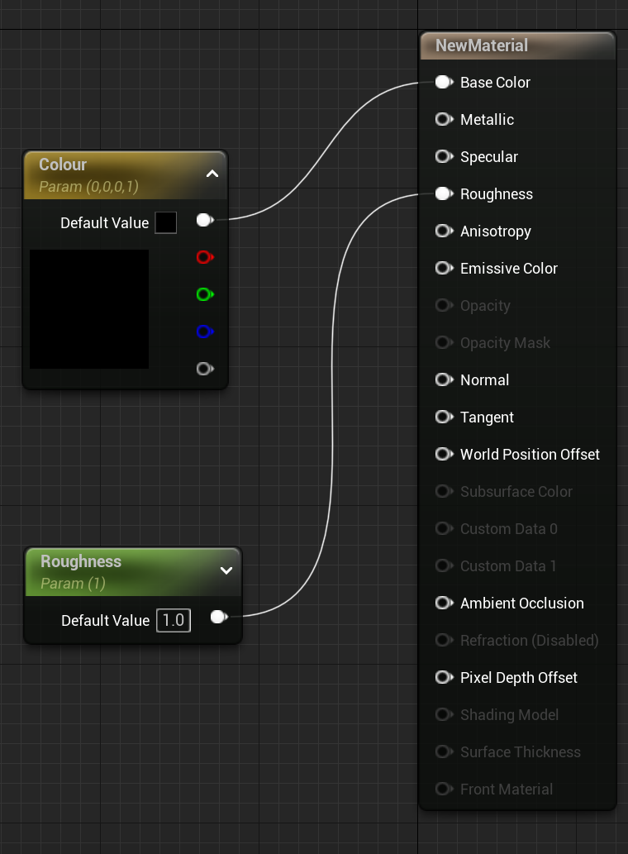The materials themselves are also quite simple, and have been chosen to look cartoony, as realism was not a priority for the prototype. It uses just a colour and roughness parameter, with grass and dirt being material instances of this material.

Figure - Material graph specification for the island materials

#### Implementation – Generation of Cones

This section is the most complex, and required additional thought to how the islands were generated. At first, I drew this diagram:

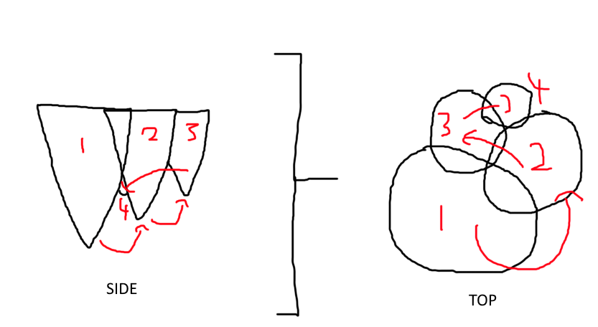

Figure - A rough diagram I drew earlier as a guide for developing the island geometry

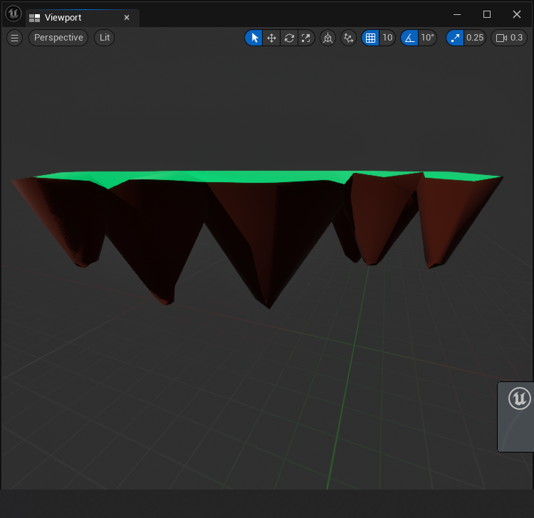Which describes how the islands are generated. An initial cone is generated and its parameters saved, and the next cone uses those parameters but slightly smaller, and so on, until the number of cones has been achieved. This worked, but generated islands that were more like chains or lines of cones, rather than spread out how I wanted. So I had to go back to the drawing board.

Figure - An early iteration of the island generation

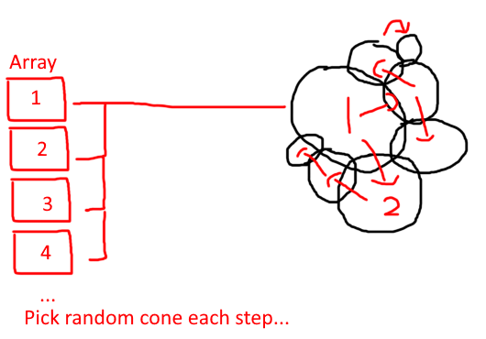Instead, the generation was changed slightly, to use an array.

Figure - A more advanced island generation diagram

This process involves adding each cone and its parameters to an array using a struct. A cone is then picked at random.

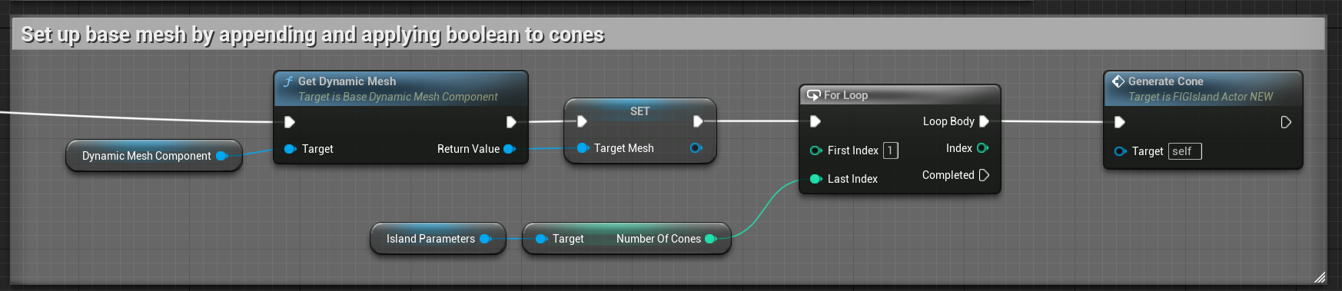

Figure - The entry point to the function; grabbing the dynamic mesh, and generating cones with a for loop

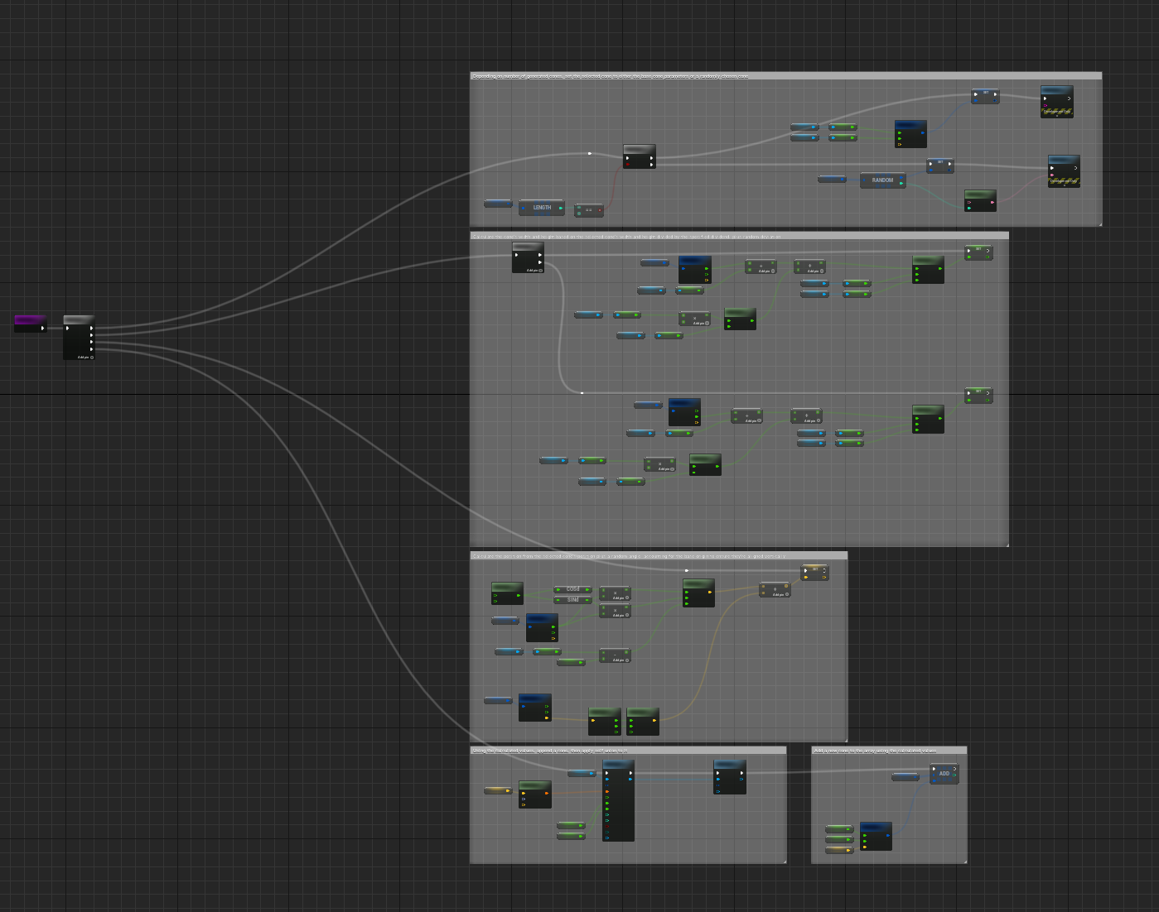A for loop is used with the number of cones required, and the dynamic mesh stored in a variable. The function for generating a cone is very large.

Figure - A zoomed out picture of the entire function graph for geometry generation

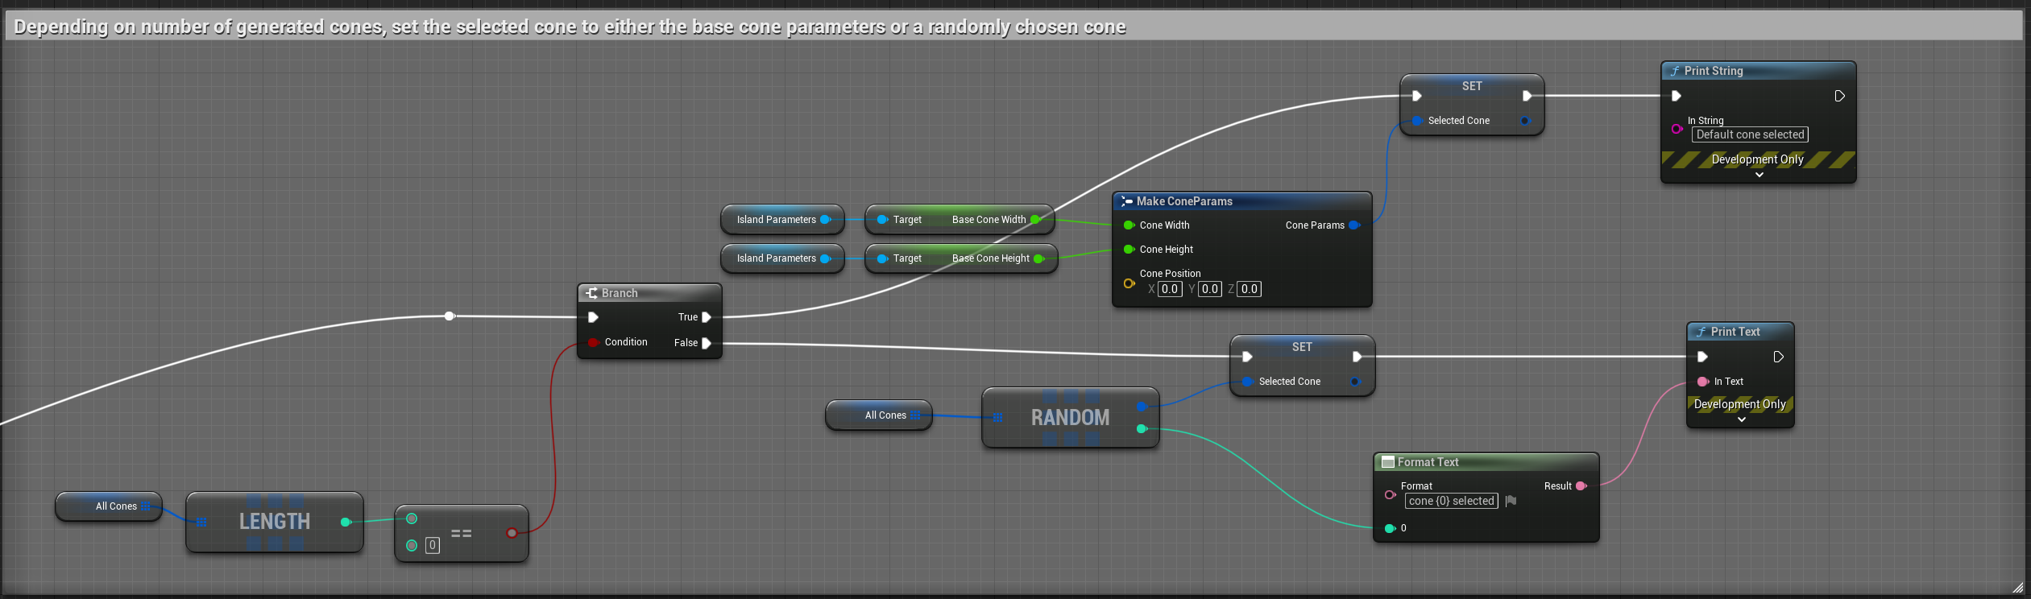

Figure - Specifying the selected cone variable based on number of cones generated

First, the selected cone is chosen. If no cones are in the array, it is generated from the base values, so that the first cone is always the largest. This serves as the basis for the island’s generation. Otherwise, a random cone is selected. This struct is then stored in a local variable for ease of access later.

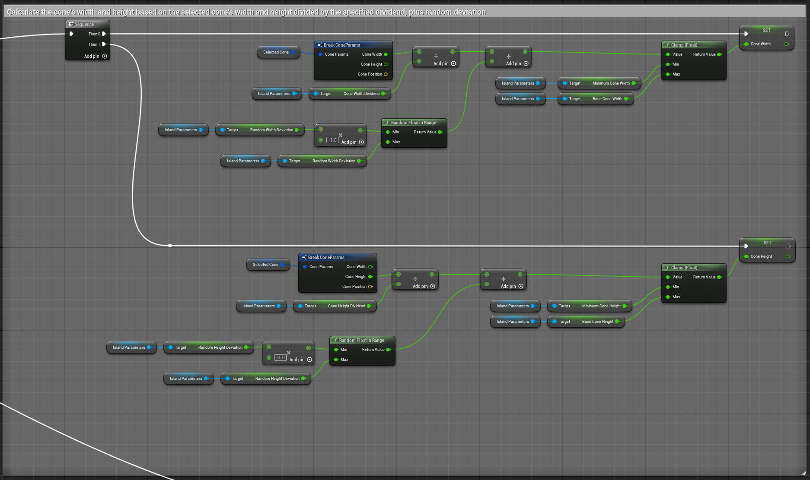

Figure - Setting up cone width and height

Next, the cones width and height are generated. As both are identical with separate values, it’s only worth going over one.

The selected cone’s height or width is grabbed, and then divided by a user specified dividend to ensure its size is somewhat smaller than the one it is based off (so not all cones are the same size, which would create boring looking islands). A random height or width deviation is then generated and added on, to add further randomisation. This value is clamped to be between the minimum and base height or width, and then set to the applicable variable.

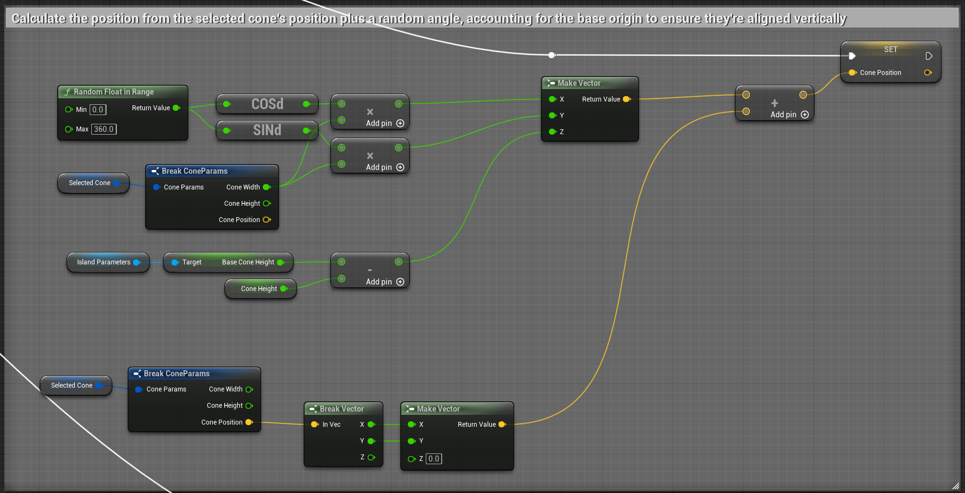Finally, the position is generated. This is done by grabbing the selected cone’s width and position and breaking out the x and y components. Z is calculated in a way that ensures the tops of all cones are level. This was done because the cone appending node only allows the origin to be either the base (bottom) or centre (middle).

Figure - Setting the cone position

The position of the new cone is generated by getting a random x and y from sin and cos, then adding on the cone’s width. This value is added to the new cone’s position.

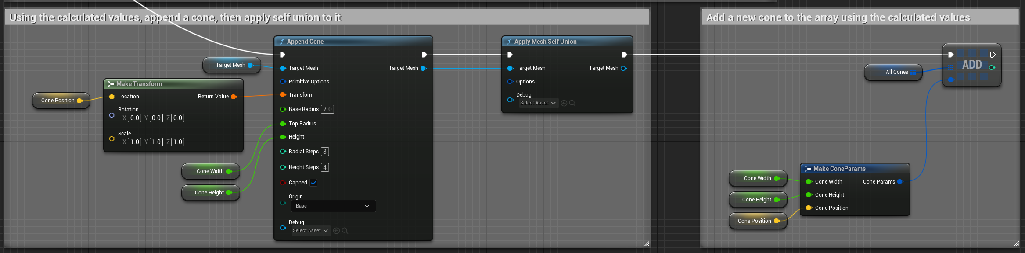

Figure - Finally generating the cone and applying self union, then adding its values to the array via a cone parameter struct

Finally, using all 3 values, a cone is appended, self union applied, then a new cone parameter struct created and added to the array for later use. This process is repeated for all required cones, resulting in the final island shape.

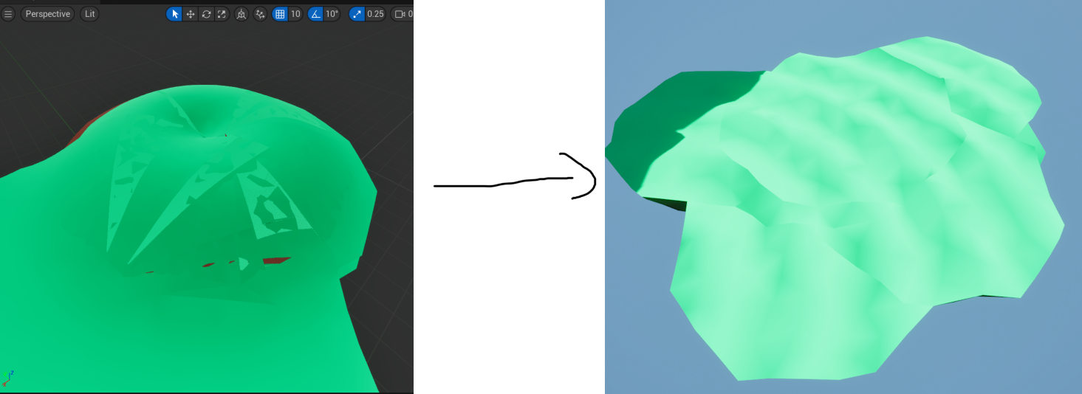Originally, self-union was applied after all cones generated, but this was a disaster. The normals were incorrect, floating geometry or flipped faces and holes were common, and it was a nightmare to fix. After trying out multiple methods repeatedly, including Geometry Script’s own repair functions to no avail, the solution proved to be surprisingly simple: Apply self-union after appending each cone! This way, none of the above problems ever occurred.

Figure - From broken geometry to clean

#### Implementation – Iterative Process

Figure - The iterative process after generating the base island shape, from remeshing, to random distortion, to final normal repair and cleanup.

Finally, the iterative process is performed. This is quite simple and makes use of built in functionality, so this section won’t go into too much detail. This section again required a lot of iteration, and many sections were torn out to try and find the cause of the broken geometry above. Eventually, after fixing that, everything slotted into place.

Originally the broken structs were collapsed into single nodes, but I opted to keep them visible and explicit, so it is clear what was happening.

#### Implementation - Additional notes

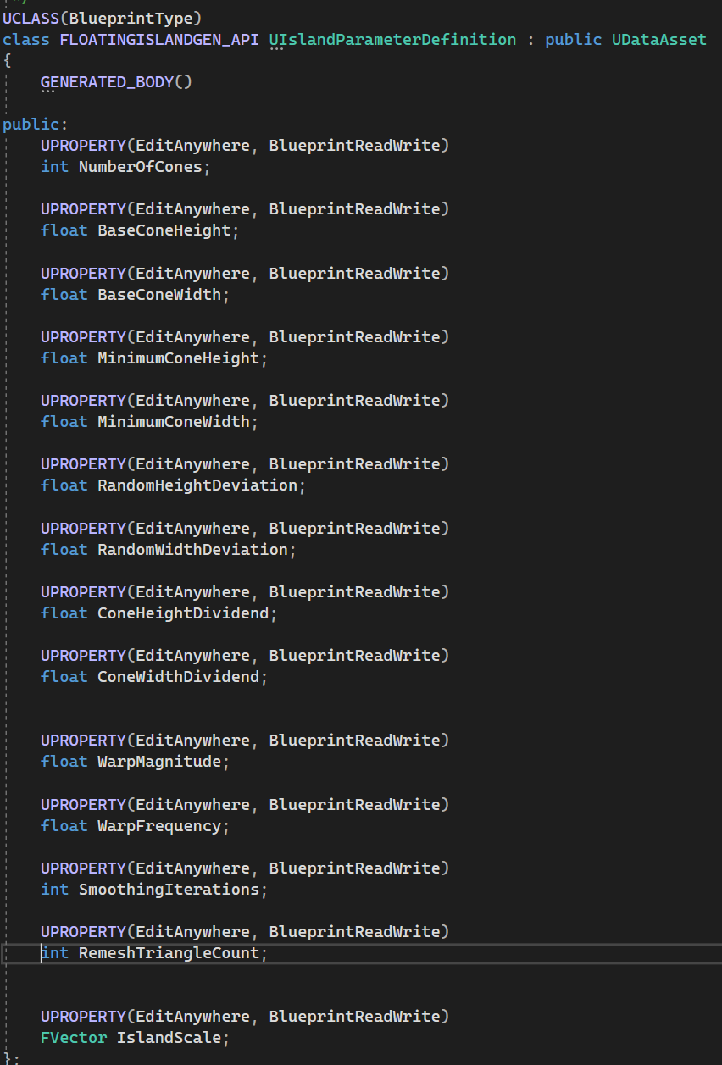A couple of sections of the island generation did make use of C++, and that’s the specification of an islands parameters. Originally these were exposed as single variables, and it was quite messy and made it hard to use elsewhere. So one of the later changes was to replace these variables with a data asset, that allows an islands parameters to be easily specified and switched out on the fly. This also ties in quite well with the level generation. These values will be explained in further detail later.

Figure - data asset definition for the island parameters

### Structural Composition of the Level

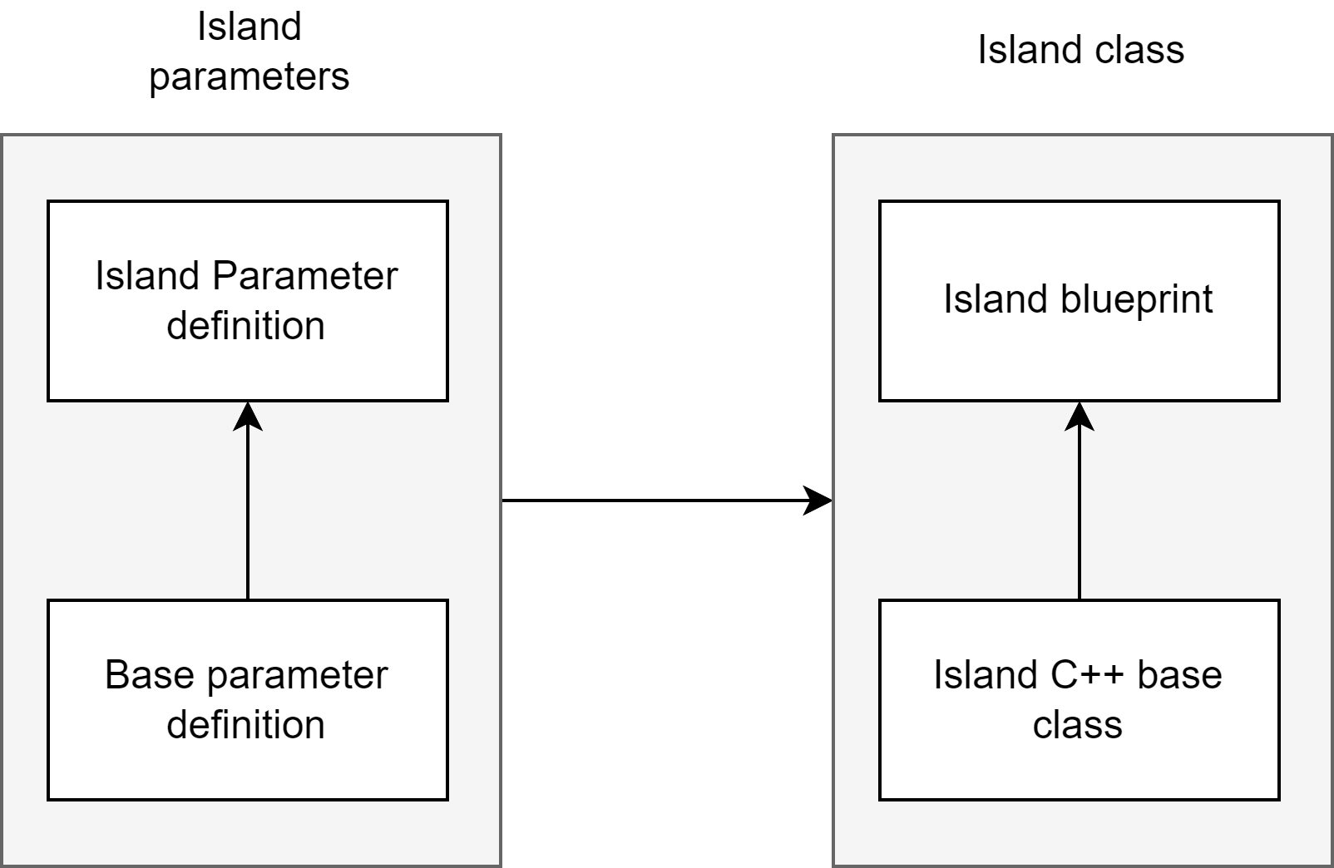Below is an annotated image of the level hierarchy from a single island placed into the level, and a diagram showing relationship between components.

Figure - A diagram showing the barebones structure of the parts that make up an island

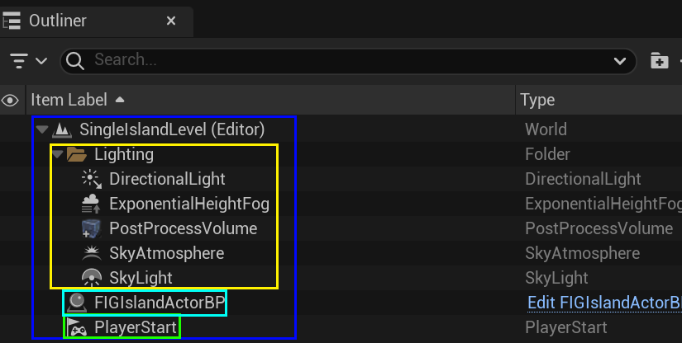

Figure - An annotated image of the components of the level

The above image shows an annotated overview of the actors in the demo level for a single island.

* **Blue** – The overall level.
* **Yellow** – Lighting objects required to make the level visible.
* **Green** – The player start.
* **Light Blue** – The island actor.

### DesIgn Evaluation

I believe when all put together, the floating island generation came together nicely. Islands are varied, generate relatively quickly, and are easily modifiable with lots of parameters. It was disappointing to not be able to implement it in C++ like I hoped for which affects the technical complexity of the component, but overall it all came together quite nicely. The use of Blueprints had a silver lining, in that it made it much easier to iterate on the island generation and find what worked and what didn’t without having to rebuild in Visual Studio.

If I were to improve on the generation in the future, I would likely split it up into a scene component that’s easily attached to an existing actor, rather than a dedicated floating island actor class. The class is designed to be inherited from so adjustments can be made, but the code doesn’t support much of the modularity I wanted in that regard, and a scene component would have helped with that.

Furthermore, prop generation could have been implemented via the islands themselves, or at least the array of prop definitions available could have been defined per island definition (procedural or predefined) rather than as a single array on the level generation class.

I could have also made further use of inheritance – As there are some parameters that are used by both island definitions, which could have easily been a base class. Specifically the number of props to spawn and - if I had gone down that route – an array of prop definitions available to the island.

Finally, islands could have had more features, like pools of water, connecting vines between islands, hanging moss, more detailed materials and falling dirt particles. All great topics for future work.

In conclusion this component has ups and downs, mainly in that the islands mostly look great and generate well with lots of variation, but the lack of C++ makes it less technically complex than I would have liked it to be, and made it harder to implement the modularity I wanted the component to use.

### Run-Time Evidence

To illustrate the completeness of the solution and the integration with the Unreal Engine Level/Map system (both World Partition and Layered Level), the following in-engine captures have been provided.

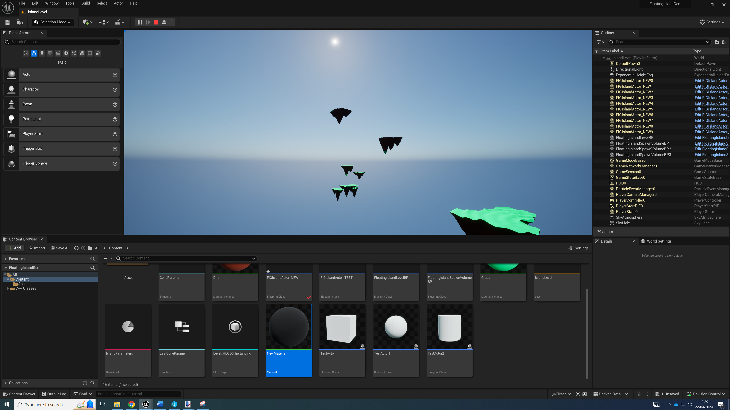The below image shows several islands from a distance, spawned and generated dynamically.

Figure 80 - Lots of islands from a distance.

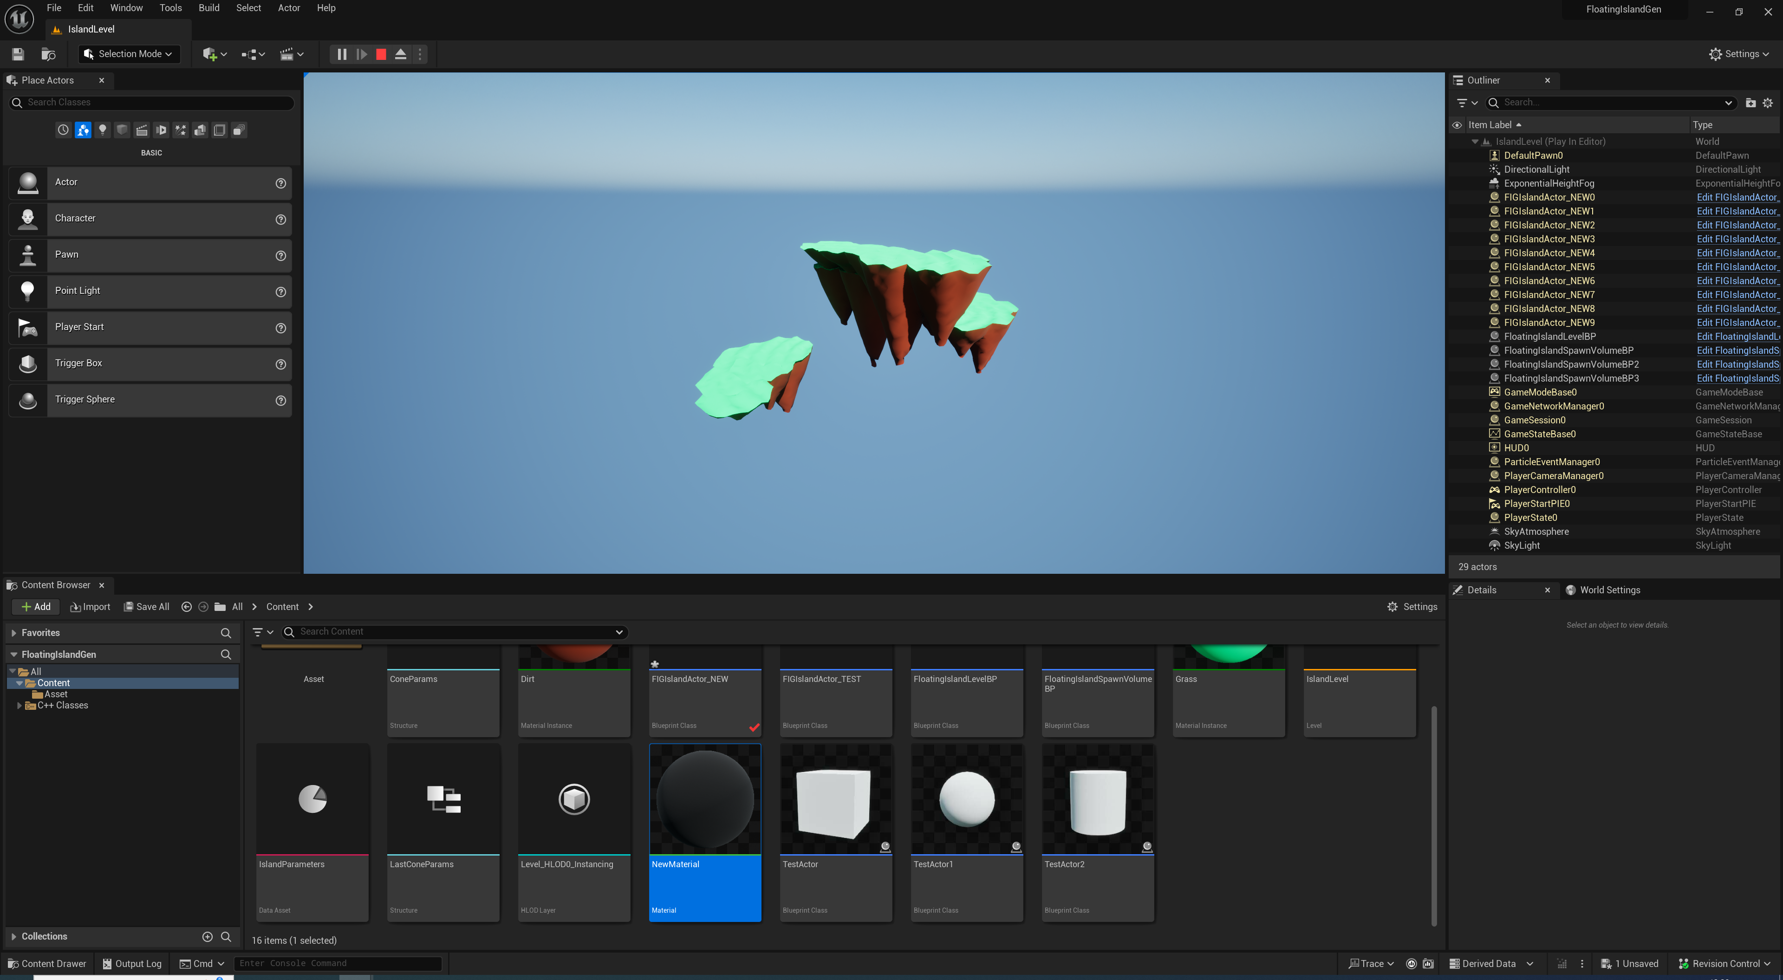The below image shows a closeup of a handful of 3 islands.

Figure 81 – Several islands close up.

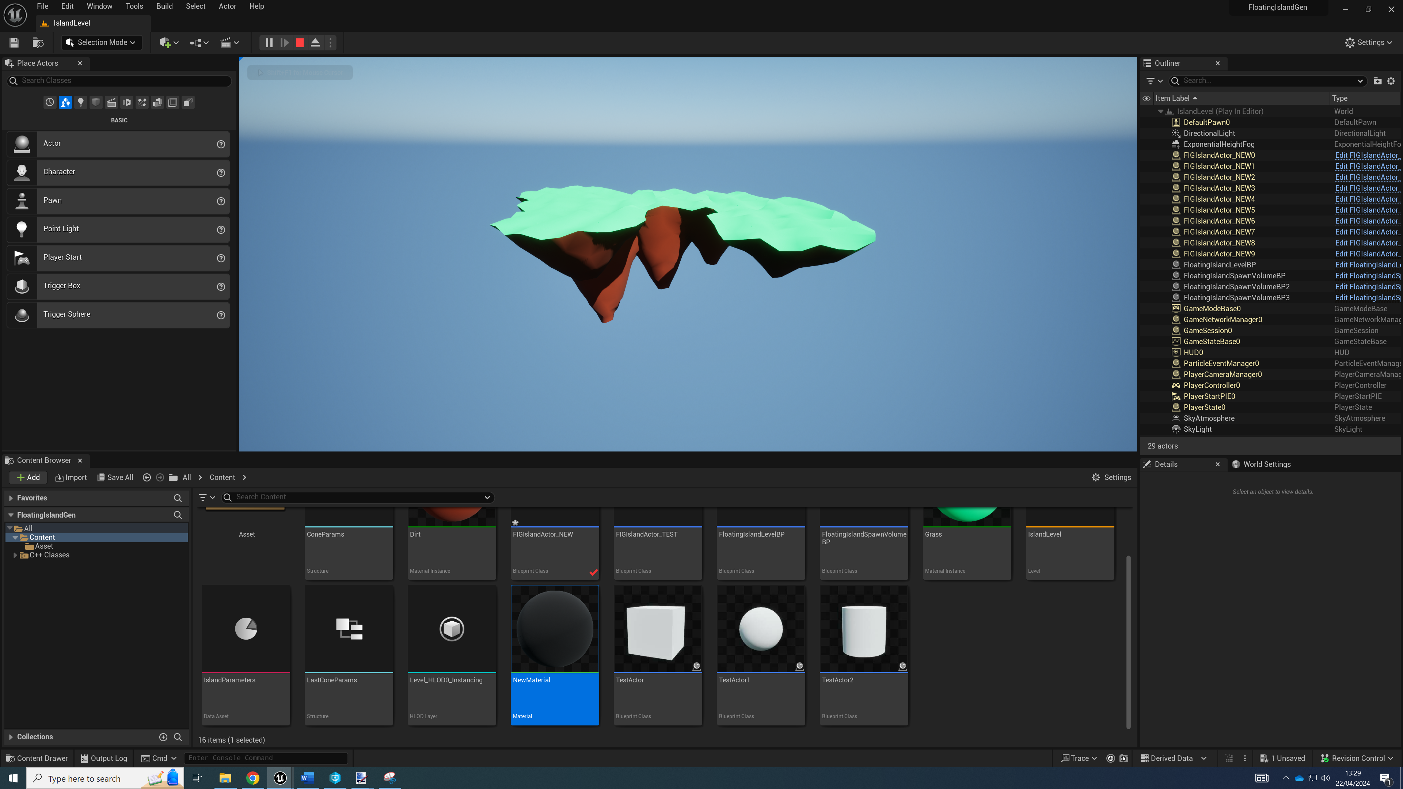The below image shows a closeup of a single island.

Figure 82 – A close up of a single generated island.

## Component #2 – Island Placement for Diverse Levels

Figure 83 - Examples of runtime island and prop placement

### Overview of Solution

This component of the project involves the dynamic placement of islands, with many options to create diverse levels. It is a single C++ class, with support for procedural prop/asset placement, multiple island parameter definitions to choose from, and multiple spawn volumes at once. Features include:

* **Predefined Actor/Procedural Actor Support** – The class can spawn islands either from premade assets or otherwise predefined blueprints, or from a selection of island parameter data assets. For example, a predefined asset could be a simple premade static mesh, or a modified procedural island that still dynamically generates at runtime, or a procedural island exported to static mesh.
* **Multiple Spawn Volumes** – Multiple spawn volumes for islands to be spawned inside of can be specified.
* **Random Asset Support** – Random props like trees and rocks can be spawned on top of the island meshes.

#### Overview

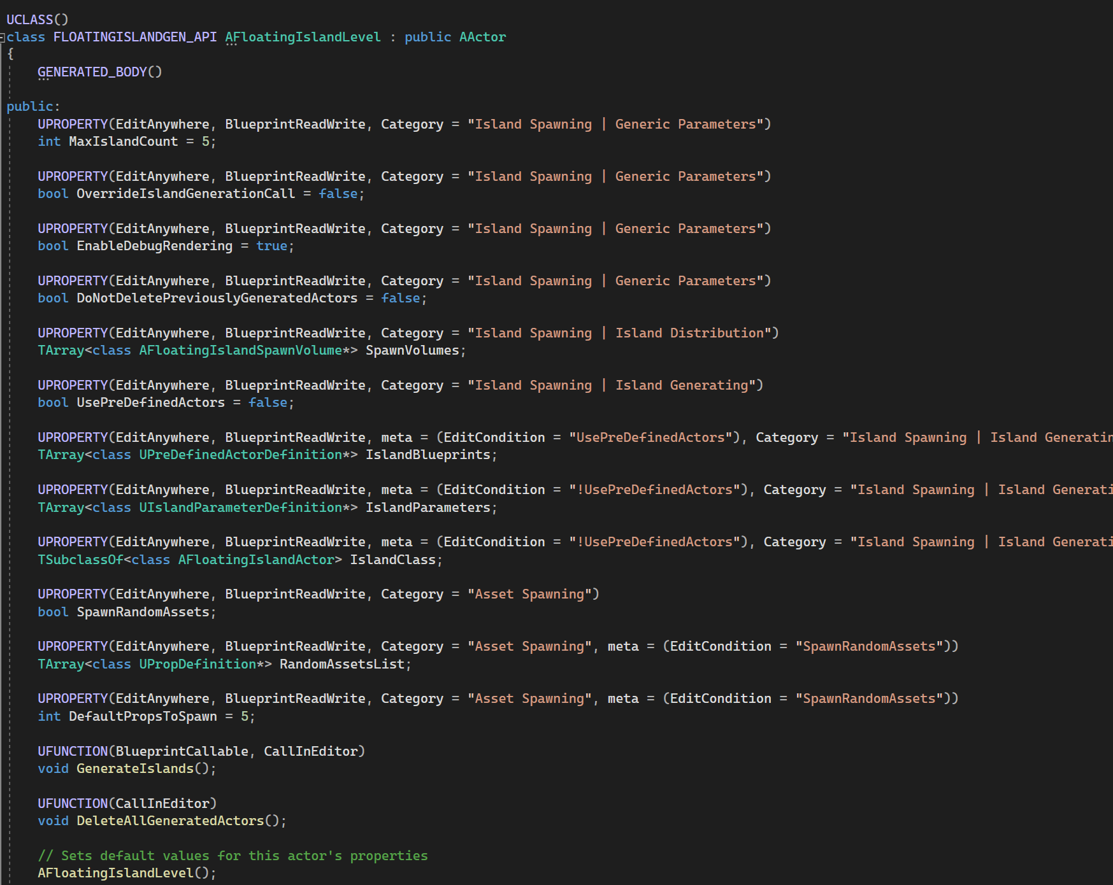

Figure - Public UPROPERTY and UFUNCTION definitions of the floating island level class

The island generator inherits from a C++ class where all functionality is implemented. This class is how most of the project was intended to be written before the issues with Geometry Script arose. As this class is intended to act as a tool for developers and designers to use, several small aspects of Unreal Engine’s C++ and Blueprints integration were used. For example meta properties were used, specifically EditCondition. This allows for only specific properties to be enabled or disabled based on checkboxes.

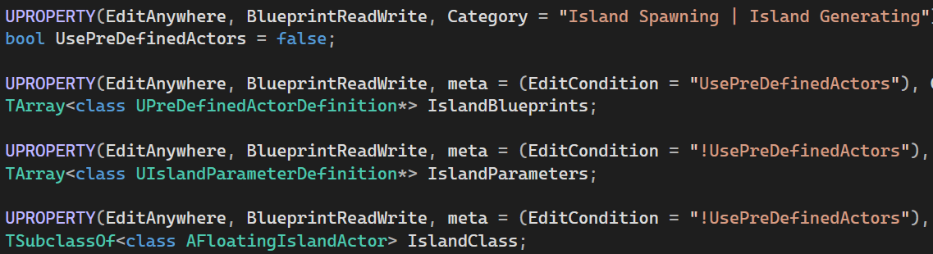

Figure - The use predefined actor boolean alongside several variables that rely on it being enabled/disabled.

|  |  |  |
| --- | --- | --- |
| **Operation/Attribute** | **Class** | **Explanation** |
| MaxIslandCount | AFloatingIslandLevel | Number of islands to generate |
| OverrideIslandGenerationCall | AFloatingIslandLevel | Stops islands from being generated on beginplay |
| EnableDebugRendering | AFloatingIslandLevel | Enables rendering of debug helpers |
| DoNotDeletePreviouslyGeneratedActors | AFloatingIslandLevel | Prevents deletion of previously spawned actors and props |
| SpawnVolumes | AFloatingIslandLevel | Spawn volumes to choose from |
| UsePreDefinedActors | AFloatingIslandLevel | Whether or not to use pre defined actors or dynamically generate them |
| IslandBlueprints | AFloatingIslandLevel | Island blueprints to pick from when generating predefined actors |
| IslandParameters | AFloatingIslandLevel | Island parameter definitions to pick from when generating dynamic islands |
| IslandClass | AFloatingIslandLevel | The class of the actor to spawn, which will have the definition applied to it |
| SpawnRandomAssets | AFloatingIslandLevel | Whether or not to spawn random assets |
| RandomAssetsList | AFloatingIslandLevel | The random assets to choose from |
| DefaultPropsToSpawn | AFloatingIslandLevel | The number of assets to spawn if using predefined actors |
| GenerateIslands | AFloatingIslandLevel | Function that generates the level, blueprint callable and overridable |
| DeleteAllGeneratedActors | AFloatingIslandLevel | Editor callable function to delete all generated actors, islands and props |
| GeneratedIslands | AFloatingIslandLevel | Islands that have been generated |
| AbsoluteRandomProps | AFloatingIslandLevel | The spawn chance of a prop definition defines how many times it will be added to this array which a prop is then picked from |
| AbsoluteIslandParameters | AFloatingIslandLevel | The spawn chance of a parameter definition defines how many times it will be added to this array which a parameter definition is then picked from |
| AbsolutePredefinedActors | AFloatingIslandLevel | The spawn chance of a predefined actor definition defines how many times it will be added to this array with a predefined actor definition is then picked from. |
| PickRandomVolume | AFloatingIslandLevel | Function to pick a random volume |
| SpawnNewProceduralIsland | AFloatingIslandLevel | Function to spawn a new procedural island |
| SpawnIslandFromBlueprint | AFloatingIslandLevel | Function to spawn a new island from a blueprint |

Table - Attributes and functions for the floating island level generator C++ class.

|  |  |  |
| --- | --- | --- |
| **Operation/Attribute** | **Class** | **Explanation** |
| Volume | AFloatingIslandSpawnVolume | Box component that acts as the spawn volume |
| BlueprintToSpawn | UPreDefinedActorDefinition | The blueprint to be spawned |

Table - Attributes and functions for the floating island spawn volume C++ class.

Take for example the above sets of variables. UsePreDefinedActors defines whether the level generator will use actors already defined by the developer, or only the island parameter data asset, dynamically spawning an island from a specified island class.

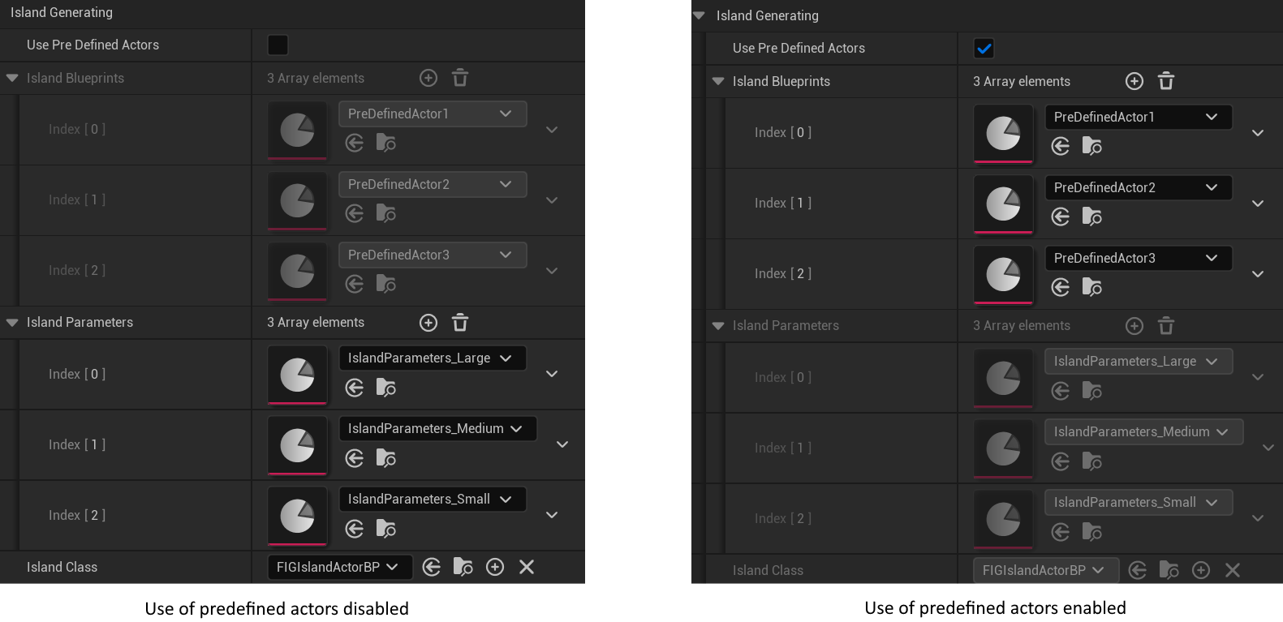

Figure - Two images showing the different sets of variables being locked off depending on if pre defined actor use is enabled or not

If this variable is enabled, then only further variables that are used for predefined actors are enabled for editing, otherwise variables for procedural actors are enabled.

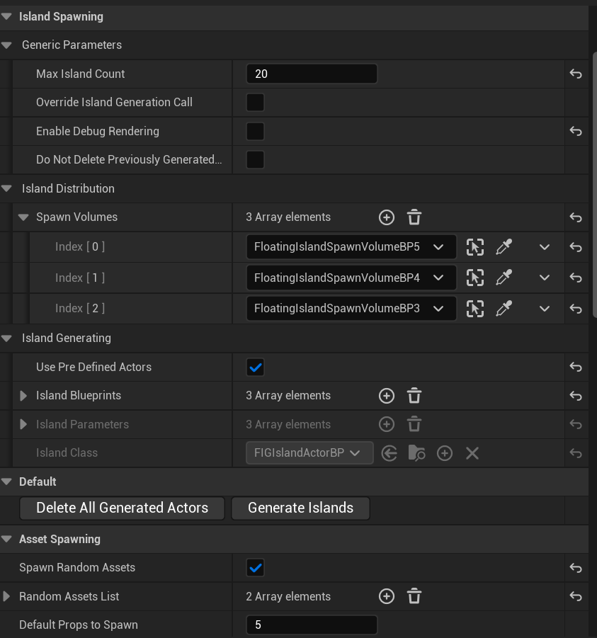Furthermore, the use of multiple categories and subcategories allows for different sections of the program to be collapsed, and organised better. It’s much easier for a designer or developer to look at several categories than a mess of variables with unclear names.

Figure 87 - All categories for the level generator are visible in this image, showing their organisation with a clean UI

#### Implementation – Island Spawning

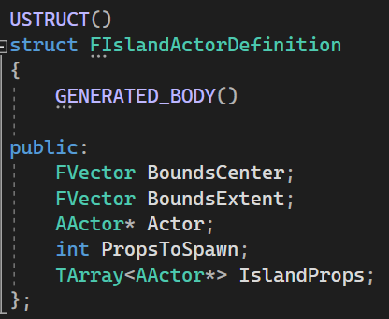All islands, procedural or predefined, after being spawned are placed into a C++ only USTRUCT that holds all data types. This was a relatively late addition in development and caused all below code to be rewritten to account for it. It allows for less unnecessary casts and makes the function for spawning props much simpler. Furthermore, it defines a relationship between the island and the props on it, rather than the props simply existing alongside the island.

Figure 88 - A struct holding a pointer to a spawned actor, its bounds, and the props that have been spawned on top of it. This struct acts as an easy way to hold data on an island, and prevents having to grab it from the island actor itself at a later date.

|  |  |  |
| --- | --- | --- |
| **Operation/Attribute** | **Class** | **Explanation** |
| BoundsCenter | FIslandActorDefinition | The centre of the islands bounds |
| BoundsExtent | FIslandActorDefinition | The extent of the islands bounds |
| Actor | FIslandActorDefinition | A pointer to the spawned actor referenced by this definition |
| PropsToSpawn | FIslandActorDefinition | The number of props to spawn for this island |
| IslandProps | FIslandActorDefinition | An array holding pointers to the props spawned by this island |

Table - Attributes and functions for the spawned island actor definition struct.

All island types are also spawned from the same entry point, a for loop that calls for the number of islands required. This many islands may not be spawned if they intersect and cannot be adjusted, but the number is typically quite close.

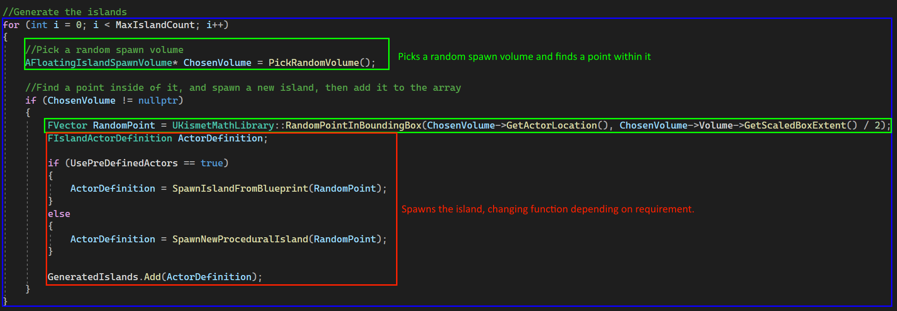

Figure - An overview of the island spawning for loop.

Before this function is called, if required, all previously spawned actors are destroyed, including props. This function involves looping through each actor definition, destroying its actor, then looping through the props assigned to it and destroying those. Afterwards, the array is emptied, so all definitions are cleared from memory.

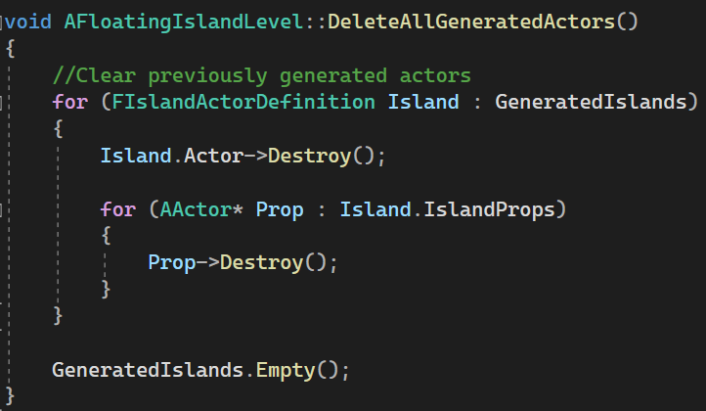

Figure - Definition of method for cleaning up spawned islands and props.

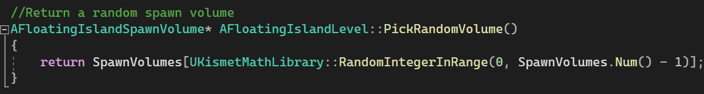

Figure - Definition of method for picking a spawn volume.

The pick random volume function simply picks a random volume from the array. Before this, a check is ran to ensure spawn volume references are present. If the array is empty, the level generator quits early and prints a message to either the log or the screen to alert the developer. Without this, the editor would crash.

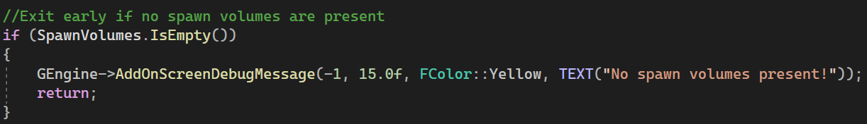

Figure - An early if statement that alerts the developer if no spawn volumes have been specified, then quits the level generator early.

The island spawning itself is split up into two functions depending on developer requirements (procedural or pre-defined actors). Both functions are relatively similar, but have been split up for organisational purposes.

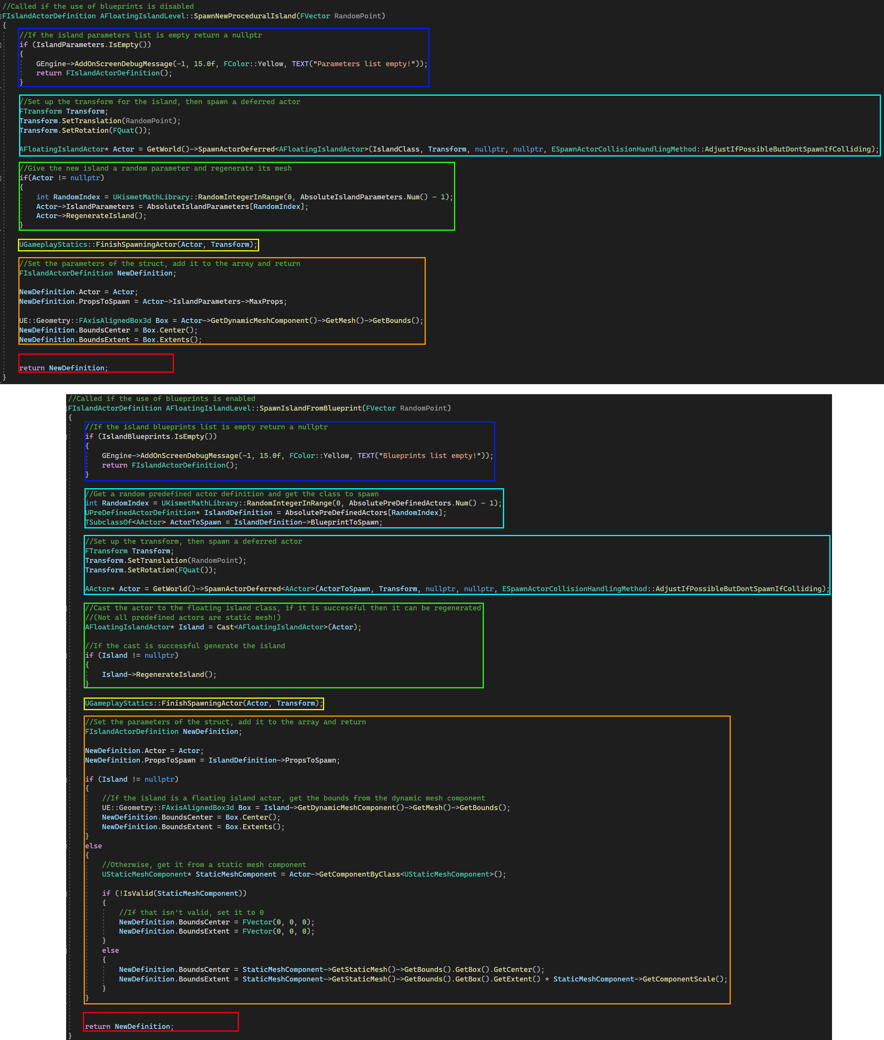

Figure - Both prop spawning functions with their methods compared. Similar areas of functionality have been annotated and are explained in further detail below.

* **Blue** – This part of both methods returns early if no island definitions or parameter definitions are present.
* **Cyan** – The actor is spawned, with a transform made from the random point parameter.
  + **Procedural** – For the procedural method, this just involves spawning a deferred class.
  + **Predefined** – For the predefined method, this involves selecting the class to spawn first, so it can be used in the spawn method.
* **Green** – Both methods must regenerate their island geometry.
  + **Procedural** – For the procedural method, this is a simple case of just picking a parameter definition, giving it to the island, and calling the method to regenerate geometry.
  + **Predefined** – For the predefined method, for simplicity it assumes that the island in question already has a parameter specified, if it is an island class at all. If the cast to the class is successful, the method is called.
* **Orange** – Both methods must set up an actor definition for the newly spawned actor and set up all parameters.
  + **Procedural** – As the actor spawned is a floating island class, it’s a simple case of grabbing the dynamic mesh component and getting its bounds.
  + **Predefined** – The predefined method is much more involved. First, the previous cast is used to see if the actor is a floating island. If so, it grabs the dynamic mesh component and gets the bounds like the procedural method. If not, it tries to get the bounds via an attached static mesh component. If none is found, it sets the values to 0.
* **Red** – Both methods return the new definition.

#### Implementation – Prop Spawning

Next, props are spawned on top of the islands, if required. This involves looping through each actor definition, grabbing the island’s bounds parameters, then running an inner for loop for the number of props to spawn, within the X and Y constraints of the bounds.

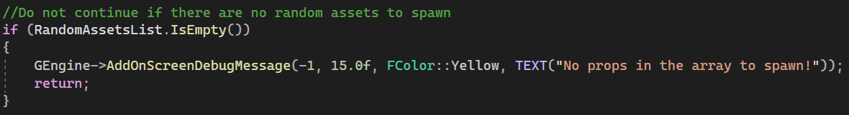

Figure – Like other areas of the program, a check is done first to ensure random props are present.

Like all other areas of the program, for safety and to prevent unnecessary code from running the array is checked to see if it is empty. If it is, it returns early, and no props are spawned.

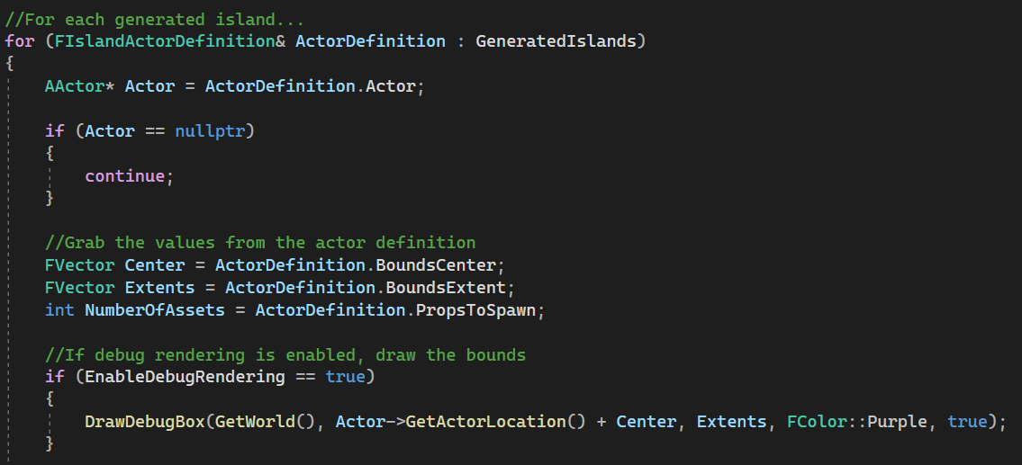

Figure - Ease of access variables are set up, and the actor is checked for validity.

Next, the actor definitions are looped through, so props are spawned on every island. For each island, the actor is first checked for validity, and the loop skips to the next actor if so. Next, ease of access variables are set up for the bounding box and the number of props to spawn, and if debug rendering is enabled a box is drawn representing the bounds.

Next, the inner for loop is ran based on the number of props present.

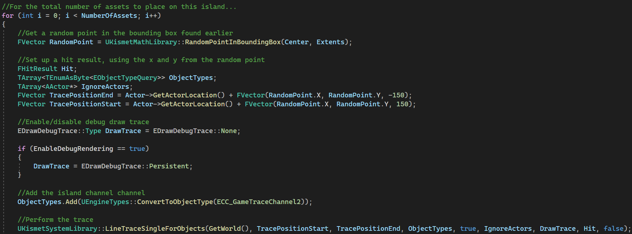

Figure - The line trace for spawning a prop is set up, and then cast.

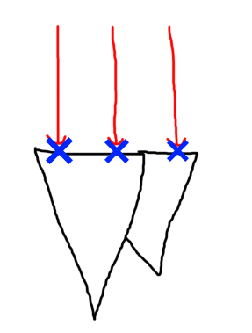A random point is grabbed from the bounding box defined outside of the inner loop, and then a line trace is set up. This line trace uses the X and Y values from the bounding box as a flat plane, with the Z being defined separately as somewhere above and below the island. The trace is cast down, and if a hit happens with the islands surface, a prop can be spawned there.

Figure 97 - Rough diagram indicating the functionality of the line trace.

The above diagram shows visually how this occurs, with the red arrows casting down, and hitting the island at the blue points.

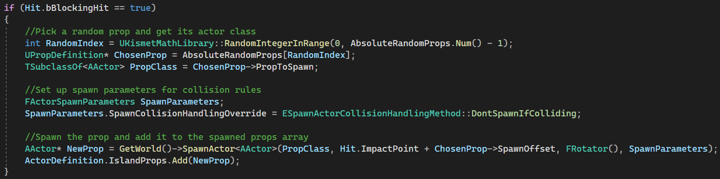

Figure – A prop is spawned from the cast’s impact point.

Then, a prop is spawned where the hit collides with the island’s surface. A random prop definition is chosen, and its class used to spawn a prop. The prop is then added to the definition’s array of prop actors.

#### Implementation – Props

The props themselves were implemented in Blueprints, as they only needed very basic functionality. The prop definition however is C++.

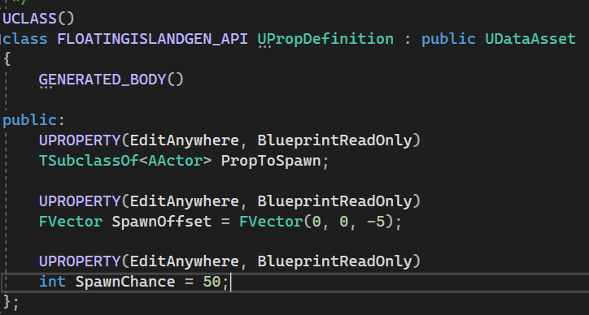

Figure - The prop definition data asset in C++.

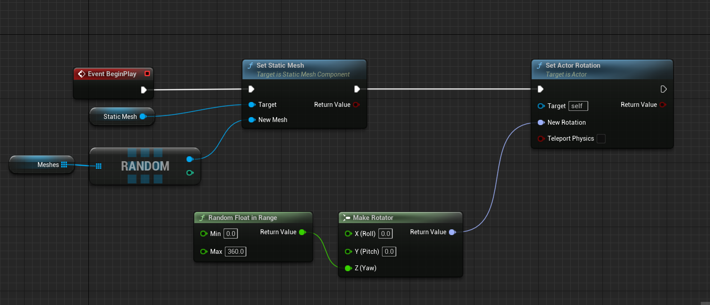The prop definition defines the spawn chance, the actor to spawn, and a spawn offset so the props can be embedded slightly within the island. Without this, some props may float due to their mesh, or due to curves on the island.

|  |  |  |
| --- | --- | --- |
| **Operation/Attribute** | **Class** | **Explanation** |
| PropToSpawn | UPropDefinition | The class of the prop to spawn |
| SpawnOffset | UPropDefinition | Vector offset from the position the prop is spawned at |

Figure - Randomised static mesh selection and actor rotation in blueprints.

The prop blueprint is a basic class that picks a random mesh from an array and sets it, then applies a random rotation.

From this, both trees and rocks are implemented.

### Structural Composition of the Level

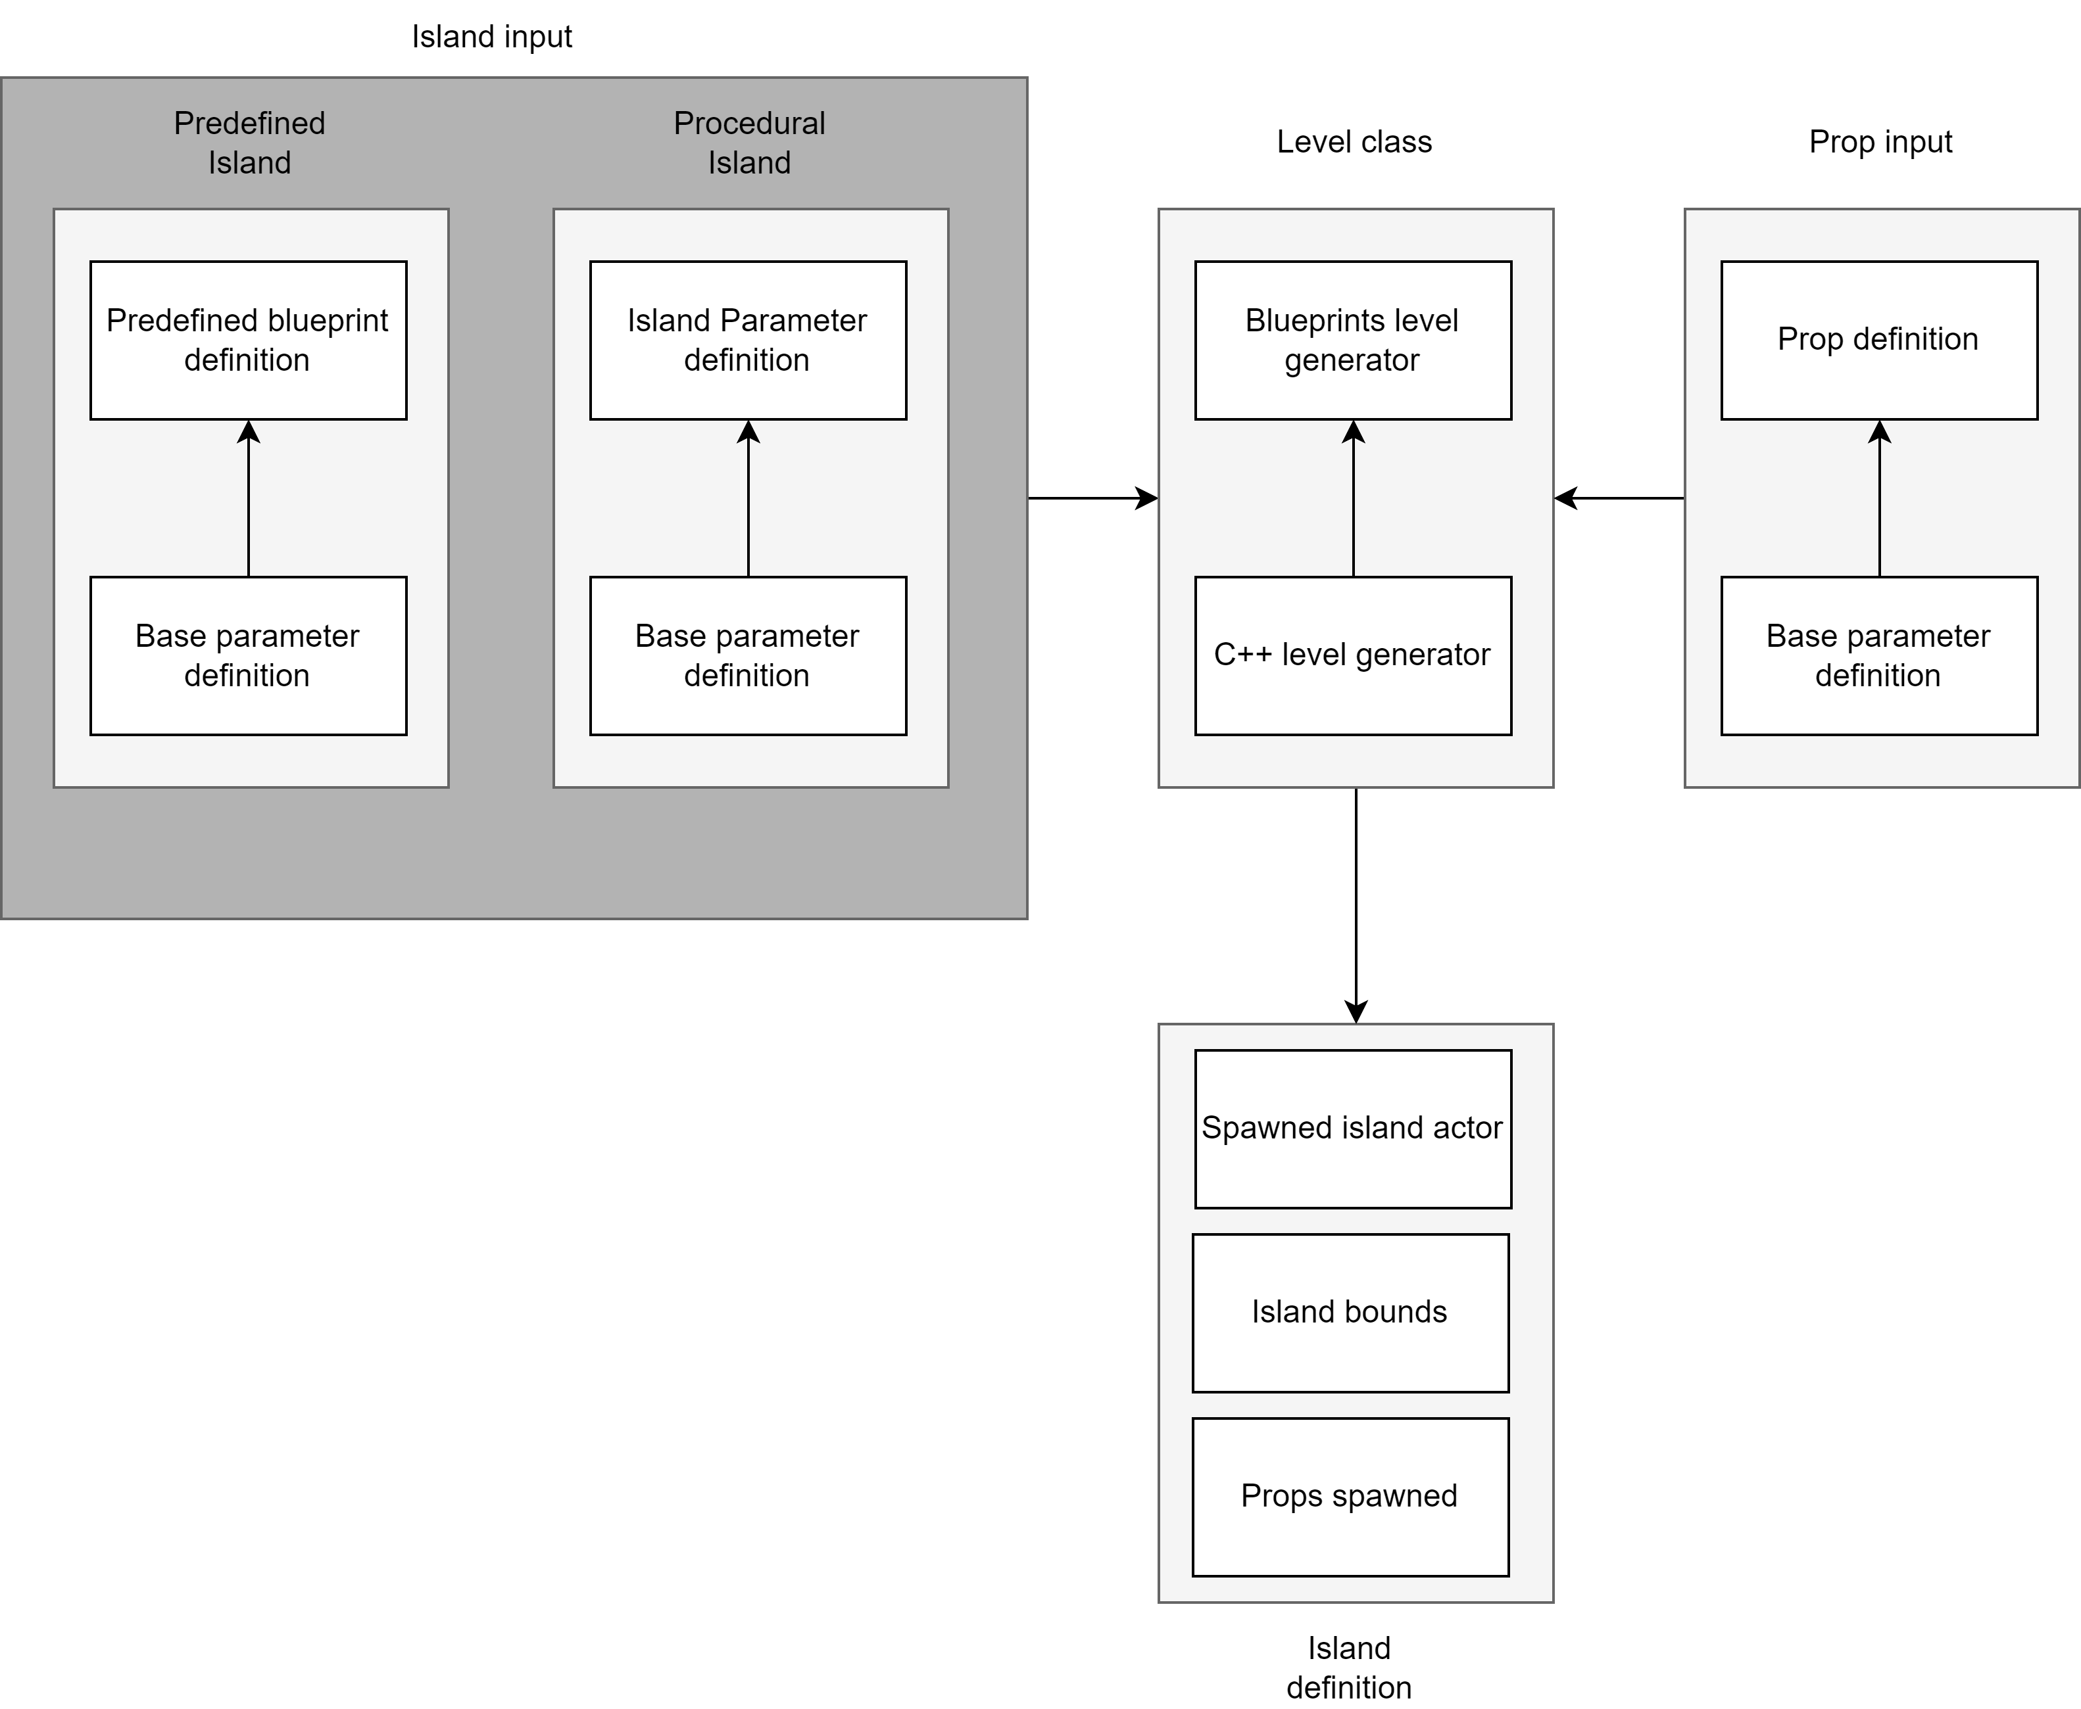Below is an annotated image of the level hierarchy from the island level generator’s functions, and a diagram showing relationship between components.

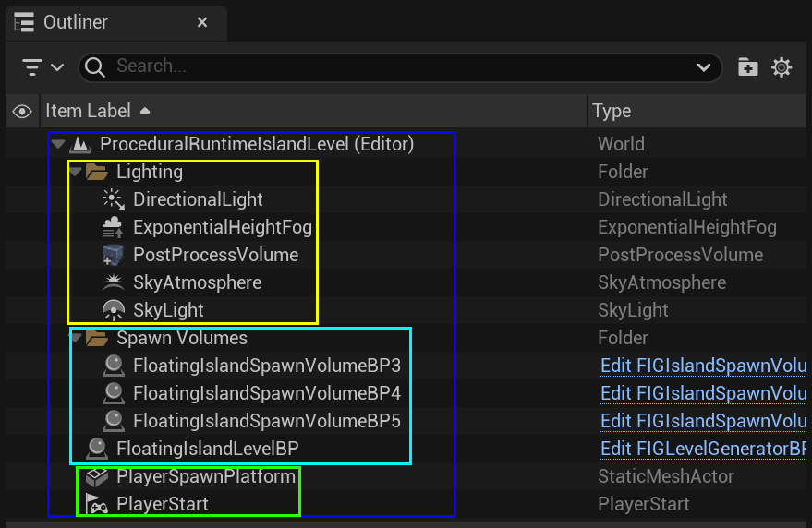Figure - A diagram showing the barebones parts that make up the level generator.

Figure 103 - An annotated image of the components of the level.

The above image shows an annotated overview of the actors in the demo level for a single island.

* **Blue** – The overall level.
* **Yellow** – Lighting objects required to make the level visible.
* **Green** – The player start, and the platform they spawn on.
* **Light Blue** – The island level generator actor and accompanying spawn volumes.

### Design Evaluation

The implementation of the island level generator was experienced as a slippery slope with lots of hurdles and redesigns of the code, but in the end, it came together well. Islands were able to generate with diverse features, support was available for different island definitions with different spawn chance, and it has been designed in a developer friendly way, with clearly defined sections for code and Booleans to enable/disable different functionality, and toggle editing on the related variables.

While the code came together well and functions well, I wish I’d taken the time to plan it more from the beginning. For example, the spawn island function went through several steps of iteration, with the process to find the bounds of an island originally being in the spawn props function. In the end, I’m glad I took the steps to add the USTRUCT to hold a spawned island (no matter the type, predefined or procedural), as that functionality made it easier to make use of the islands for spawning props. The use of an island props array per island also establishes them as the owner, making it clearer what belongs to what.

As stated in the previous design evaluation, if I had decided to select the route of an island defining what props it wants to have the choice to spawn, then a “spawn props/destroy props” function may have been better to add to the island class itself. This could have been implemented in C++, and implementing the island generation as a modular dynamic mesh component would have helped with this too.

Furthermore, islands are simply placed with a random point inside a given bounding box, more thought could have been taken to (for example) use noise to place specific islands in specific places, creating more unique looking formations of islands.

Overall, there are several improvements that could have been made to this component which will fit well for future work, but the system in general works successfully, and helps to generate diverse levels.

### Run-Time Evidence

To illustrate the completeness of the solution and the integration with the Unreal Engine Level/Map system (both World Partition and Layered Level), the following in-engine captures have been provided.

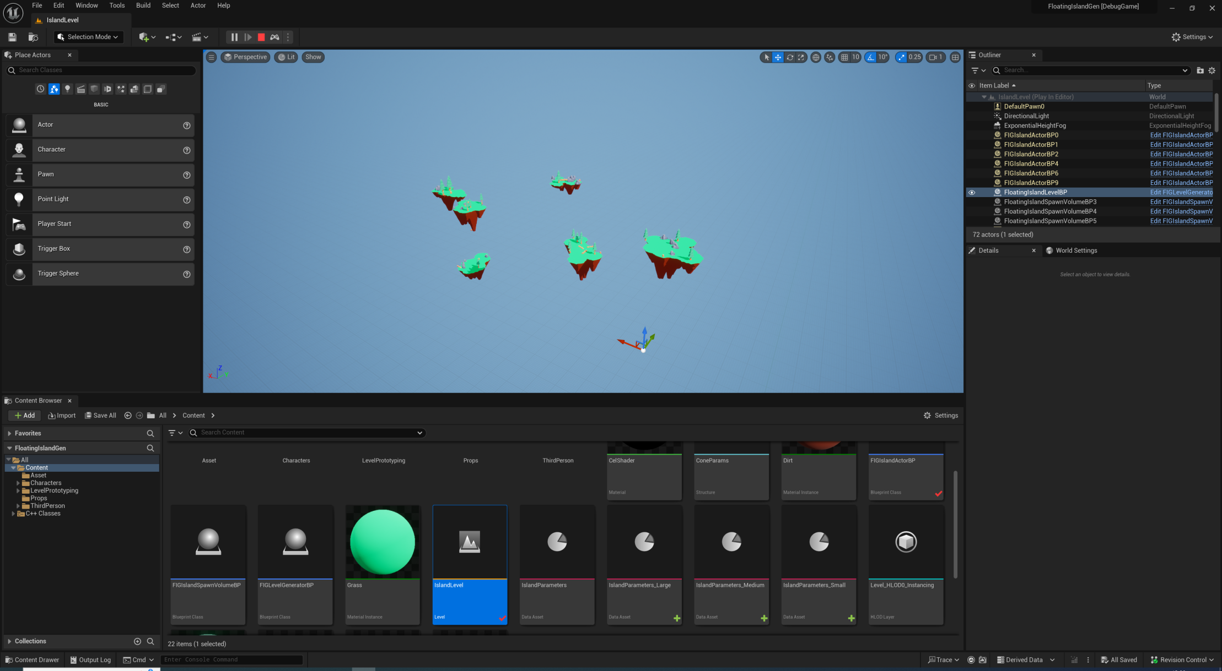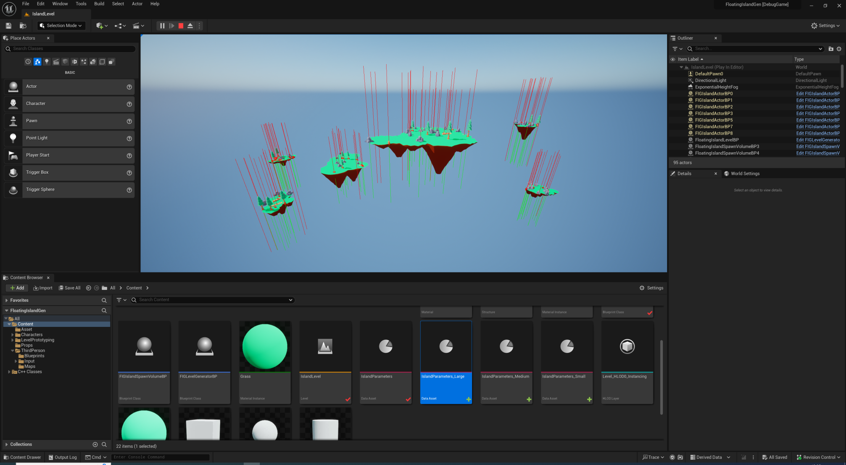The below images shows several procedurally generated islands with props on top. The first image showcases islands with the line traces visible with debug rendering enabled.

Figure 105 - Some islands with props visible.

Figure 104 - Overview of islands with props on them, with debug rendering enabled.

## Conclusion

In this chapter we discussed the implementation of the project artefact. This included general Unreal C++ syntax, and an overview of each component and how it was realised, followed by the field definitions and brief evaluation of the pros and cons of the design decisions. In the next chapter, there will be a more detailed evaluation of the project artefact with more in-depth analysis.

# Project Evaluation

## Introduction

This chapter will evaluate the project in detail, specifically whether it is fit for purpose, performing tests of functionality will be followed by a discussion of the types of testing and which one would be best suited for the artefact.

## Choosing a Testing Methodology

### Types of Testing

When testing software, it’s important to select something that works well for the program in question. There are many different types of testing, from black/white/grey box to functional acceptance testing, unit tests, integration tests and more. This section will go over some of them and decide which would be best for testing.

#### Black, White and Grey Box

These three methods of testing are all very similar to each other, with some variation.

* **Black Box** – Black box testing refers to software testing where the functionality of the software is not known. It’s done without internal knowledge of the product and focuses on its external attributes and behaviours.
* **White Box** – White box testing, also referred to as glass box, involves testing with the knowledge of internal data structures, program architecture and logic flow. This testing works from the developer’s point of view.
* **Grey Box** – Gray box is a combination of both types of testing, involving inputs and outputs of the program for testing purposes but the test design is tested using information about the code.

(tarunsinghwap7, 2023)

|  |  |  |
| --- | --- | --- |
| Black Box | Grey Box | White Box |
| Performed by end users, but also testers and developers | Performed by end users | Performed by developers |
| Knowledge of internal software is not required | Knowledge of internal software related to testing is known | Knowledge of internal software is known |
| Suitable for functional and business testing | Suitable for deeper functional, business or domain testing | Used for all forms of testing |

Table - Features of Black, Grey and White Box testing.

I don’t think any of these testing types would suit the artefact, as I both don’t have end users to test, and the nature of the project makes it more of an opinion-based prototype (someone may have differing opinions on what makes a floating island look good – something that doesn’t exist in real life!)

#### Functional Acceptance Testing

Functional Acceptance testing is a form of testing that aims to see if the software meets the specified functionality and requirements (Stan Pittet, 2023). They require that the entire program is running and focus on replicating end user behaviours. They can also go further than this and measure the performance, rejecting changes if goals are not met.

This type of testing is a good fit for the program, as it aims to simply try and identify whether functionality and purposes have been met. It also tries to do this from the point of view of an end user, which works well as I am able to perform the tests in Unreal myself and ensure they meet the requirements.

#### Unit Testing

Unit Tests are very low level, being close to the source of the application. They test individual methods and functionality of the program’s classes, components and structures (Stan Pittet, 2023).

This type of testing has been performed already technically, as during the process of building the program I routinely checked whether what was being written fit the purposes and made it easier to implement further functionality. There was a lot of adjustment this way, especially in the level generator, as I had to ensure the requirements and functionality such as user customisation were met, while still having the code be well written and able to function with all of these different choices available to the user.

### Testing Types Chosen

I believe functional acceptance testing as the main choice of testing works perfectly for the program. I can take the role of an end user (another developer) and execute tasks within the program as if I was using it to build a level and generate islands. Furthermore, unit tests have already been performed to ensure the implementation of functionality is smooth and works well. I will approach this by going over each of the functional and non-functional aspects of the program. I will then assess whether they work as intended or could be improved and document each one in a table below.

## Evaluation Details

### Analysis

The developed artefact was composed from the functional requirements that are documented in Chapter 3 – the evaluation of the artefact therefore has been conducted using industry standard software engineering evaluation techniques to verify the behaviours of my software via functional requirement acceptance testing.

The qualitative aspects of the artefact are evaluated via analysis of the key non-functional requirements that are satisfied by both the run-time execution and development techniques used in this project.

The following sections present an overview of the results of this testing.

The hope is that this artefact provides a research testbed for future development and extension of Procedural Island Generation using modern PCG Techniques and has been designed with this in mind – these potential areas are explored in the project conclusions.

### Functional Requirement Testing

Unit testing has been performed by adding blueprints and actors to levels, and testing whether they work as intended.

#### Prototype Functional Requirements

|  |  |  |  |  |  |
| --- | --- | --- | --- | --- | --- |
| Requirement ID | Tested Component | Success Criteria | Results | Comments | Evidence (Appendix: Testing Evidence) |
| ARCH1 | Island Generation | Islands can be generated at runtime and design time | Pass | No comments. Islands can be generated both at runtime and design time with call in editor UFUNCTIONs. | ARCH1 Appendix |
| ARCH2 | Island Generation | Developers will be able to export islands to FBX | Tentative Fail | Due to time constraints, nor me or my supervisor could find the option to export to FBX in time. | ARCH2 Appendix |
| ARCH3 | Island Generation | Developers will be able to reuse parts of the code, the code must be modular. | Tentative Pass | Some of the code is modular, but not to the extent I would have liked it to be. | ARCH3 Appendix |
| ARCH4 | Island Generation | Developers must be able to work visually, and design islands with parameters rather than through code. | Pass | Islands can be generated and updated in design time and runtime with appropriate functions, using a data asset. | ARCH4 Appendix |
| ARCH5 | Island Generation | Developers must be able to work from code only | Pass | All appropriate functions are available both publicly in C++ and as UFUNCTIONs | ARCH5 Appendix |
| ARCH6 | Island Generation | Islands must be able to be textured dynamically | Pass | Though basic, Islands can be textured, and have a material specified for dirt and grass. | ARCH6 Appendix |
| ARCH7 | Island Generation | Islands must have collision | Pass | Note that complex trimesh collisions had to be used otherwise the generated collisions were inaccurate. This is not ideal, but works fine enough for the prototype. | ARCH7 Appendix |

Table - Prototype functional requirements testing.

#### Component #1 Functional Requirements

|  |  |  |  |  |  |
| --- | --- | --- | --- | --- | --- |
| Requirement ID | Tested Component | Success Criteria | Results | Comments | Evidence (Appendix: Testing Evidence) |
| MG1 | Island Generation | Developers should be able to generate islands quickly at runtime and design time | Tentative pass | Highly dependent on number of islands and their triangle count. The uniform remesh is by far the most intensive, but around ~1000 triangles is required to prevent mesh distortion at the tips of the island. | |
| MG2 | Island Generation | Developers should be able to generate a wide variety of islands | Pass | No comments. Island parameters and randomisation allow for a wide variety of islands to be generated. | MG2 Appendix |
| MG3 | Island Generation | Wide variety of parameters | Pass | No comments. Many parameters are available for developers to use. | ARCH4 Appendix |

Table - Functional requirements testing for the island component.

#### Component #2 Functional Requirements

|  |  |  |  |  |  |
| --- | --- | --- | --- | --- | --- |
| Requirement ID | Tested Component | Success Criteria | Results | Comments | Evidence (Appendix: Testing Evidence) |
| IP1 | Island Level Generation | Developers should be able to specify a large variety of parameters when spawning islands. | Pass | Developers can specify several parameters, and even combine use of predefined and procedural islands when spawning. | IP1 Appendix |
| IP2 | Island Level Generation | Developers should be able to use spawn volumes | Pass | Developers can specify any number of spawn volumes and the level generator will adjust to account for as many as have been specified, picking any at random. Originally, the requirement was for both spawn volumes and PCG script, but this was cut due to constraints. | IP2 Appendix |
| IP3 | Island Level Generation | Developers should be able to use existing meshes | Pass | Developers can specify entirely custom blueprints with custom functionality, and even combine those with other procedural islands. | IP3 Appendix |
| IP4 | Island Level Generation | Developers should be able to spawn props on top of the islands | Pass | Developers can specify a list of props and these assets will spawn on top of the islands, and even specify how many props can spawn on an island. | IP4 Appendix |

Table - Functional requirements for the island level generation component.

### Non-Functional Requirement Testing

This section will go over a qualitative discussion of several non functional requirements, since they can’t be tested via traditional means. The chosen non functional requirements are:

* **Island Quality** – How good do the islands look? Are they varied?
* **Extensibility** – How easily can the tool be integrated into an existing project?
* **Interoperability** – How will the tool work with other Unreal Engine projects?

#### Island Quality

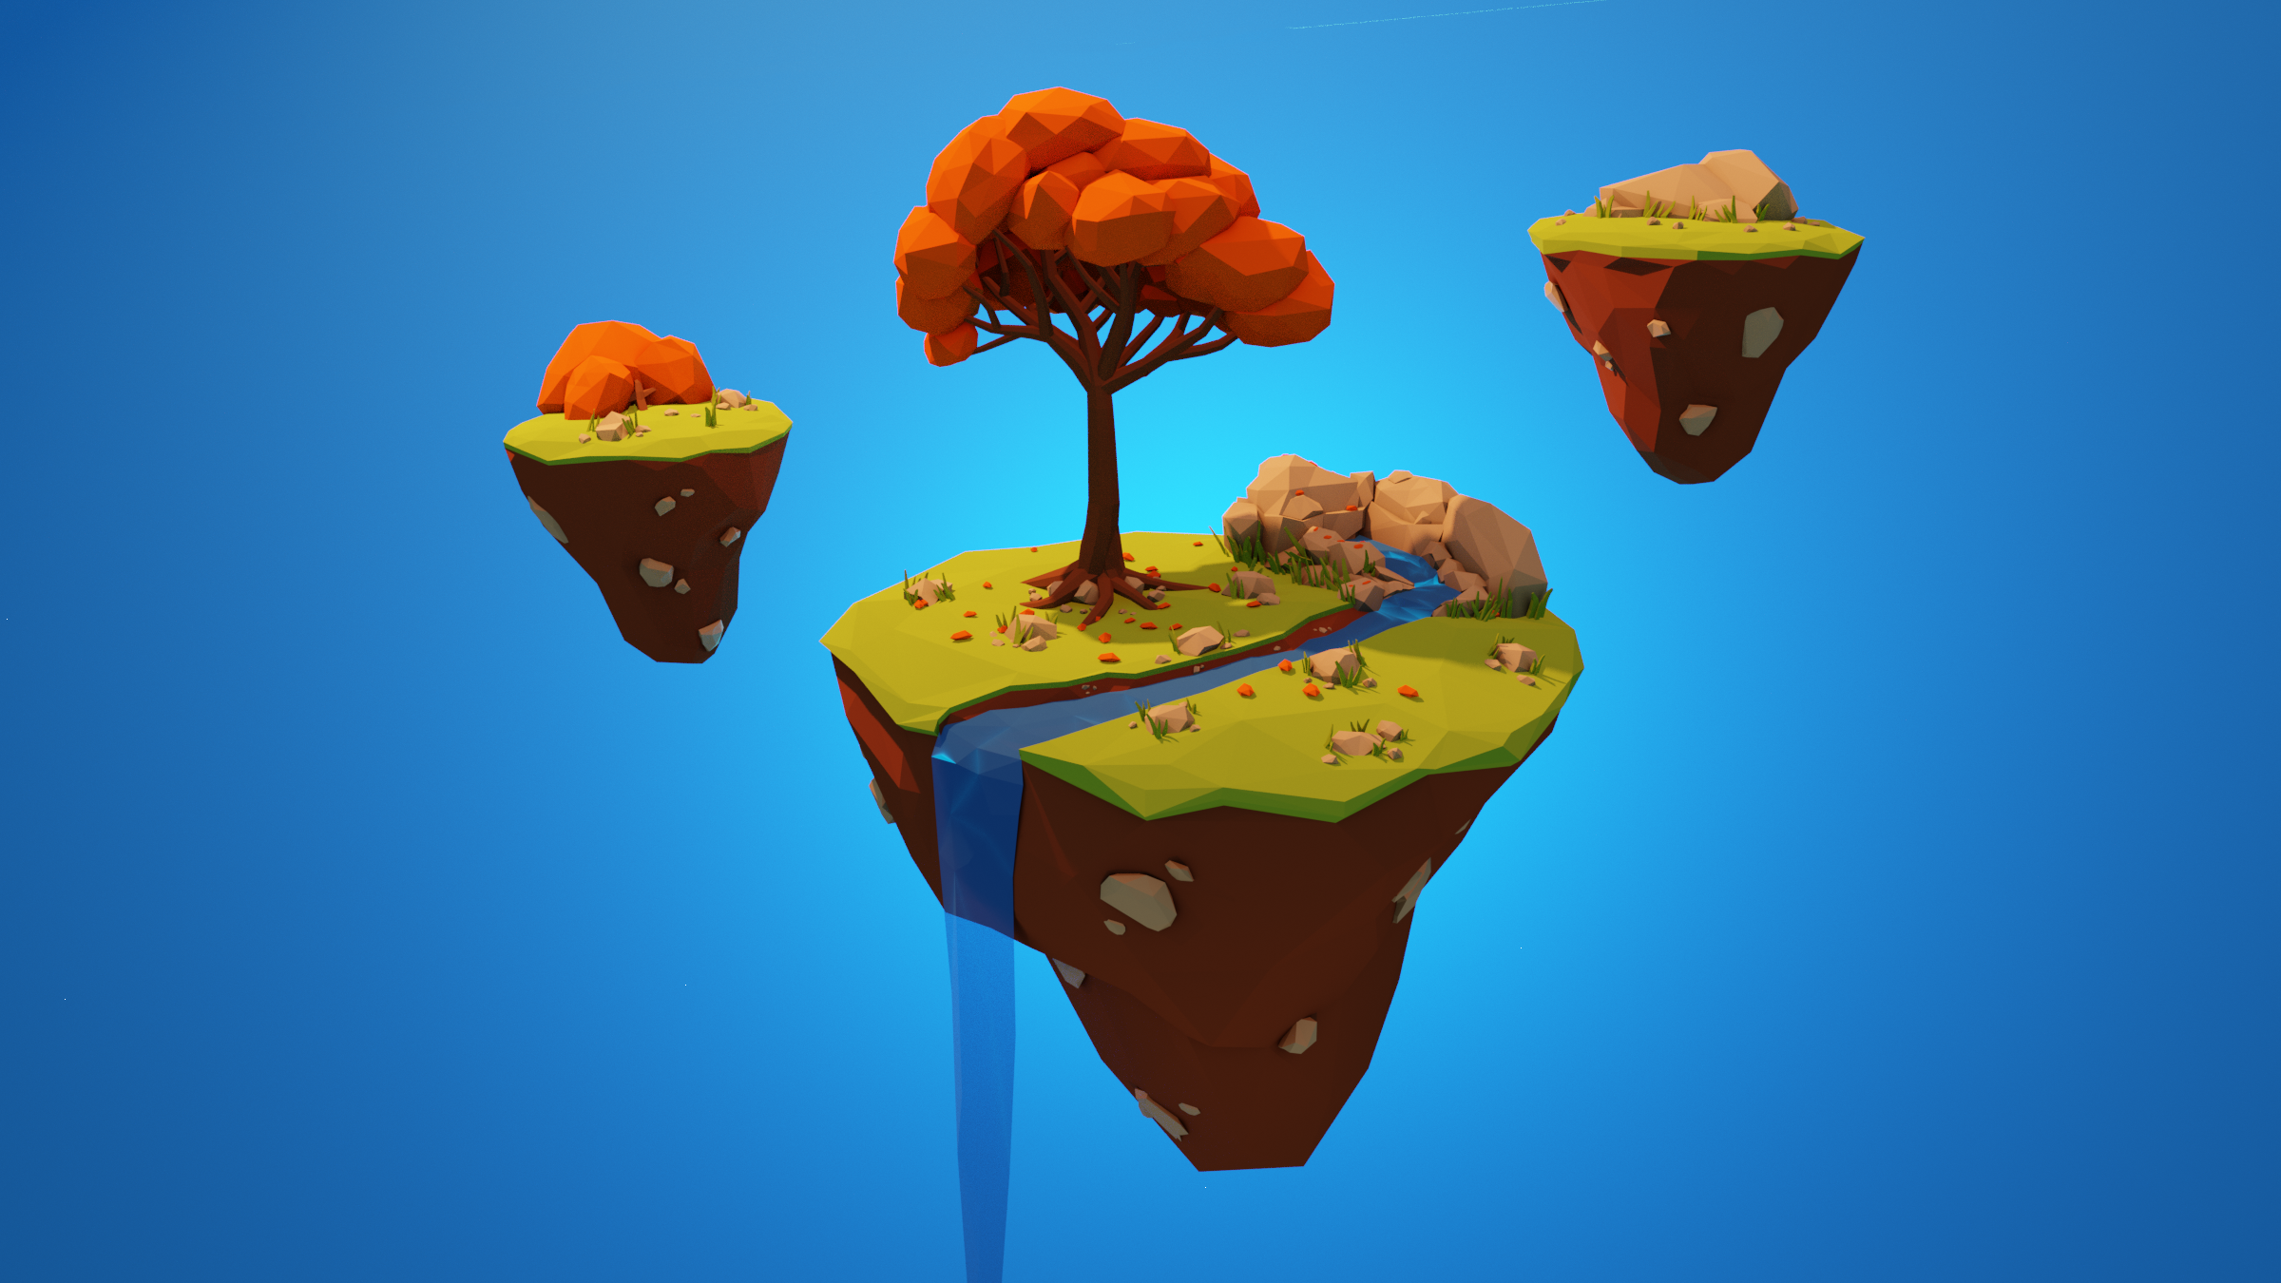The island generator itself is capable of generating a wide variety of islands, with many different parameters to create a nice, varied amount of islands of different sizes. It’s hard to objectively say if they look good or not, so this discussion will use images found online as examples of floating islands.

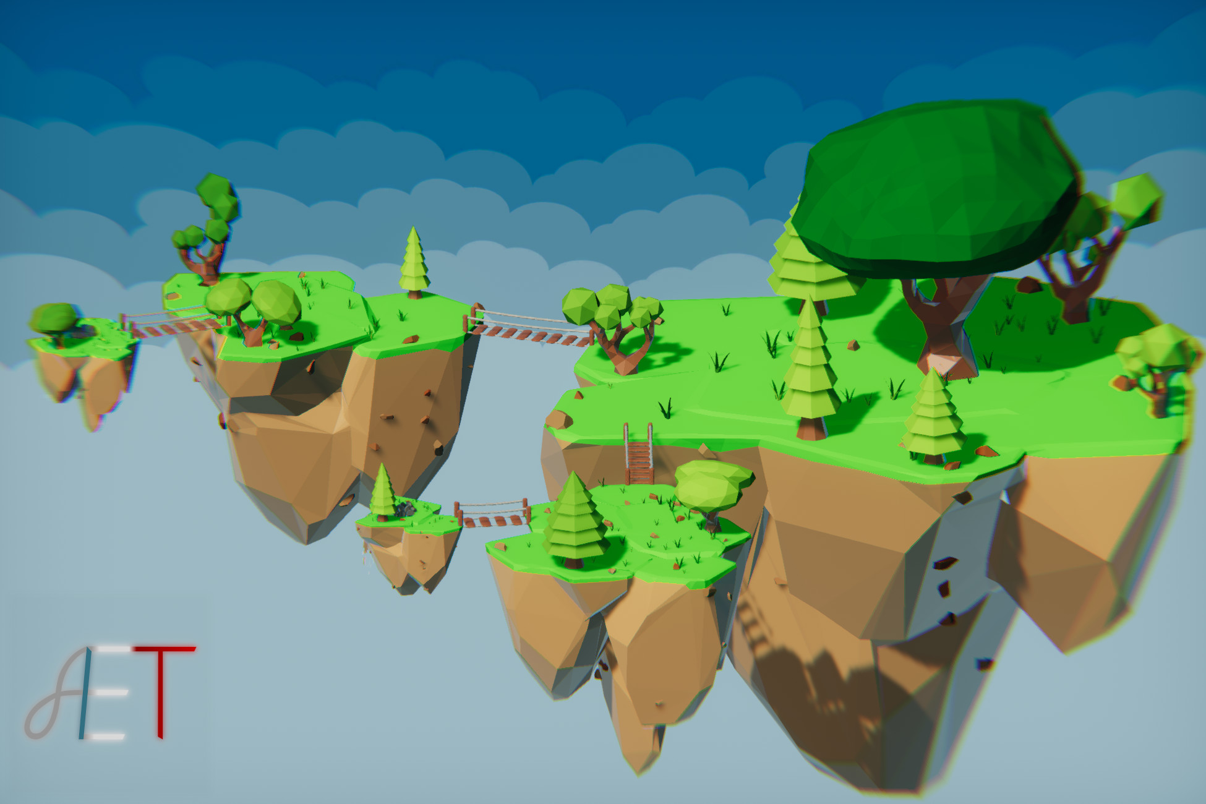Figure – Hand crafted 3D models of floating islands.[37]

Figure – More examples of floating island assets.[38]

Note the above sets of hand crafted islands. All share similar parameters, tapering shapes (like upside down cones), rocky uneven surfaces, and typically contrasting textures of grass and rock/dirt.

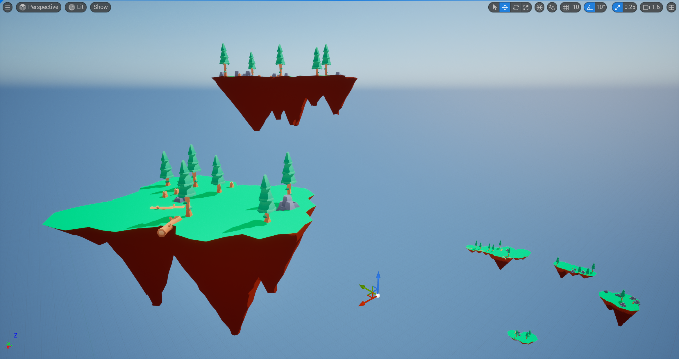

Figure - Some examples of my own floating islands.

Compared to the islands generated by the program, which generally fit the same features. For the most part, the islands come out looking quite well and varied, with interesting shapes underneath and a wide variety of outlines and surfaces.

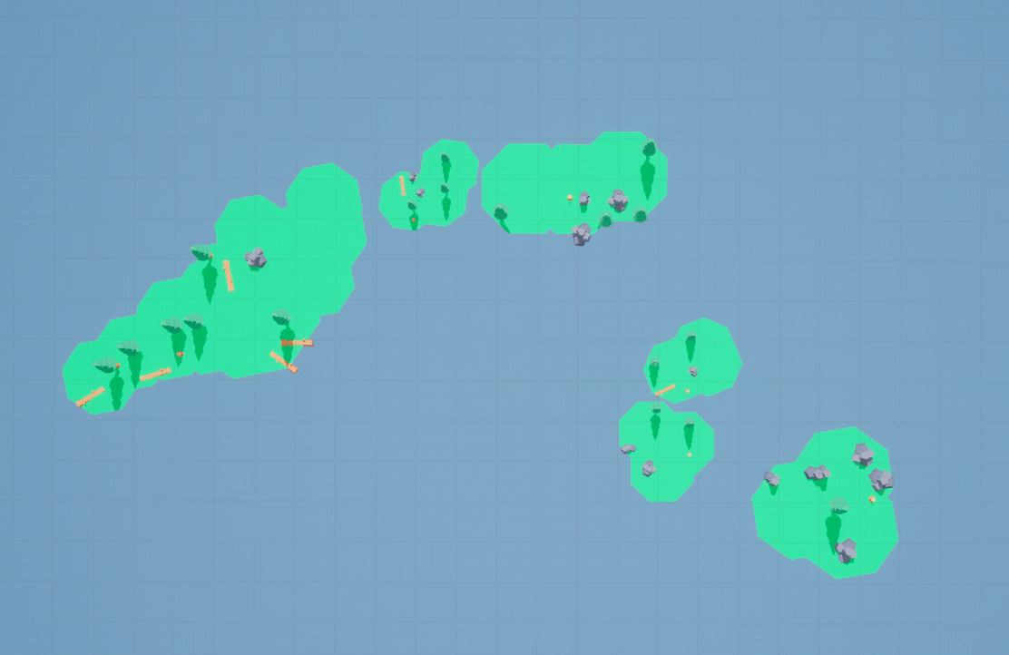

Figure - An example of some different island shapes from top down.

There are some downsides to this type of cone based generation, in that the use of circles is quite visible in all island shapes. The larger islands also have some issues, with lots of cones that are similar sizes. This is however easily fixed through the island parameters, specifically by setting a higher cone height dividend, so subsequent cones are always somewhat smaller.

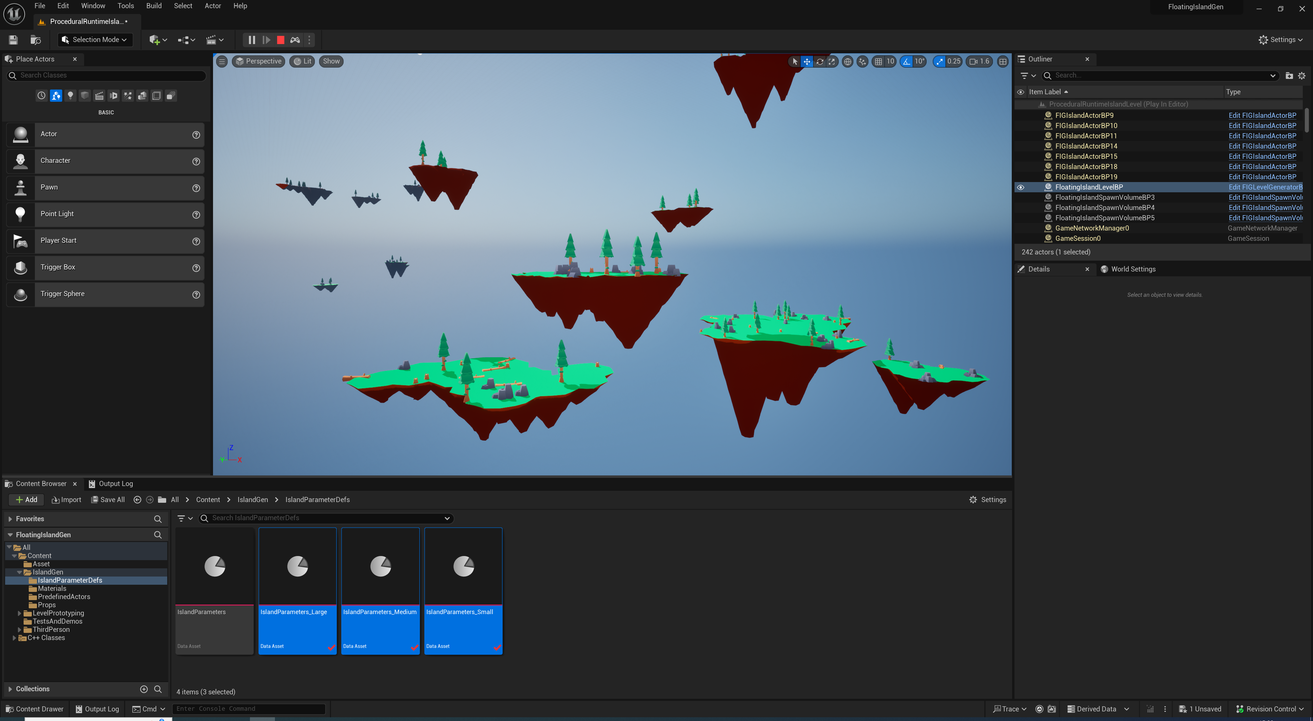

Figure - Examples of medium and small islands with lots of variety.

It’s my belief that the medium and small islands are where the program excels easily, with nice island variety easily reproducible. The larger islands require a lot of adjustment but can sometimes give nice looking results.

The island generation could have been improved with a more sophisticated way of placing the cones, by ensuring they don’t intersect each other and are always fanning outwards. This would likely have its own sets of downsides, where islands take more fuller rounder shapes, rather than some appearing longer or wider.

Some of the islands also have common cone shapes, and can offer little variation in that regard. This is another area for improvement, where extra cones can be placed lower down, intersecting other cones, to create a look of multiple separating tips.

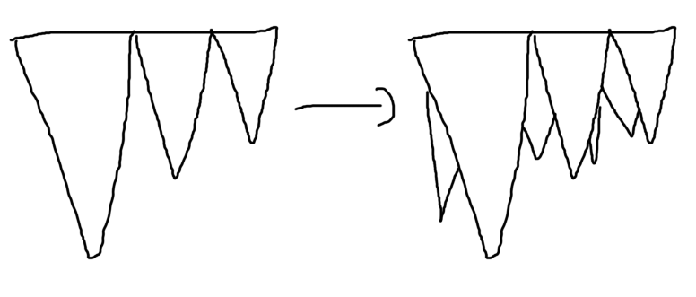

Figure - An example of how the island generation could possibly be improved with additional cones and shapes.

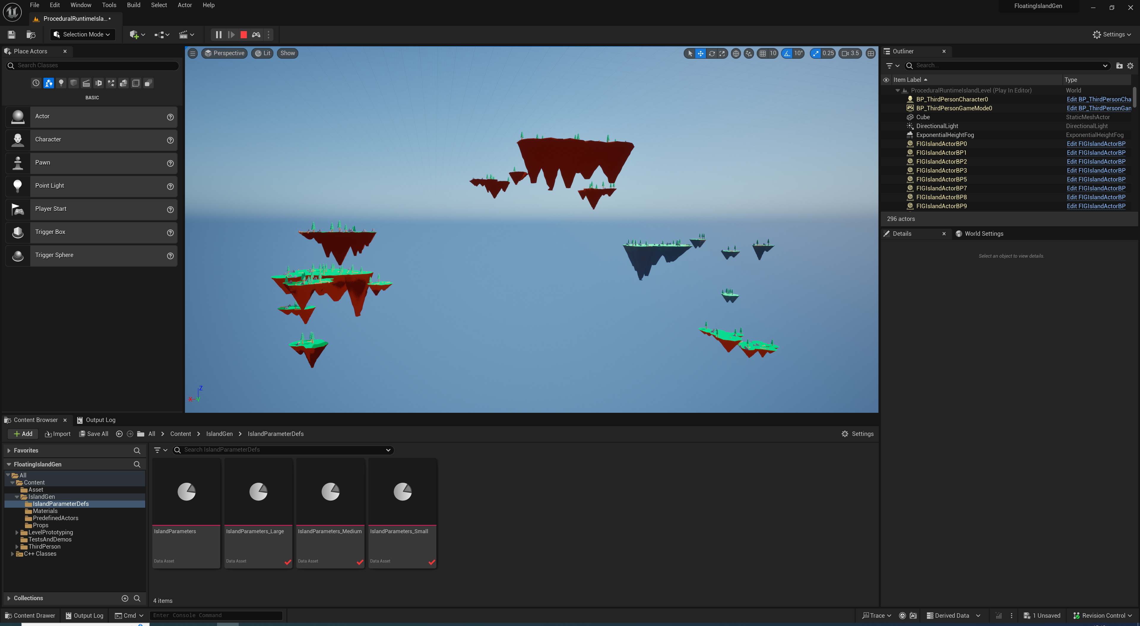

Figure - A zoomed out overview of the level and all islands generated.

The level generation is another area I think the program works quite well, with islands being varied and separated, taking interesting forms that could be fun to explore and play around.

#### Extensibility

The tool is easily used alongside an existing project or as a basis for a new project. All tools and sections can be migrated and imported, and this allows for runtime islands to be inserted into a new project with ease.

The use of the island actor itself is quite limiting. It can be inherited from and adjustments made or edited directly, but the lack of modularity I wanted at the beginning of the project prevents this from being taken further, like with a custom island component inheriting from dynamic mesh component, which would have improved the extensibility by allowing for the component to be easily moved around and attached to different actors.

Migration of project to future versions. At the time of writing, Unreal Engine 5.4 as just launched – The project is however easily migrated to future versions of unreal engine with a right click, as the C++ API will be identical for future versions. As all modern level structures are used, compatibility is ensured .

With this in mind, I think the extensibility of the program is serviceable, but there are notable areas that can be improved with future work.

#### Interoperability

Like above, I believe the interoperability of the program is serviceable, and could be a lot worse. Unreal Engine theoretically should be able to export and save dynamic meshes as a static mesh, but we were unable to locate this functionality in time. If this functionality was available, then interoperability would have been improved. There are some other areas where the interoperability works well, however:

* Export Options (e.g. Export as FBX/Migration into other projects/omniverse).
* As export options are available in Unreal Engine, and migration is still possible, the tool is easily moved into other projects (or existing island meshes if they are the only requirement). If omniverse was developed more thoroughly for the project, then this would be a great interoperability feature, and would allow the islands to be migrated to other tools entirely.
* Integration with semi procedural levels works perfectly, both through islands generated and spawned by the class, and non-procedural island placement. The island generator is capable of spawning procedural islands and hand-crafted islands alongside each other without issue. Furthermore, the island generation itself is compatible with other areas of Unreal Engine. Developers would easily be able to improve the island generation with their own high quality materials, and further improvements could allow them to override the material generation entirely. Developers are also able to create their own scenes of levels, and add improved lighting and post processing functionality as they choose.

#### Closing Notes

The application did consider the Omniverse exporting workflow, but this functionality was excluded due to time constraints and it being out of the scope of the project. The benefits of this would be:

* Easily migrating islands to other projects.
* Generating islands and being able to update them in real time, then move them to other programs.
* Being able to use Unreal as a central place to create island scenery, then migrating it to other programs and solutions as required, for example if they were being used as a scene for an animation.

I believe the approaches taken in this project are compatible with Omniverse’s USD system and In-Memory asset streaming via the Unreal Omniverse Connector.

## Conclusions

Ultimately, the island generation software serves as a great basis for something even better down the line. It generates varied islands and levels, is capable of lots of customisation, but is slightly brought down by the lack of modularity I wanted, and the lack of any real API that allows for easier generation of islands on the fly. It relies on manually spawning or placing islands and then calling the generation function on them either by hand in editor or via Blueprints, or the use of the level generator. In the future, I would like to focus more on these aspects, as well as improving the island generation itself with further procedural elements.

# Conclusion

## Project Conclusion

### Project Overview

As discussed extensively in the previous section, the project has a number of pros and cons, and a number of things went right and wrong.

To reiterate, this project involved the research into existing PCG solutions, frameworks, and games within the industry, as well as different game engines that made use of it, and several PCG algorithms. The aim was to create a “niche” tool that hadn’t really been done before – capable of creating floating island geometry and meshes.

Overall the project was a success, I am very pleased with the islands generation, the level generation, the quality of the code and my attempts to make the system modular (even if they failed a little bit). Many personal real-life hurdles came up that prevented the project from being finished as quickly as I would have liked, and which have also prevented me from giving the code as much thought as I would have liked.

Despite these hurdles I believe the project is a solid base for real improvement, and I’ll enjoy returning to it in the future and maybe even releasing it on the Unreal marketplace for other developers to make use of.

### What I Learned

Throughout the 6 months working on this project, I’ve gained extensive knowledge into all areas procedural, and helped to further my grasp on topics like the programmable graphics pipeline, vertex and index buffers. Research has included case studies into games which make use of procedural content in exciting ways, as well as differences between runtime and design time PCG – a topic necessary for the basis of the project, a tool capable of creating content at runtime and design time.

I’ve delved into the history of procedural content, including games and pioneering algorithms, current trends in the industry, and finally existing game engine support for PCG via built in or third party solutions.

### Comparison with existing solutions

[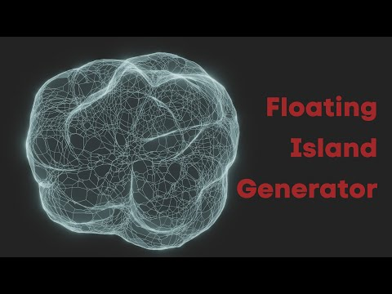](https://www.youtube.com/embed/BdXlGDUgXIY?feature=oembed)Several existing examples of floating island generation exist, but these are bespoke and not designed as a tool usable by other developers. To briefly discuss them:

Figure 112 - A supposed floating island mesh generator available in Blender.

[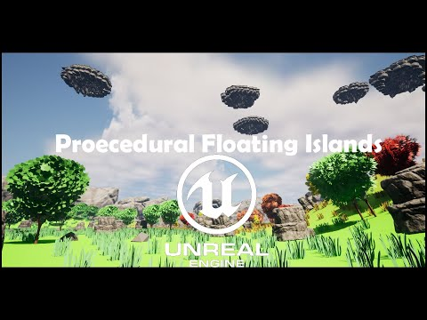](https://www.youtube.com/embed/ZA9c2b59_c0?feature=oembed)The above tool was found very early in development of the project, and claims to be a floating island generator that generates meshes in Blender. Upon further watching, the tool seems to be comprised of a simple mesh deformer, as most meshes created only vaguely resemble floating islands.

Figure - A PCG Graph based tool that creates floating islands with their own biomes.

The above tool also creates floating islands which are a notable improvement over the first example. The tops are much more varied than my own islands (with the prop spawning on mine only being a basic example). One downside to this option compared to my own seems to be that the islands are very jagged and blocky, and don’t look very natural from the sides and bottom.

[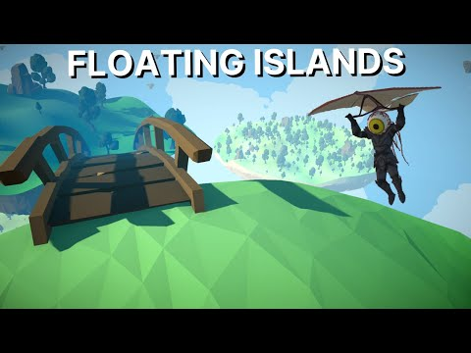](https://www.youtube.com/embed/XwzTmW4klQk?start=182&feature=oembed)Finally, a comparison to the dev log that started off this whole idea. This is a game that makes use of procedural floating islands which for the most part look great but are very flat from the bottom. This is an area where I think my program improves, with the islands looking much more varied on the bottom.

Figure 114 - A devlog for a game using procedural floating islands in Unity.

I think my program overall acts as a much better base for creating floating islands, offering lots of variety and customisation, as well as most importantly looking like natural islands that could easily be made to be higher poly and more detailed. It’s also easily integrated into existing projects, rather than having to be written from scratch from a tutorial.

## Strengths and Weaknesses

If I were to redo my project in the future, there are several things I would try to improve.

In terms of the project itself, code and structure:

* **Modularity** – As explained, the modularity is one area I’m not too happy with. I’d try to split the island generation up into a separate dynamic mesh component and attempt to create a basic API that allows for dynamic creation of islands on the fly.
* **Extensibility** – In terms of extensibility, the tool in its current state is easily integrated into existing projects but lacks a little in being able to adapt it and extend it to more custom solutions due to the limitations in modularity.

In terms of time management and priorities:

I would definitely try to begin on the code aspects sooner, as the entire thesis was shelved for a couple of months while I prioritised coursework and other areas, as well as the personal hurdles that arose during development. Had I known about all of this in advance, even though I had the domain analysis and technical research completed by December, I would have begun sooner on the code and design, which would have given me more time to think about the more technical aspects of the program.

## Future Work

As mentioned previously there are a number of areas I would love to improve on if I kept working on the project.

* **Improving Generation** – The generation could be significantly improved with extra details, like improving the generation of the mesh with more sophisticated techniques and algorithms. Some other areas of improvement could include:
  + **Use of Noise for Props** – Noise could be used when generating props to sit on top of the islands, to create more varied and cohesive effects than just sporadic placement. For example, noise can be used to create a proper forest of trees.
  + **Use of PCG Script** – PCG Script could be incorporated into the prop placement to provide more sophisticated rules and generation for the tops of the islands, with the amount of options it has, PCG Script could also allow for more interesting generation on top of the islands, like houses and mountains.
  + **Smaller Details** – Extra details could be generated with Geometry Script, like vines connecting islands within line of sight, hanging moss and vines, pools of water and waterfalls, and falling dirt particles with Niagara underneath the islands.
* **Improving Collisions** – I would like to go back to the collisions and figure out why simple collisions caused so many inaccuracies. This caused me to have to use complex trimesh collision, which I believe is one of the things impacting performance in the final project.
* **Improving Modularity** – One big focus of the program I want to go back and touch on is the lack of modularity. This includes aspects such as:
  + **Inheriting from Dynamic Mesh Component** – Inheriting from dynamic mesh component for the island class would increase the modularity a lot, as the island mesh generation could be added to any blueprint, rather than limited to a single blueprint class as it is now. This would give developers more freedom in what they can do.
  + **Creating a basic API** – A basic lightweight API could free developers from relying on the blueprint class and the level generator. The only requirement would be to create island parameter definition data assets, which is how island parameters are specified. This would allow them to, for example, call a method in Blueprints or C++ to generate and spawn an island on the fly wherever they wanted. This can be done now, but requires a bit more work to manually set up a blueprint (or use the existing actor, which developers may not want to do). The overall goal with such a system would be to give developers freer reign over the program to define an island class how they want, or to ignore that and to simply spawn them where they are needed.

Adjacent areas could also be explored further, like different options for exporting and migration.

* **Omniverse** – Had it been in scope, omniverse would have been a great exploration, and improved the interoperability of the artefact greatly.
* **DataSmith** – Unreal Engine’s DataSmith would have been another interesting area to explore, allowing for a unified way of exporting island assets.
* **FBX** – Islands could be exported to FBX for further improvement.
* **TwinMotion** – Islands could be exported to TwinMotion to quickly construct scenes.

## State of the Domain

Based on what you have studied and implementation where do you see your area going in the next few years – try to be forward-thinking.

[](https://www.youtube.com/embed/Z_DssjLeGa0?feature=oembed)It’s hard to see what will come next with procedural content generation, as it’s such a huge field of study with so much work put in already. In terms of Unreal Engine specifically, which is what the program was developed in, there are already several systems in development.

Figure 115 - State of Unreal livestream, showing future content coming to the engine.

Unreal has many plans for future procedural content generation, including additions to the procedural content generation system to allow procedural landscapes to be developed at runtime and filled with assets and props.

Furthermore, the Unreal product board showcases many PCG systems coming in the future.

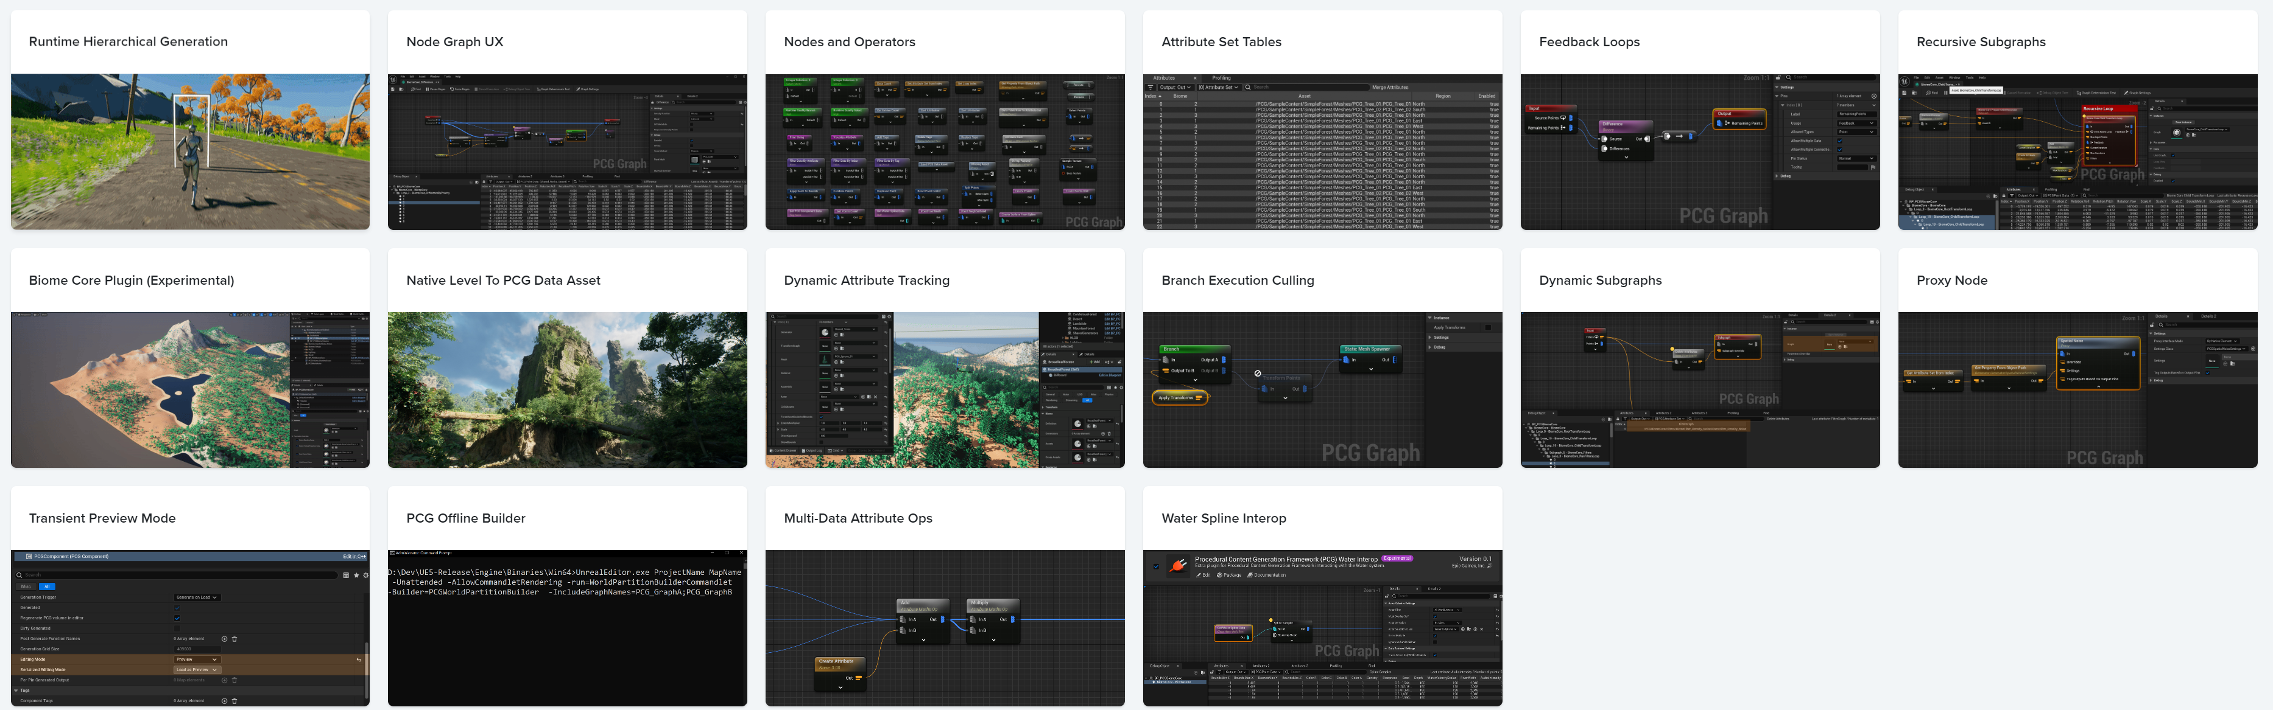

Figure - Upcoming PCG additions to Unreal Engine.

Some of these additions include:

* **Runtime Hierarchal Generation** – Runtime Hierarchal Generation allows for user defined grid size with procedural generation, generating procedural content on the fly as the camera or user enters new areas.
* **New PCG Nodes** – Several new PCG nodes are being worked on as additions to the existing PCG graph.
* **Recursive Subgraphs** – Recursive Subgraphs exist for the PCG graph, allowing a graph to recursively run itself over and over. Safeguards are included to prevent infinite recursion.
* **Level to PCG Data Asset** – A new action that allows a level to be converted to a point cloud representation as a PCG data asset, all user created content is converted to the new format.

# Appendices

## Project Management

This chapter presents an overview of the project plan and how the project has been managed.

### Original Specification and Time Plan

The original project developed and submitted for the artefact was much different to the one seen here:

*“Specific Examples of Algorithms and whether they are suited to a particular genre of game.*

* *L-Systems*
* *Noise (perlin etc)*

*In this project I hope to showcase how various procedural generation techniques can be used to generate a realistic and varied game world. This world will take the form of an outside landscape featuring grass, hills and various flora. Various elements can be generated using different algorithms, such as trees with L-Systems and more.”*

The project was going to explore the generation of a varied and realistic game world, and would have been much better suited towards PCG Script alongside the construction of various 3D assets. The main reason behind deviating this was due to the concern of the project being too alike to existing PCG solutions, and wanting to create something more unique.

Figure 117 - The original project time plan.

### Revised Time Plan and Changes to project Goals

The project had deviated widely from the original plan, only maintaining the idea of generating landscapes and spawning props and “various 3D assets”. The project has changed entirely to be focused around the dynamic creation of the landscape only, with props and 3D assets being spawned from third party assets and 3D content imported into Unreal Engine.

### Supervision Meeting Logs

Screenshots/Collation of the Project Supervision Meeting reports, signed by both parties.

## Sources

Additional content was sourced from kenney.nl, particularly the trees, rocks, and various other props spawned in the level: <https://kenney.nl/assets/survival-kit>

The cel shader used for the islands was sourced from this video: https://www.youtube.com/watch?v=s-l1ZSuVaMs

## Testing Evidence

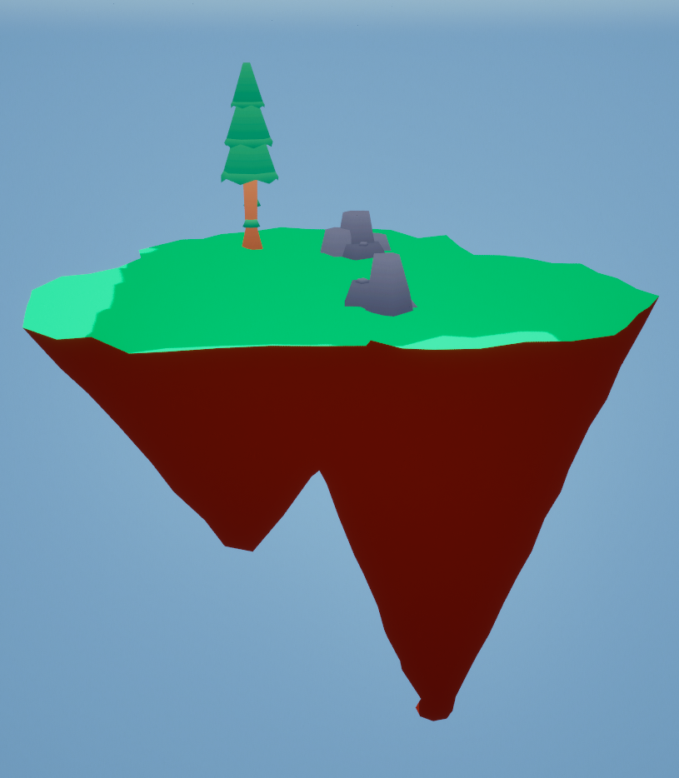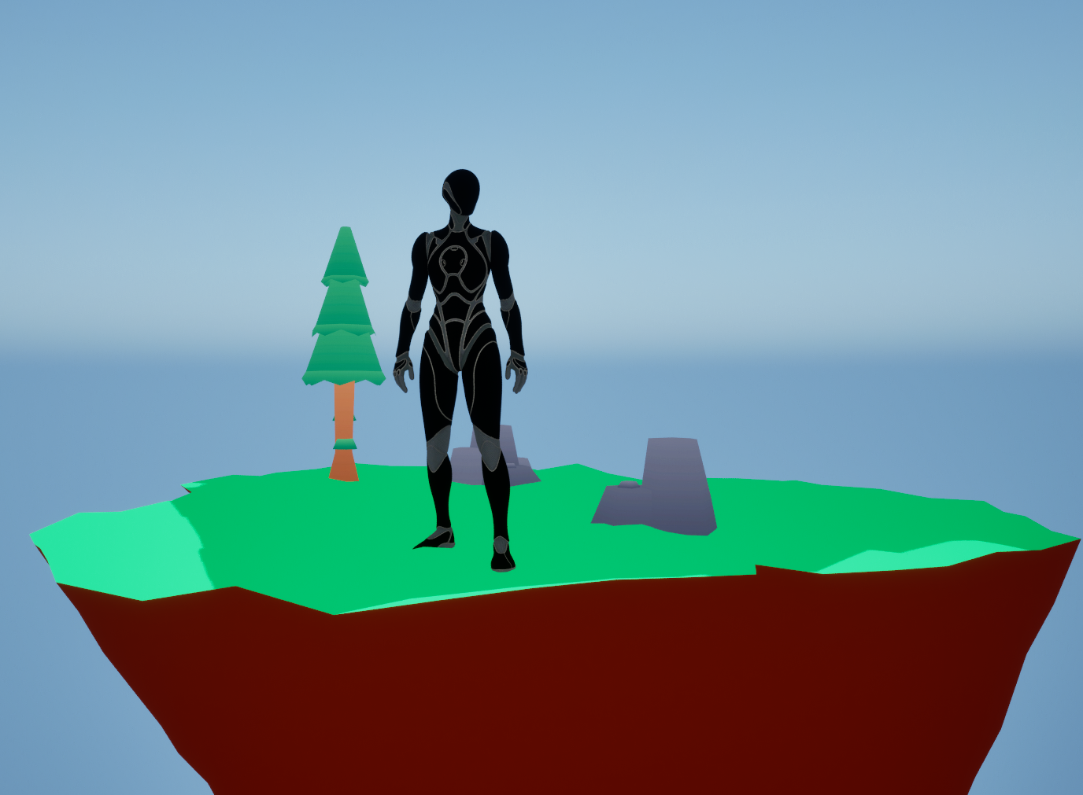

Figure 119 - Testing evidence - ARCH1

Figure 118 - Testing Evidence - ARCH1

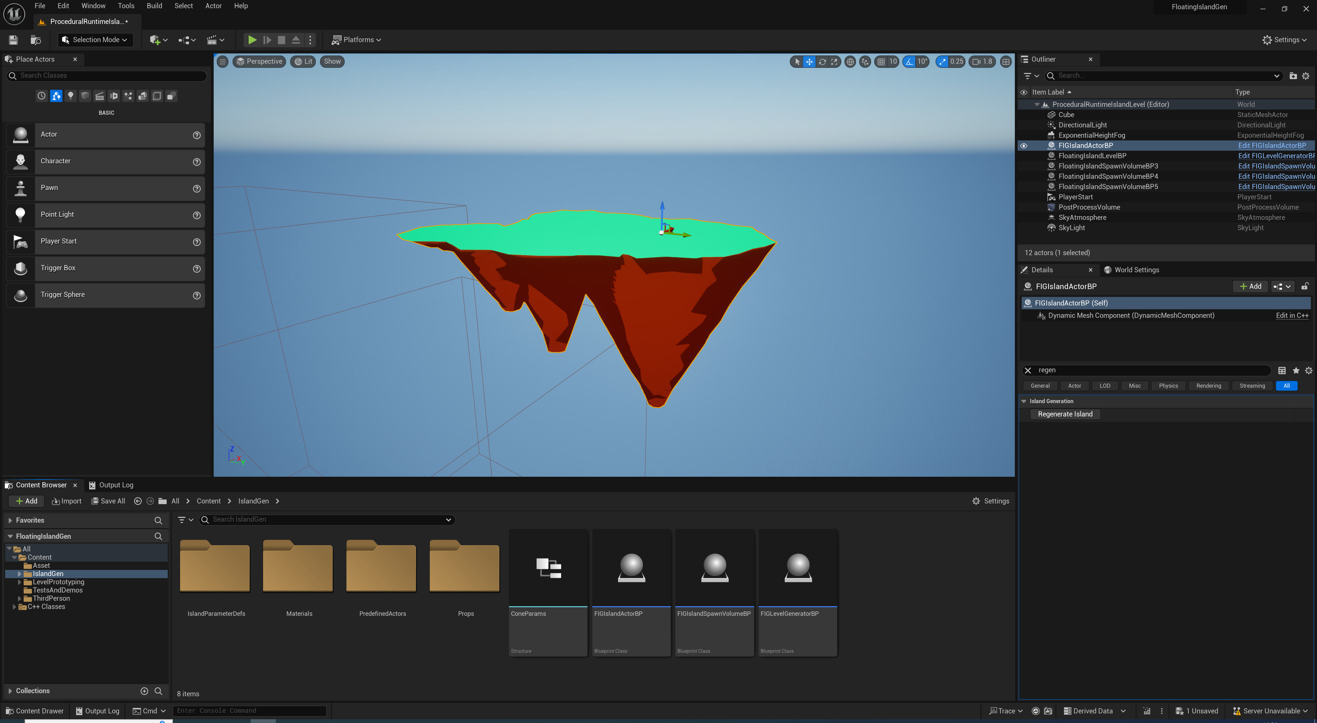

Figure - Testing Evidence - ARCH1 (Note the Regenerate Island button in the outliner)

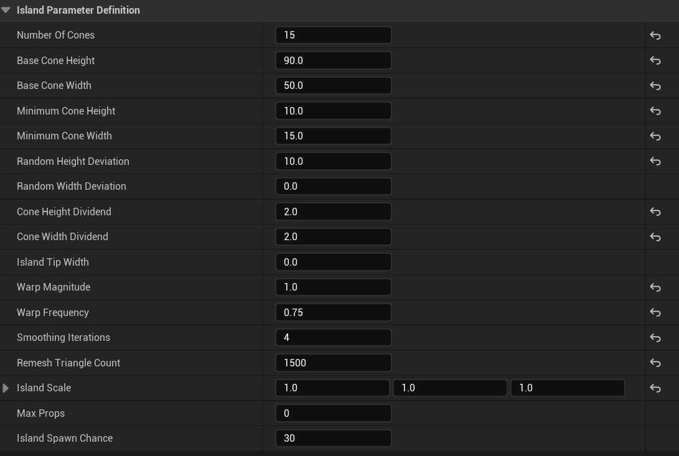

Figure - Testing Evidence - ARCH4

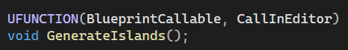 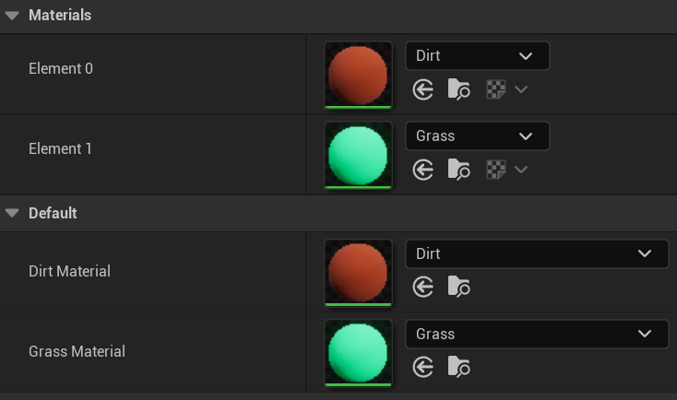

Figure 122 - Testing Evidence - ARCH5

Figure - Testing Evidence - ARCH6

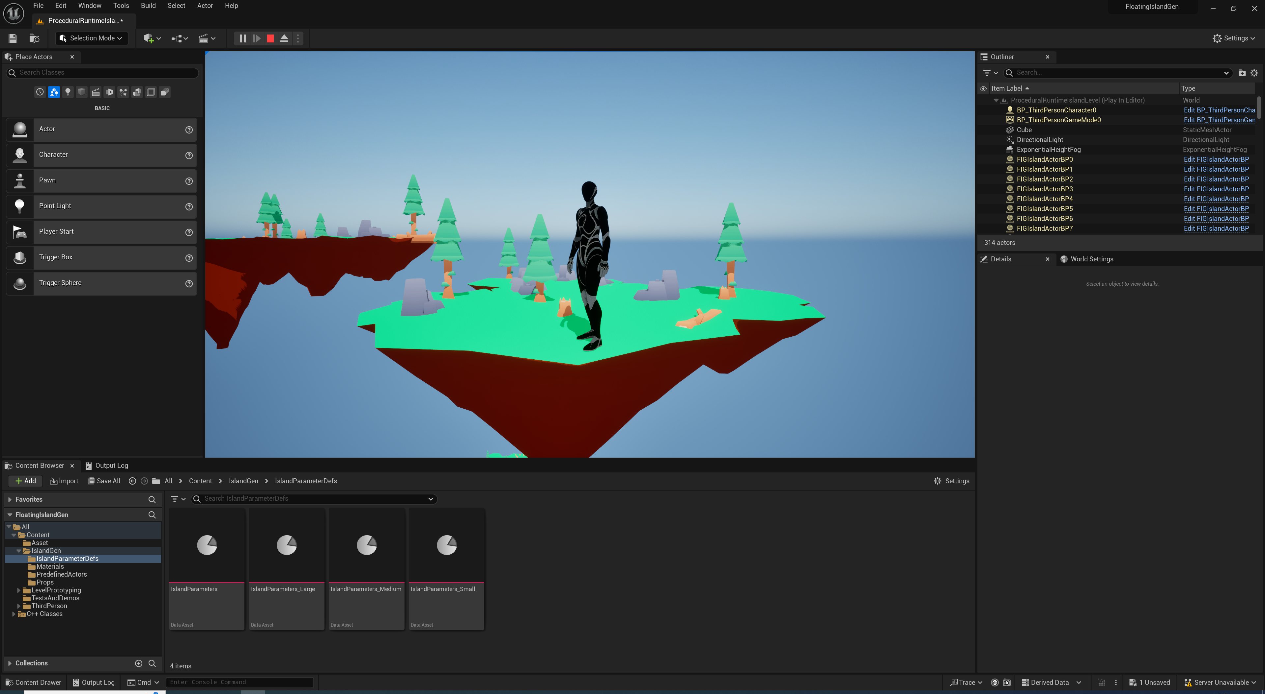

Figure - Testing Evidence - ARCH7

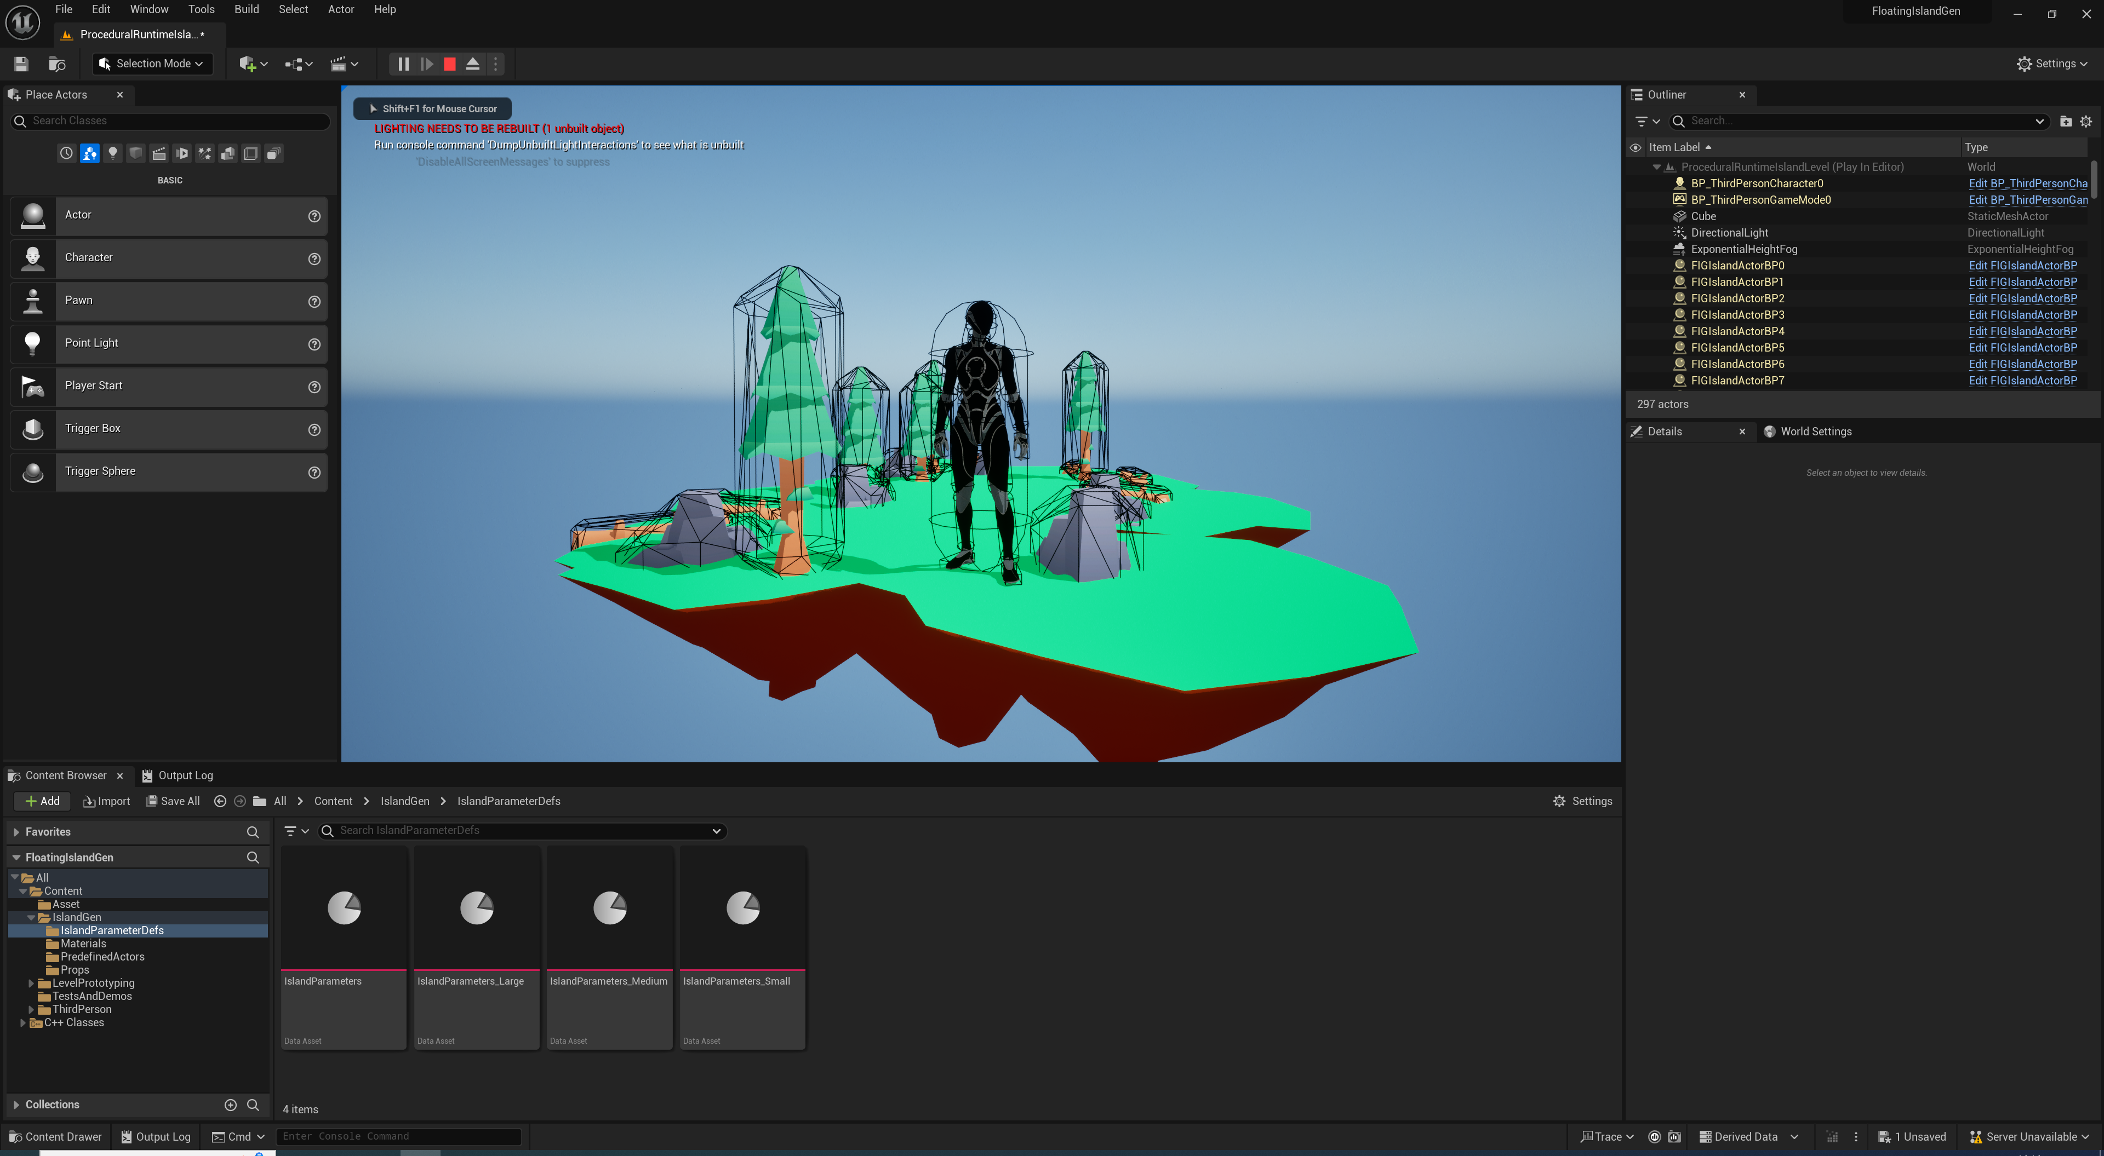

Figure - Testing Evidence - ARCH7 (Note that collision boxes do not show up on the dynamic mesh, but they are present)

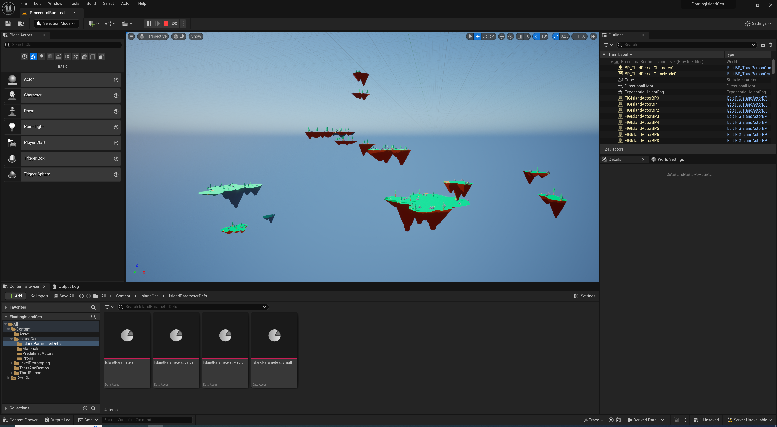

Figure - Testing Evidence - MG2 (Note the wide variety of island meshes)

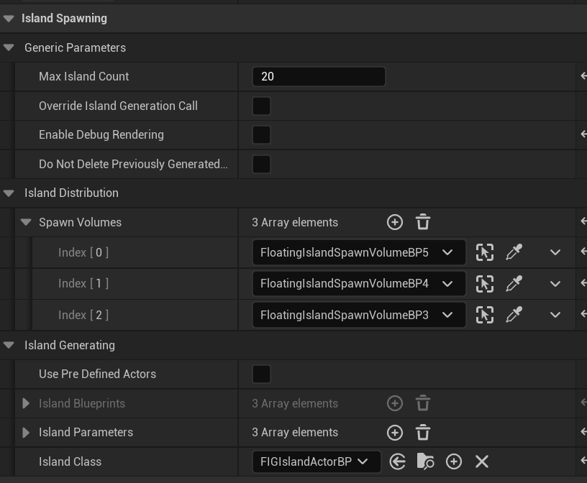

Figure - Testing Evidence - IP1

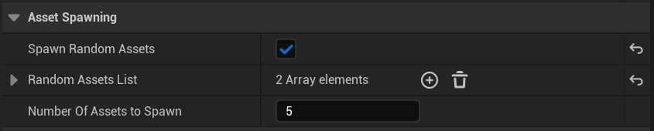

Figure - Testing Evidence - IP1

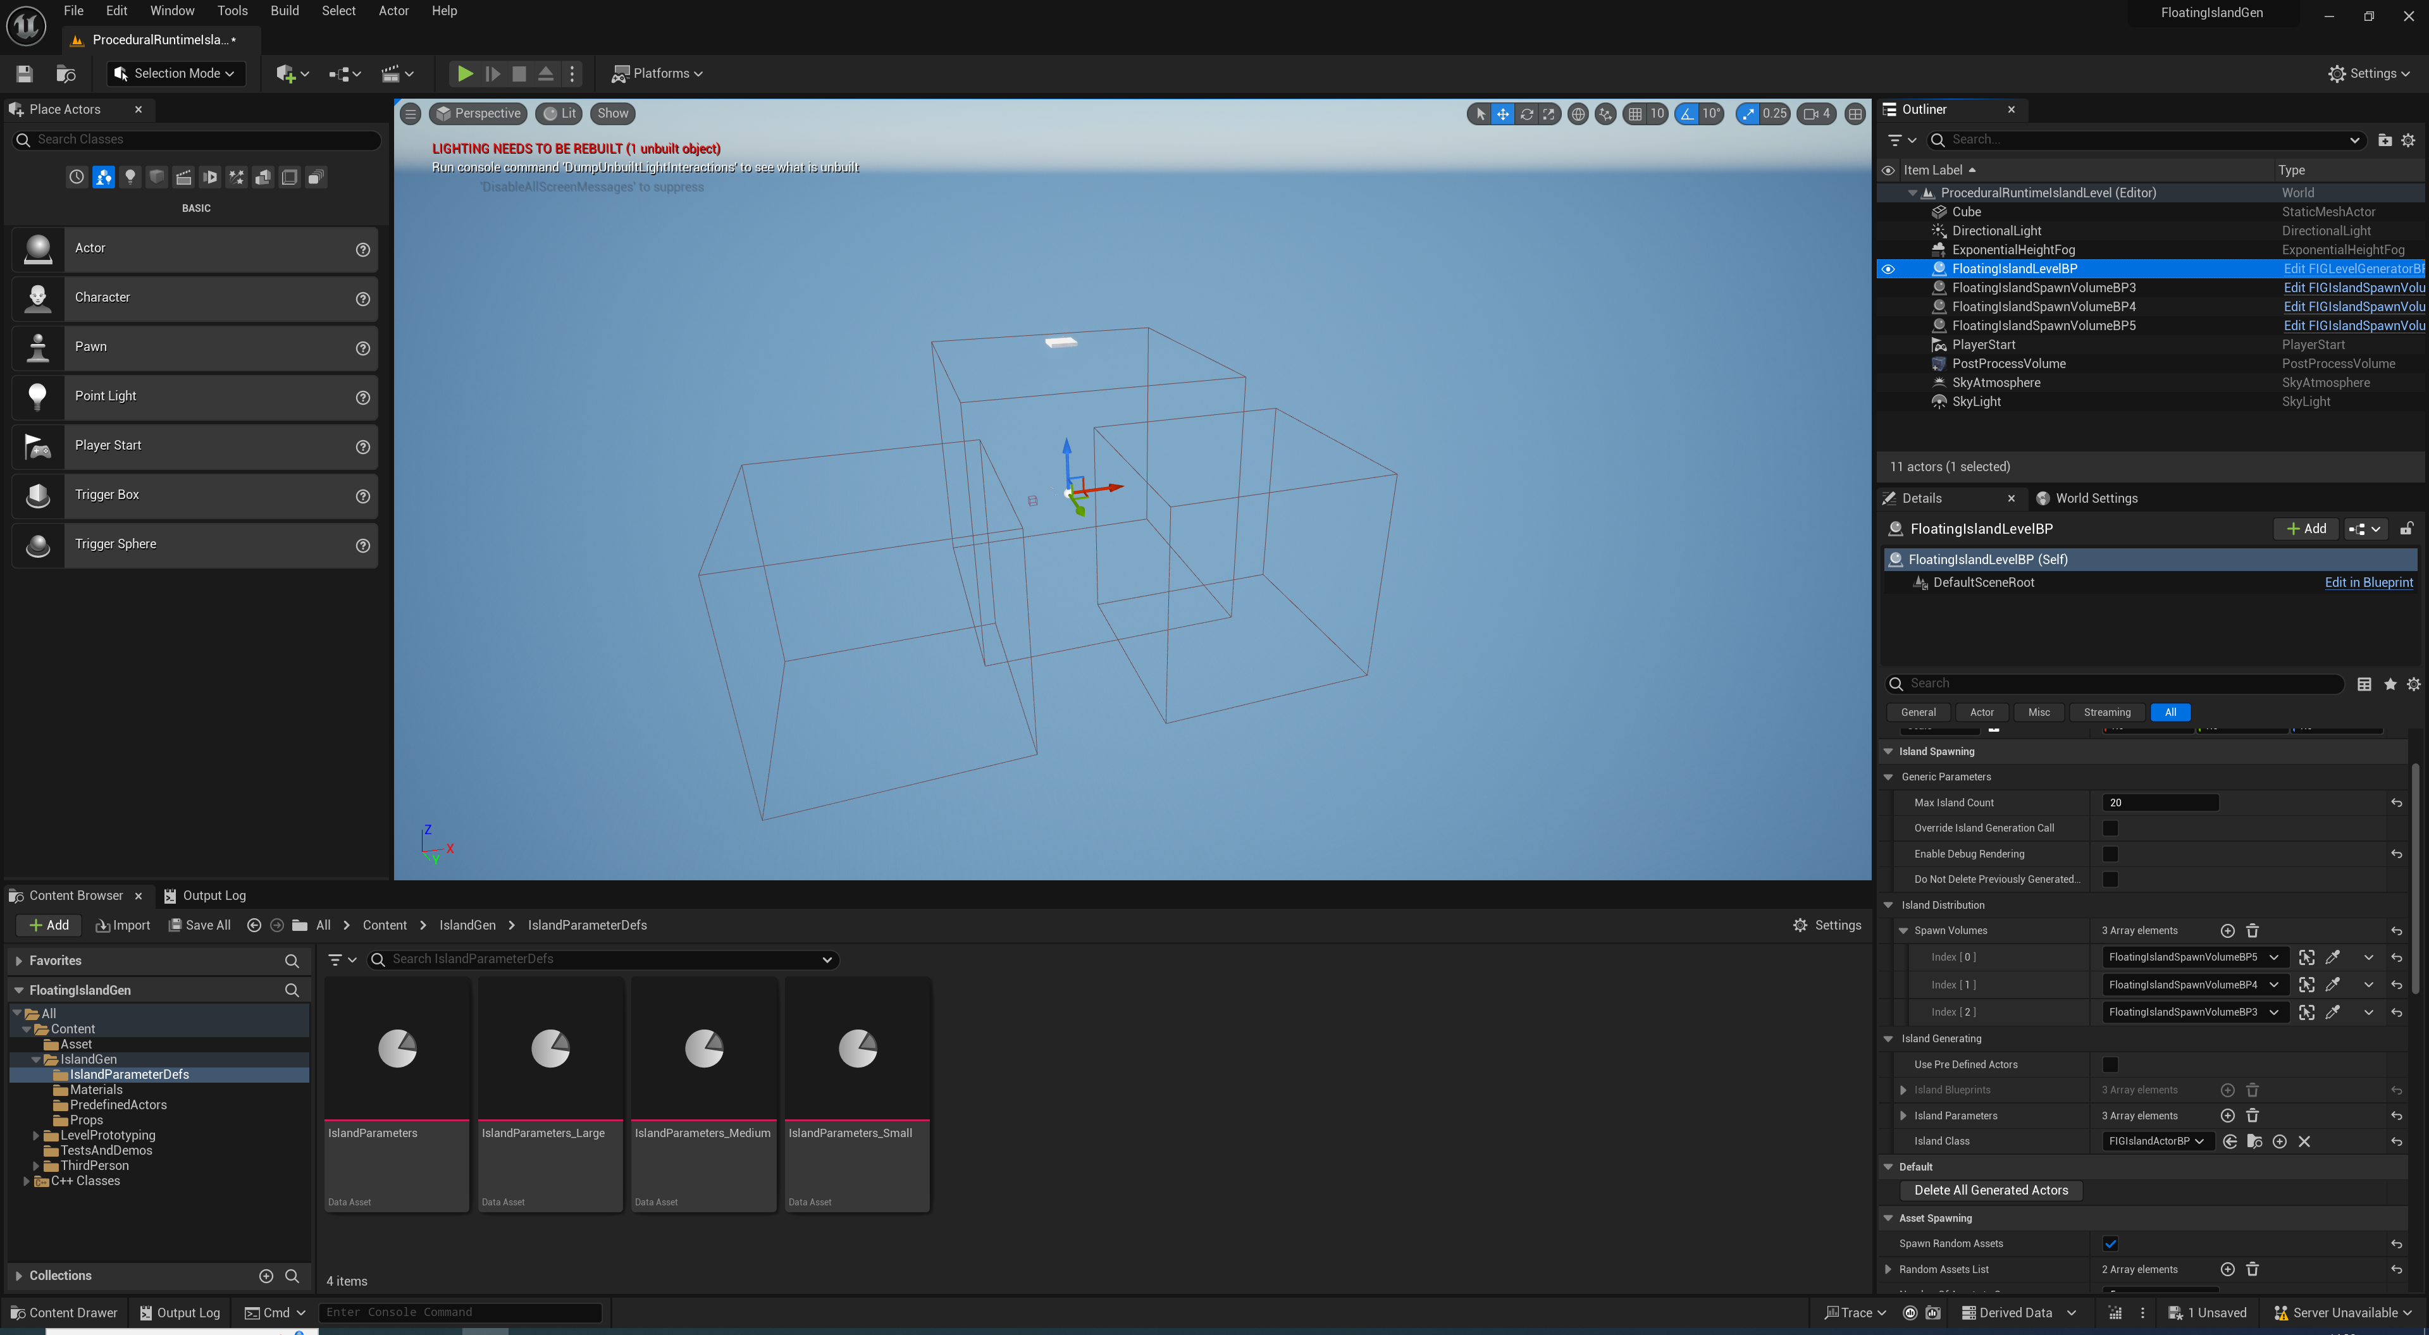

Figure - Testing Evidence - IP2 (Notice the 3 spawn volumes, which are also specified in the outliner on the right for the level generator)

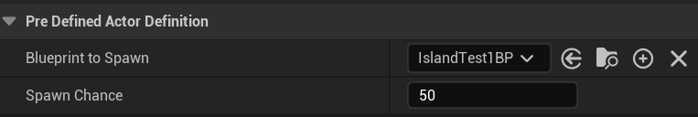

Figure – Testing Evidence - IP3 (Developers can use a predefined actor definition to specify any blueprint to be spawned)

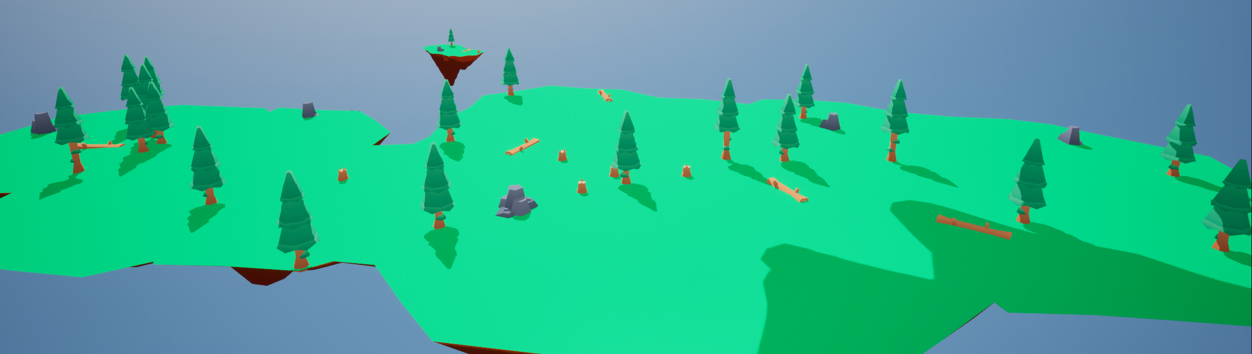

Figure - Testing Evidence - IP4

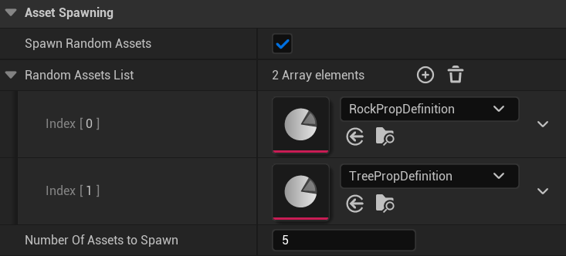

Figure - Testing Evidence - IP4

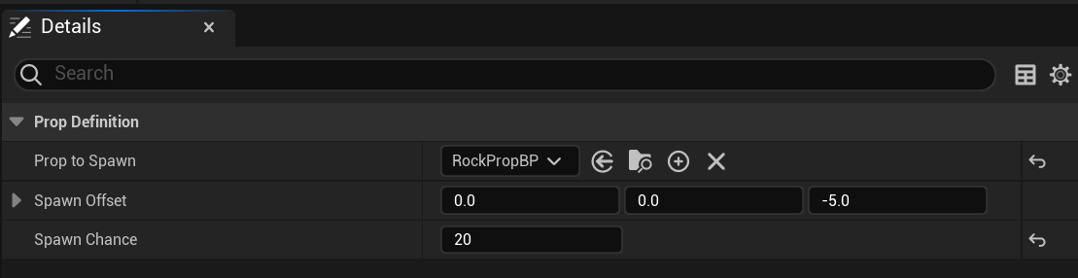

Figure - Testing Evidence - IP4

# Bibliography

*3D Graphics with OpenGL - The Basic Theory*. (n.d.). Retrieved December 19, 2023, from https://personal.ntu.edu.sg/ehchua/programming/opengl/CG_BasicsTheory.html#zz-6.

Akenine-Moller, T., Haines, E., & Hoffman, N. (2019). *Real-time rendering*. AK Peters/crc Press.

Alien Isolation - Steam. (2014). *Alien Isolation*. https://store.steampowered.com/app/214490/Alien_Isolation/

Amnesia: The Bunker - Steam. (2023). *Amnesia: The Bunker*. https://store.steampowered.com/app/1944430/Amnesia_The_Bunker/

Baek, N., & Kim, K. J. (2019). Design and implementation of OpenGL SC 2.0 rendering pipeline. *Cluster Computing*, *22*(Suppl 1), 931–936.

Blatz, M., & Korn, O. (2017). A very short history of dynamic and procedural content generation. In *Game Dynamics: Best Practices in Procedural and Dynamic Game Content Generation* (pp. 1–13). Springer.

Blinn, J. (1996). *Jim Blinn’s corner: a trip down the graphics pipeline*. Morgan Kaufmann.

Boeing, G. (2016). Visual analysis of nonlinear dynamical systems: chaos, fractals, self-similarity and the limits of prediction. *Systems*, *4*(4), 37.

Borderlands - 2K. (2023). *Borderlands*. https://borderlands.2k.com/en-GB/

Darren Grey. (2013, October 27). *Screw the Berlin Interpretation!* https://archive.ph/sx9EW

Deep Rock Galactic - Steam. (2020). *Deep Rock Galactic*. https://store.steampowered.com/app/548430/Deep_Rock_Galactic/

Epic Games - Actors and Geometry. (2023). *Unreal Engine*. https://dev.epicgames.com/documentation/en-us/unreal-engine/actors-and-geometry-in-unreal-engine

Epic Games - Geometry Script Overview. (2023). *Unreal Engine Docs*. https://dev.epicgames.com/documentation/en-us/unreal-engine/geometry-script-reference-in-unreal-engine?application_version=5.0

Epic Games - Procedural Content Generation Framework Overview. (2023). *Unreal Engine*. https://dev.epicgames.com/documentation/en-us/unreal-engine/procedural-content-generation--framework-in-unreal-engine

Epic Games - Procedural Mesh. (2023). *Unreal Engine*. https://docs.unrealengine.com/4.27/en-US/BlueprintAPI/Components/ProceduralMesh/

Epic Games - Skeletal Meshes. (2023). *Unreal Engine*. https://dev.epicgames.com/documentation/en-us/unreal-engine/skeletal-mesh-assets-in-unreal-engine

Epic Games - Static Meshes. (2023). *Unreal Engine*. https://dev.epicgames.com/documentation/en-us/unreal-engine/static-meshes

Giesen, F. (2011). *A trip through the Graphics Pipeline*.

Hänggi, P., & Marchesoni, F. (2005). Introduction: 100 years of Brownian motion. In *Chaos: An Interdisciplinary Journal of Nonlinear Science* (Vol. 15, Issue 2, p. 26101). American Institute of Physics.

Hennessy John, & Patterson David. (2011). *Computer Architecture A Quantitative Approach* (fifth). Morgan Kaufmann.

Jeff Farris. (2020, February 20). *Forging new paths for filmmakers on “The Mandalorian.”* https://www.unrealengine.com/en-US/blog/forging-new-paths-for-filmmakers-on-the-mandalorian

Jeff Lait. (2009, October 27). *POWDER*. http://www.zincland.com/powder/index.php

Kenney. (2021, October 27). *Procedural Generation: An Overview*. https://kentpawson123.medium.com/procedural-generation-an-overview-1b054a0f8d41

Koderz, & Triaxis Games. (2023). *Realtime Mesh Component Documentation*. https://rmc.triaxis.games/

Left 4 Dead 2 - Steam. (2009). *Left 4 dead 2*. https://store.steampowered.com/app/550/Left_4_Dead_2/

Mandelbrot, B. B., & Mandelbrot, B. B. (1982). *The fractal geometry of nature* (Vol. 1). WH freeman New York.

Minecraft - Mojang. (2023). *Minecraft*. https://www.minecraft.net/en-us

Perlin, K. (1985). An image synthesizer. *ACM Siggraph Computer Graphics*, *19*(3), 287–296.

Raft - Steam. (2022). *Raft*. https://store.steampowered.com/app/648800/Raft/

*ROGUEBASIN*. (2008, October 27). https://roguebasin.com/index.php/Main_Page

Ryan Schmidt. (2020). *Command-Line Mesh Processing with Unreal Engine 4.26*. https://www.gradientspace.com/tutorials/2020/9/21/command-line-geometry-processing-with-unreal-engine

Schmidt, R. (2022, December 19). *Unofficial Geometry Script & DynamicMeshComponent FAQ - Gradient Space*.

Smith, G. (2015). An Analog History of Procedural Content Generation. *FDG*.

Stan Pittet. (2023). *Atlassian - Types of Testing*. https://www.atlassian.com/continuous-delivery/software-testing/types-of-software-testing

tarunsinghwap7. (2023). *Geeks for Geeks - Difference between Black/White/Grey Box*. https://www.geeksforgeeks.org/difference-between-black-box-vs-white-vs-grey-box-testing/

Valheim - Steam. (2021). *Valheim*. https://store.steampowered.com/app/892970/Valheim/

van Muijden, J. (2017). *GPU-based procedural placement in Horizon Zero Dawn*.

Vuontisjärvi, H. (2014). *Procedural planet generation in game development*.

Wihlidal, G. (2016). Optimizing the graphics pipeline with compute. *Game Developers Conference*, *2*(3).

Yo Takatsuki. (2007). *Cost headache for game developers*. http://news.bbc.co.uk/1/hi/business/7151961.stm

Ziegler, G. M. (2013). *Mathematik-Das ist doch keine Kunst!* Albrecht Knaus Verlag.

Zink, J. (2010). *Chronicles of the Hieroglyph*. Chronicles of the Hieroglyph. https://hieroglyph3.wordpress.com/

1. <http://usefuljs.net/fractals/>
2. http://kitfox.com/projects/perlinNoiseMaker/
3. (Source: https://upload.wikimedia.org/wikipedia/commons/0/0c/Rogue_Screenshot.png)
4. https://www.trustedreviews.com/reviews/borderlands-2
5. https://www.eurogamer.net/ocean-survival-adventure-raft-is-coming-to-consoles
6. https://minecraft.fandom.com/wiki/Screenshot
7. <https://www.gadgetmatch.com/left-4-dead-2-the-final-stand-last-ever-update/>
8. <https://custodiexitus.com/2017/04/14/5-showsmoviesgames-to-pass-the-time-on-easter/alien-isolation-gameplay-screenshot/>
9. <https://mypotatogames.com/zelda-breath-wild-weather-can-change-terrain/>
10. https://www.guerrilla-games.com/read/gpu-based-procedural-placement-in-horizon-zero-dawn
11. <https://www.unrealengine.com/en-US/blog/unreal-engine-4-24-to-ship-with-free-quixel-megascans-unreal-studio-features-and-more>
12. https://www.worldviz.com/post/tech-tip-how-to-have-tracked-fbx-avatars-in-vizconnect-using-3dsmax-and-mixamos-auto-rigging
13. https://docs.unrealengine.com/4.27/en-US/BuildingWorlds/Landscape/QuickStart/
14. https://dev.epicgames.com/documentation/en-us/unreal-engine/procedural-content-generation-overview
15. https://forums.unrealengine.com/t/procedural-mesh-examples-free/64411
16. https://prefabricator.dev/
17. https://www.deeprockgalactic.com/
18. https://screenrant.com/valheim-wallpaper-mobile-backgrounds/
19. https://store.epicgames.com/en-US/news/amnesia-the-bunker-is-a-chilling-underground-obstacle-course-of-horror
20. Real-Time Rendering, 4th edition
21. Real-time Rendering, 4th edition
22. Real-time Rendering, 4th edition
23. Real-time Rendering, 4th edition
24. Real-time Rendering, 4th edition
25. A Trip Through the Graphics Pipeline
26. Design and Implementation of OpenGL SC 2.0 Rendering Pipeline
27. Real-time Rendering, 4th edition
28. https://hieroglyph3.wordpress.com/samples/
29. https://developer.nvidia.com/falcor
30. https://forums.unrealengine.com/t/procedural-mesh-examples-free/64411
31. <https://dev.epicgames.com/documentation/en-us/unreal-engine/procedural-content-generation-overview>
32. https://docs.unrealengine.com/4.27/en-US/WorkingWithContent/Types/StaticMeshes/HowTo/SettingCollision/
33. https://docs.unrealengine.com/4.27/en-US/WorkingWithContent/Importing/FBX/ImportOptions/
34. <https://www.rokoko.com/integrations/unreal>
35. https://docs.unrealengine.com/5.3/en-US/datasmith-plugins-overview/
36. https://www.productplan.com/uploads/2019/01/Blog-for-agile-feedback-in-post-01.png
37. https://www.reddit.com/r/blender/comments/bcdf6y/a_simple_low_poly_floating_island_scene_i_made/
38. https://assetstore.unity.com/packages/3d/environments/landscapes/urp-low-poly-floating-islands-162431?aid=1101l4LJP&utm_campaign=unity_affiliate&utm_medium=affiliate&utm_source=partnerize-linkmaker